Simulation of the mechanical and electrical behavior of
lithium-ion battery electrodes
Clara Sangrós¹, Carsten Schilde¹, Astrid Pistoor, Arno Kwade¹
¹ Institute for Particle Technology, TU Braunschweig (Germany)
*Corresponding author: c.sangros@tu-braunschweig.de
Highlights
- Discrete element method (DEM) simulations can represent particulate electrodes
- Simulations give insight into structure-process-property relationships
- Electrical conductivity based on the electrode structure via an implemented algorithm

1. Introduction
Lithium-ion batteries are widely gaining popularity as electrochemical power sources, becoming also remarkably successful in the electric power vehicle market. Batteries are composed of electrodes which consist of porous composite materials coated on a substrate. To date, several investigations have clearly confirmed the impact of electrode microstructure on performance metrics such as energy and power densities, cycling stability, cell life and battery safety [1,2].
Bearing in mind the particulate nature of such electrodes, this work proposes a discrete element method (DEM) simulation approach to describe both the behavior of the particles and the binder along the calendering manufacturing step. Additionally, a post-processing tool is implemented to determine the electrical conductivity based on the DEM-generated structures and their connectivity. This electrode property is of considerable importance and ultimately controls the performance of the battery. However, an electrode structure which enables a proper electrical conductivity might hinder the ionic conductivity at the same time. As a consequence, finding optimal electrode architectures that offset competing tradeoffs can be challenging and thus, there is a clear need to fully comprehend the influence of electrode microstructure on cell performance.
2. Methods
Within this project, Li [Ni_{1/3} Mn_{1/3} Co_{1/3}]O₂ (NMC) cathodes were investigated. The discrete element method (DEM) was chosen as a valid simulation approach to represent particulate electrodes. Details on the numerical method can be found in [3]. In general lines, an elasto-plastic contact model was combined with a bond model to reproduce the mechanical response of NMC cathodes by taking into consideration the stiffness of the particles and the binder. The method to simulate the electrical conductivity was based on the connectivity of the numerical structures. To this aim, a pathfinding algorithm was implemented to design an equivalent circuit that can subsequently assess the overall network electrical resistance. Simulations were combined with experiments to calibrate and validate the outcomes. In particular, indentation measurements on single NMC particles were carried out to parametrize the DEM contact model as shown in [3]. The specific electrical conductivity was measured according to [4].
3. Results and discussion
The calendering manufacturing process was investigated within this work via DEM simulations and real experiments. Once they were validated, the simulations could predict the elastic recovery of the cathode structure, a key aspect that cannot be experimentally determined to date. Figure 1 shows the evolution of the porosity under four different maximum calendering stresses. The elastic recovery of the electrodes, which was proved to depend on the calendering degree, ranged from 10.25 % up to almost 17 %.
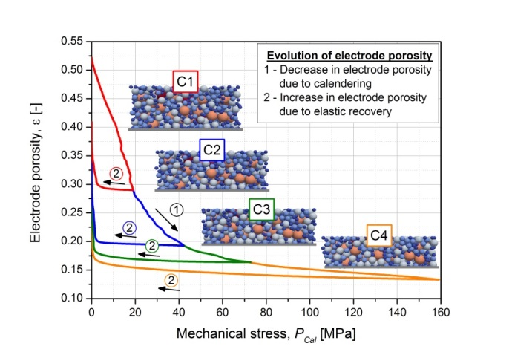
Figure 1. Evolution of the electrode porosity along the calendering process
Electrons move through the electrode particle assembly overcoming electrical resistances. Bearing this in mind, the implemented algorithm was used to identify the electrical pathways within the calendered cathodes. By considering particles as nodes and direct or bond contacts as lines, the structure could be converted into a resistance network. The overall resistance could be resolved afterwards by using Kirchhoff´s circuit laws, which allow to solve complex circuits defining a set of equations for the current and voltage. Results proved that the method could reproduce the experimental trend suitably. Furthermore, it was possible to successfully apply the method to other electrode configurations, which is of great importance in view of improving electrode design for a wide range of applications.
4. Conclusions
Within this work, lithium-ion battery cathodes were simulated to investigate their behavior during the calendering process and assess their specific electrical conductivity. By combining the numerical approach with experiments, the proposed simulation method can give insight into the overall electrode structural, mechanical and transport properties in view of predicting and designing improved materials.
References
- A.Kwade, W.Haselrieder, R.Leithoff, A.Modlinger, F.Dietrich, K.Droeder, Nat Energy 3 (2018) 290–300.
- H.Bockholt, M.Indrikova, A.Netz, F.Golks, A.Kwade, Journal of Power Sources 325 (2016) 140–151.
- C.Sangrós Giménez, C.Schilde, B.Finke, L.Froboese, A.Kwade, Powder Technology (2019) submitted.
- L.Froboese, P.Titscher, W.Haselrieder, A.Kwade, Materials Characterization 133 (2017) 102–111.

