Comparison of process synthesis methods:
case study of the design of membrane separation processes

Thibaut Neveux^{1*}, Bernardetta Addis², Christophe Castel³, Veronica Piccialli⁴, Eric Favre³
1 EDF R&D, EDF Lab Chatou, F-78400 Chatou, France ; 2 Université de Lorraine, CNRS, LORIA, F-54000 Nancy, France ; 3 Université de Lorraine, CNRS, LRGP, F-54000 Nancy, France ; 4 University of Rome Tor Vergata, 00133 Rome, Italy
*Corresponding author: thibaut.neveux@edf.fr
Highlights
- First systematic and critical comparison of process synthesis strategies
- Rigorous coupling of module simulation and optimization is key
- Novel process designs are identified through process synthesis
- Guidelines for selection of the best process synthesis approach are proposed

1. Introduction
In the field of process synthesis (or process design), various methods have been proposed to select a set of equipment with their operational conditions and their interconnection in a process flowsheet. These methods may vary from empirical approaches (where the “process designer” proposes an architecture based on his/her expertise or using hierarchical decomposition methods and then uses a simulation tool to validate the proposed design by means of sensitivity analysis) to optimization-based approaches (where the process synthesis problem is posed as a mathematical problem) [1].
In this paper, it is proposed to compare several methods from the field of Process System Engineering (PSE) on a common process synthesis problem.
2. Methods
Three methods, developed by the paper’s authors, are selected for the comparison (see Table 1).
Table 1. Process synthesis approaches and mathematical formulation chosen in this paper.
Synthesis approach | Mathematical formulation | Software tool | Ref.
Superstructure-based | Global optimization NLP | AMPL + Knitro | [2]
Superstructure-based | MINLP solved by Ant Colony Optimization | Prosim + MIDACO | [3]
Ab-initio (no superstructure) | Evolutionary Programming | Dedicated | [4]

These approaches differs in the synthesis approaches (based or not on a superstructure, i.e. a virtual process including various structural alternatives) and mathematical formulations used to solved the optimization problem.
The comparison procedure is summarized as follows:
- Definition of the synthesis problem (all): available components, unit operations, associated degrees of freedom and their range, objectives and constraints.
- Problem formulation (approach-specific) to fit the method’s requirements.
- Calibration (all): check that the physico-chemical models for unit operation and process simulation give the same results by performing parametric screening (crucial step).
- Optimization (approach-specific): run each algorithm and isolate optimal solutions.
- Validation (all): simulation of the optimal solutions within a process simulator.
The results can be then compared on the basis of various criteria such as: best solutions, exclusivity of solutions (process structure and parameters), computational time, ease of use for a process engineer, etc.
3. Case study: O₂/N₂ separation
A case study of N₂ production from air using membranes is chosen for the comparison. Results are analysed from both structural (number of stages and recycles) and design/operational parameters (membrane surfaces, pressure ratio) points of view. The design is performed using an economic objective function considering capital costs (turbomachineries, membranes, heat exchanger) and operational and maintenance costs (energy, membrane replacement, operation), together with technological constraints and minimal levels of purity for produced N₂ from 90% up to 99.9%.
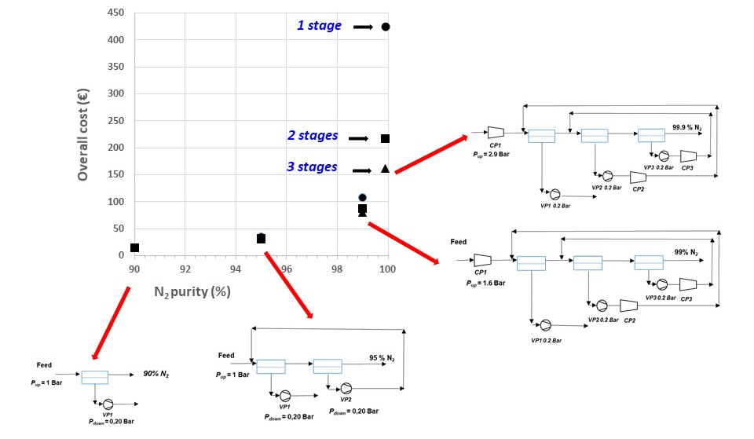
Figure 1. Example of configurations for O₂/N₂ separation for several recoveries and purities [2].

References
- Q Chen, O Grossmann, Ann Rev Chem Biomolec Eng 8 (2017), 249–283
- A Ramirez-Santos, M Bozorg, B Addis, V Piccialli, C Castel, E Favre, J Membr Sci 566 (2018), 346-366
- Q Zhao, T Neveux, M Mecheri, R Privat, P Guittard, JN Jaubert, Comput Aided Chem Eng 43 (2017), 767-772
- T Neveux, Chem Eng Sci 185 (2018), 209–22

