Production, crosslinking and characterization of DexMA/PAA systems
Miriam Cappello¹, Niccoletta Barbani¹, Caterina Cristallini², Giovanni Polacco¹ and
Sara Filippi^{1*}
1 Dipartimento di Ingegneria Civile e Industriale, Università di Pisa, Largo Lucio Lazzarino 2, 56122 Pisa, Italy; 2 CNR, Istituto per i Processi Chimico Fisici, IPCF SS Pisa, c/o Largo Lucio Lazzarino 2, 56122 Pisa Italy
*Corresponding author: sara.filippi@unipi.it
Highlights
- DexMA/PAA systems were designed for applications in material science and biomedical field
- UV photo-crosslinking and thermal treatment were able to stabilize the systems in water
- FT-IR and DSC analysis showed the presence of chemical interactions between DexMA and PAA

1. Introduction
In the last decades, the use of polysaccharides has undergone a rapid progress in many different areas of material science and engineering including pharmaceuticals, biomedical use, food supplements, and cosmetics. The most widely used polysaccharides as biomaterials are alginate, chitosan, hyaluronan, gellan gum and dextran. Dextran (Dex), a bacterial-derived polysaccharide, consisting essentially of α-1,6 linked D-glucopyranose residues with a low percent of α-1,2-, α-1,3-or α-1,4-linked side chains, has received a great interest for column chromatography application, cell culture technology and drug delivery systems [1]. The elevated hydrophilicity of dextran imparts high resistance to protein adsorption, a fundamental requirement for use in implantable medical devices and drug or protein targeting carriers [2]. Layer-by-layer assembly can be considered a versatile tool for coating of implantable materials based on the use of polyelectrolytes such as polystyrene sulfonate, polyallylamine, chitosan and polyacrylic acid. In this work, the design, preparation and characterization of new materials based on dextran (DexMA) and polyacrylic acid (PAA) was reported in order to obtain a bioartificial material that combines polyelectrolyte properties with high protein surface and anti-fouling characteristics due to polysaccharide moieties.
2. Methods
Dextran derivatized with glycidyl methacrylate (DexMA) was performed according to a literature method [3] and was confirmed by FT-IR analysis. DexMA/PAA systems were prepared by a combination of UV photo-crosslinking and thermal treatment using different DexMA/PAA weight ratio: 100/0, 80/20, 60/40, 40/60, 20/80, 0/100. A morphological (SEM) and physico-chemical characterization (FT-IR, DSC, TGA) was performed on the systems, before and after crosslinking. Swelling and mass loss tests on the samples were also carried out.

3. Results and discussion
SEM images of the DexMA/PAA 60/40 system, before and after crosslinking (Figure 1), show a dense structure for untreated sample and a heterogeneous porosity for crosslinked sample. FT-IR analysis on the same samples (Figure 2) shows a decrease of the band intensity at 1000 cm⁻¹, due to the COC stretching of the pyranose ring, a reduction of bands at 3300 cm⁻¹ and 1070 cm⁻¹, both due to hydroxyl groups of dextran, and the appearance of a peak at 1230 cm⁻¹, typical of a C-O ester stretching. These results indicate that the UV photo-crosslinking and thermal treatment lead to the breaking of the pyranose ring and the formation of an ester bond between PAA and DexMA.
DSC analysis, carried out on samples, showed a single glass transition temperature, confirming the presence of chemical interactions between DexMA and PAA.
TGA thermograms show characteristic degradative events of both components, and a mass loss event between 200°C and 300°C that could be ascribed to the breaking of glycosidic bonds caused by thermal treatment.
Stability in water was also tested for all samples. In particular swelling in water, swelling in saturated steam water and mass loss tests were performed. Mass loss tests showed a higher stability in water for DexMA/PAA samples after UV irradiations at 256 nm followed by thermal treatment. Swelling tests confirmed the presence of chemical interactions between the components and the efficacy of crosslinking. Concerning the trend of swelling ratio versus the composition of the DexMA/PAA mixtures, a minimum was observed for the DexMA/PAA 60/40 system.

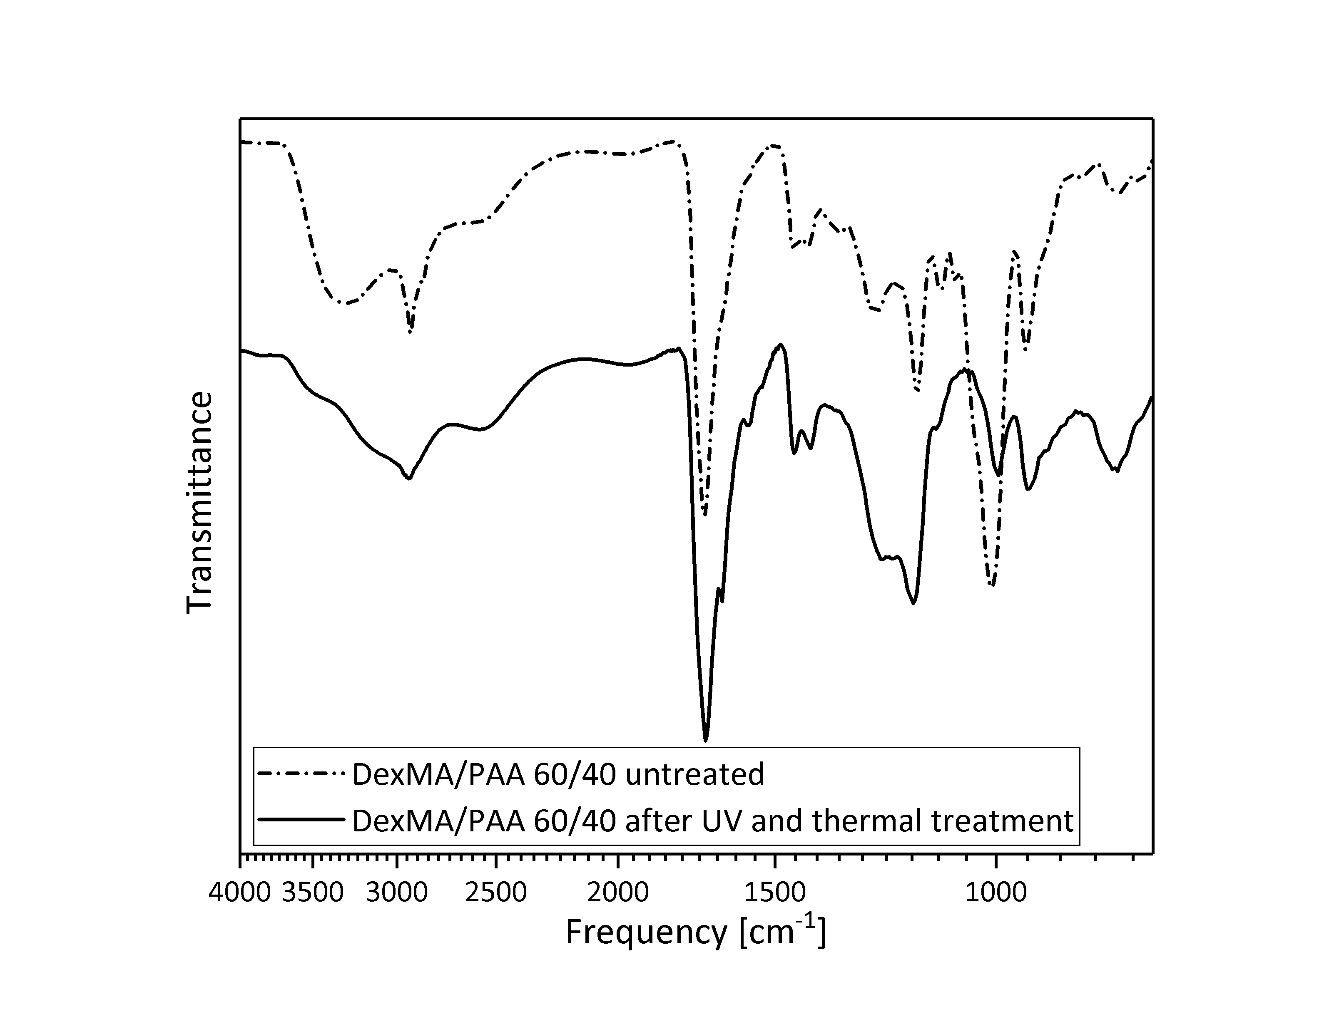
Figure 1. SEM images of untreated DexMA/PAA 60/40 (a) and UV Figure 2. FT-IR of untreated and treated
and thermal treated DexMA/PAA 60/40 (b). DexMA/PAA 60/40.
4. Conclusions
DexMA/PAA systems were prepared by using an innovative combination of crosslinking treatments thus making these materials attractive for use in many biomedical applications.
References
- A. Banerjee, R. Bandopadhyay, International Journal of Biological Macromolecules 87 (2016) 295-301
- T. G. Shutava, K.S. Livanovich, A.A. Sharamet , Colloids and Surfaces B: Biointerfaces 173 (2019) 412-420
- W.N.E. van Dijk-Wolthuis, J.J. Kettenes-van den Bosch, A. van der Kerk-van Hoof, W.E. Hennink, Macromolecules 30 (1997) 3411-13.

