Effect of bubble dynamics and bubble induced turbulence (BIT) on chemically reacting bubbly flows
Manuel Taborda, Martin Sommerfeld
Multiphase Flow Systems, Institute for Process Engineering, Otto-von-Guericke-University Magdeburg; Zeppelinstraße 1, 06130 Halle (Saale), Germany
*Corresponding author: e-mail: manuel.taborda@ovgu.de
Highlights
- Point-particle Euler/Lagrange method for reacting bubbly flows.
- Tumbling bubble rise model and shape oscillations.
- Sub-grid-scale Turbulence modification modeling.
- Validation for single bubble rise with mass transfer.
- Validation for a laboratory column with chemisorption of CO₂ in NaOH solution.

1. Introduction
Bubble columns as multiphase reactors are commonly used in industry since they yield a high contact area, which affects directly the required mass transfer. Nevertheless, the flow structure and bubble behaviour are very complex so that appropriate modelling in the frame of numerical calculations is still today a challenge, especially when mass transfer and chemical reactions are involved. Bubbles from a certain size show oscillations in the shape and a zig-zag/helical motion, which cannot be captured by classical Lagrangian models anymore. In order to do so, the bubble dynamics should be taking into account not only for the momentum, but also for the mass transfer and chemical reactions.

2. Numerical method and modelling
Based on the Euler/Lagrange approach, numerical predictions of bubble columns were conducted, where all the relevant forces acting on bubbles, such as drag, transversal lift, virtual mass, fluid inertia, wall, Basset and naturally gravity/buoyancy were considered. A stochastic modification of bubble eccentricity and motion angle is used to mimic oscillations (Sommerfeld et al., 2018). The effects of such bubble dynamics on mass transfer were modeled through a dynamic Sherwood number (Montes et al., 1999). Large Eddy Simulation (LES) was used for modeling flow and turbulence of the carrier phase, considering not only the effect of sub-grid-scale (SGS) turbulence on bubble motion (Lipowsky & Sommerfeld, 2007), but also BIT modification by bubbles (Lain et al.; 2002, Sommerfeld, 2001; Sato & Sekoguchi, 1975). SGS turbulence effects were also taken into account through modification of the diffusion coefficient in the species equation. With an analogy to the turbulent dispersion model, SGS variations on the bulk concentration seen by the bubble were also considered.

3. Results and discussion
The model validation was performed by comparing the results with experimental data (hydrodynamic and species transport) present in the Literature (Sommerfeld and Bröder, 2009; Merker et al., 2017; Darmana et al., 2007). The performance of the involved different models, bubble induced turbulence, bubble dynamics, dynamic Sherwood number were tested for these different cases. Good agreement with the experimental observations, not only with regard to the liquid dynamics but also with volume change of single bubbles in time and concentrations of participating species in the bubble column. This was only possible when bubble dynamics in the frame of Euler-Lagrange approach was considered, even with point-particle approximation. The decay of volume from CO₂ single bubbles rising in water were compared with data presented in the literature and good agreement was found. A comparison with experiments of bubble swarms and chemical reactions was also realized. In this case, the predicted decay of pH due to chemisorption of CO₂ in a NaOH solution was satisfactory only when bubble dynamics and enhancement factor were considered.
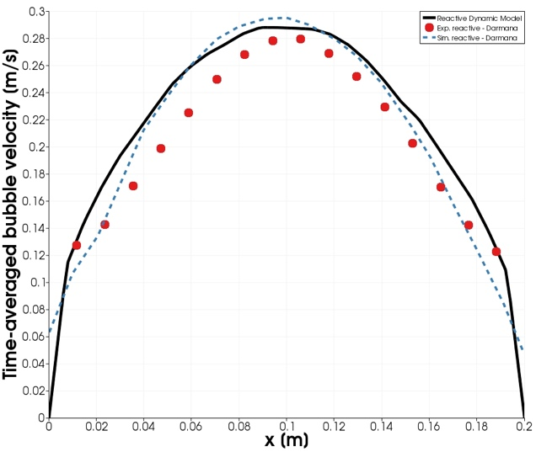
Figure 1. Time-averaged bubble velocity profile at z/H = 0.75.
References
Sommerfeld, M., Muniz, M. and Reichardt, T.: On the importance of modelling bubble dynamics for point-mass numerical calculations of bubble columns. Journal of Chemical Engineering of Japan, Vol. 51 301–317 2018.
Montes, F.J., Galan, M. A, Cerro, R.L.: “Mass transfer from oscillating bubbles in bioreactors”, Chemical Engineering Science, vol. 54, 3127-3136, 1999.
Lipowsky, J. and Sommerfeld, M.: LES-simulation of the formation of particle strands in swirling flows using an unsteady Euler-Lagrange approach. Proceedings of the 6th International Conference on Multiphase Flow, ICMF2007, Leipzig Germany, Paper No. S3_Thu_C_54, 2007.
Lain, S., Bröder, D., Sommerfeld, M. and Göz, M.F.: Modelling hydrodynamics and turbulence in a bubble column using the Euler-Lagrange procedure. International Journal of Multiphase Flows, Vol. 28, 1381-1407, 2002.
Sato, Y and Sekoguchi, K.: Liquid velocity distribution in two phase bubble flow. International Journal of Multiphase Flow. Vol. 2, no. 1, 79-95, 1975.
Sommerfeld, M., Bröder, D.: Analysis of hydrodynamics and microstructure in a bubble column by planar shadow image velocimetry, Ind. Eng. Chem. Res. 48, 330–340, 2009.
Darmana, D., Henket, R., Deen, N. and Kuipers, J.: Detailed modelling of hydrodynamics, mass transfer and chemical reactions in a bubble column using a discrete bubble model: Chemisorption of CO2 into NaOH solution, numerical and experimental study. Chemical Engineering Science, Vol. 62, 2556–2575, 2007.

