Steps towards continuous cellulose hydrolysis via Oscillatory Flow Bioreactors (OFBs)
Judith Buchmaier¹, Christoph Brunner¹, Anh. N. Phan², Adam P. Harvey², Rama Krishna Gudiminchi³, Bernd Nidetzky³, Bettina Muster¹

1 AEE - Institute for Sustainable Technologies, Industrial Processes and Energy Systems,
Feldgasse 19, 8200 Gleisdorf, Austria
2 Newcastle University, Chemical Engineering and Advanced Materials, Newcastle upon Tyne NE1 7RU, United Kingdom
3 Austrian Center of Industrial Biotechnology, 14 Petersgasse, A- 8010 Graz, Austria
*Corresponding author: j.buchmaier@aee.at
Highlights
- Oscillatory Flow Bioreactor (OFB) readjusted from batch to continuous mode
- Continuous processing of cellulose slurry with 15% solid loading possible
- 4 continuous hydrolysis procedures for optimized mixing and overcoming product inhibition
- Enhanced conversion rates at low enzyme input

1. Introduction
The extraction of valuable and pure resources from biogenic material such as lignin, hemicellulose and cellulose is of great importance for the economic realization of biorefineries. Lignocellulosic waste (food waste, forest residues, agricultural waste, etc.) is abundant and therefore a source of special interest, when looking at the production of biobased chemicals and commodities. [1]
Within this study a special focus was put on process intensification steps in terms of an innovative reactor design (Oscillatory Flow Bioreactor, OFB) for overcoming some of the main challenges and hurdles occurring in lignocellulosic conversion processes. The OFB was designed addressing the inefficient (mass and heat transfer inefficiencies) and energy consuming mixing of viscous bioslurries which conventionally are handled at low solid loadings in stirred tank reactors and suffer poor process performance due to a rather slow reaction and product inhibition.
2. Methods
A modular setup of the Oscillatory Flow Bioreactor – enabling batch mode as a first step was designed as follows: Reactor length is adjustable by applying 1 to 2 reactors, baffles of various thickness (2 mm and 3 mm) and different shape (helical) can be inserted. Sinusoidal waveform oscillations in ranges of 0-10 Hz frequencies and 0-11 mm amplitudes are imposed. The overall OFB design is based on Oscillatory Baffled Reactor OBR studies in literature [2] such as on experimental studies at the University of Newcastle.
The conversions were conducted with pure α-cellulose in 50 mM sodium citrate buffer (citric acid monohydrate and tri-sodium citrate dehydrate, Merck Millipore) at pH 4.8, at 50 °C. A DMA 35 device (Anton Paar) was used to measure Glucose formation by density assessment with. Conventional Dinitrosalicylic (DNS) assay were used for detailed evaluation. Batch OFB tests were conducted at different angles, frequencies, amplitudes, viscosities, with different media (ligno-cellulosic material), solid loading (mg/ml) and enzyme loadings (FPU).
3. Results and discussion
The specifically designed Oscillating Flow Bioreactor OFB has been successfully developed for high solid loading (SL) biogenic slurries to ultimately switch from batch to continuous enzymatic hydrolysis processes. Enzymatic conversion experiments of 24 h duration showed, that the batch OFB system generated 3,69 % (70,54 mg/ml) more sugar at similar theoretical mixing power density (12% SL, 2,05 Hz) compared to the reference STR system. The treatment of very high SL (15%) revealed sugar formations of up to 6,7 % higher than its reference system. As shown in Table 1 the 3 mm baffle showed a better conversion performance (+5%) than the thinner 2mm type. Notably also, the OFB system demonstrates similar conversion as the STR while using 20% less FPU of enzyme blend at only 4,8 % power density. Summing up the OFB system exhibited high potential for enzymatic conversions.
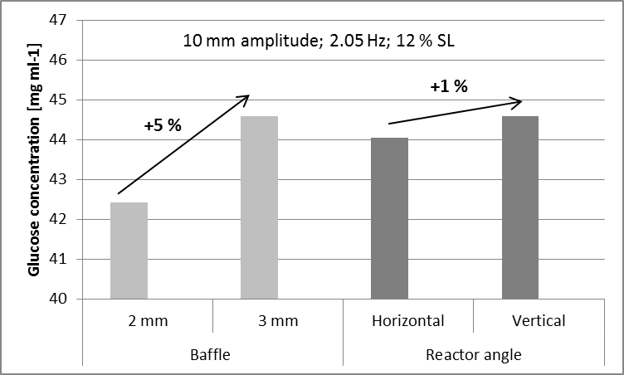
Figure 1. : Steps towards design optimization (left), schematic of OFB plant (right)
The final plant concept is shown in Figure 1 (right side). Conti OFB set-ups consisted of the following configurations ranging from 1-4 OFB reactors in series, Oscillation parameters of 10 mm amplitude, 1-3 Hz and net-flow velocities of up to around 150ml/min.
4. Conclusions
Different steps resulted in best configuration and operating conditions in OFB - Batch mode, these were transferred into OFB - Conti mode. OFB - Batch results gave very satisfying results in terms of glucose production, enzyme input and theoretical energy input, compared to reference STR system. High solid loading of 15% α-cellulose were reproducibly tested. Various configurations of OFB - Conti tests are tested at the moment. Results will be presented at the conference
References
- S. Chundawat, G. Beckham, M. Himmel, B. Dale, Annu Rev Chem Biomol Eng, 2 (2011) 121-145.
- M. Abbott, G. V. Perez, A. P. Harvey, M. K. Theodorou, Chem. Eng. Res. Des.92 (2014) 1969.

