Development and validation of an experimental based particle breakup model for Lagrangian CO₂ dry-ice simulations
Arthur Rudek^{1,2}, Rudolf Kombeitz¹, David Muckenhaupt¹, Thomas Zitzmann¹,
Gerald Russ¹ and Barry Duignan²
1 Hochschule Darmstadt, Haardtring 100, 64295 Darmstadt, GERMANY 2 Technical University Dublin, Bolton Street, Dublin-1, IRELAND
*Corresponding author: arthur.rudek@h-da.de
Highlights
- Experimental insight into CO₂ dry-ice particle impact and breakup behaviour
- Development of a new particle breakup model for Lagrangian particle tracking
- Wind-tunnel experiment for the validation of the new particle breakup model

1. Introduction
A new particle breakup model is presented for Lagrangian particle tracking, which was developed in the context of the design process of a new CO₂ dry-ice based cleaning system for commercial aircraft engines. Particle breakup resulting from solid wall impacts is considered. The model is based on a large statistical database, which is derived from experimental particle impact data captured using two high speed cameras. In this work, approximately 4000 primary particles were recorded impacting a solid wall with various wall temperatures and using a range of impact velocities and impact angles. The recordings were post-processed by in-house-developed digital image processors to obtain secondary particle numbers, sizes and velocities. These secondary particle characteristics are discussed in the context of the experimental parameters and show significant dependence on impact angle and velocity and negligible dependence on target temperature. Using this data, a mass- and energy-based formulation is applied to predict particle breakup statistics in numerical simulations. The approach chosen is shown to be mass-, momentum- and energy conservative and is implemented in the commercial numerical code Ansys CFX. An additional validation experiment for the new particle breakup model is presented, in which a dilute dry-ice laden air flow is established in a wind-tunnel set-up containing a flat plate target. Particle collisions upon this plate are recorded using two high speed cameras and post-processed as described above. A comparison of the experimental data with numerical predictions of the same situation shows satisfactory overall agreement. The limitations of the new model are discussed and future developments are addressed based on these results.
2. Methods
The procedure presented is mainly influenced by the extensive investigations towards dry-ice by KRIEG [1], REDEKER [2] and HABERLAND [3] and the most recent water-ice particle breakup studies by HAUK et al. [4], VARGAS et al. [5] and those from PAN and RENDER [6] and GUEGAN et al. [7]. The modelling assumption used is comparable to what was introduced by CHAPELLE et al. [8]. The particle breakup process is governed by an overall mass- and energy balance of the impacting particles. It is derived from a theoretical model analysis and simplified based on a sensitivity analysis. A fundamental HSC experiment is made, where single dry-ice particles are recorded while impacting solid walls at a range of impact velocities, angles and wall temperatures. The data acquired from post-processing of these recordings represents the statistical database for the new particle breakup model and the model is used in numerical simulations in the Lagrangian particle tracking toolbox in Ansys CFX.
3. Results and discussion
Representative experimental particle data and total results are presented. The dry-ice breakup process is discussed in physical terms, such as shown for example in Fig. 1, left. The main validation study compares numerical particle numbers and sizes to experimental results. The predictive capabilities of the new model implementation are determined in conjunction with simulation set-ups of the validation case; a numerical example is shown in Fig. 1, right.

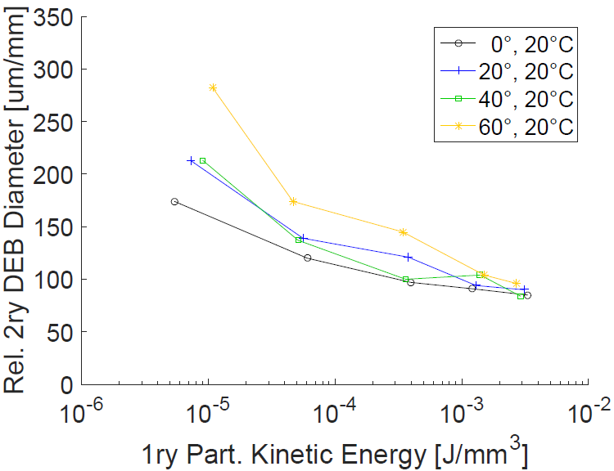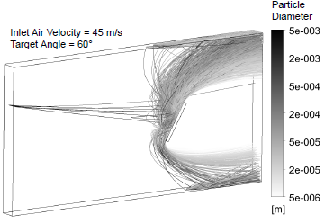
target
plate
2ry particles
1ry particles
particle
injection
Figure 1: Particle sizes after 1ry particle breakup (left), particle breakup simulation in wind-tunnel setup (right).

4. Conclusions
A single particle experiment was presented to generate breakup statistics for dry-ice particles which are typically used in aircraft defouling applications. The statistical database was analyzed and it was found that the secondary particle numbers, sizes and velocities are mainly dependent on the primary particle impact velocity and on the impact angle. There was almost no dependency found on the target temperature, however, additional temperature effects at high impact velocities cannot be ruled out. Secondly, a wind-tunnel validation study of the new model was presented in which predicted values were compared to corresponding experimental data. Mean deviations of 5 to 10 % are encountered for the prediction of the secondary particle sizes. The prediction of the particle sizes of specific size classes is more precise than the prediction of the overall particle size. This can be attributed to more significant inaccuracies in the predictions of the numbers of secondary particles, which show mean deviations as high as 27 %.

References
- M. C. Krieg, Analysis of the effects of dry-ice blasting (in German), PhD-Thesis, TU Berlin, 2008.
- C. Redeker, Erosion and removal by dry-ice blasting (in German), PhD-Thesis, Univ. Hannover, 2003.
- J. Haberland; Cleaning and deburring with dry-ice (in German), PhD-Thesis, Univ. Bremen, 1999.
- T. Hauk, Investigation of the impact & melting process of ice particles, PhD-Thesis, TU Darmstadt, 2016
- M. Vargas et al., Ice particle impacts on a flat plate, IN: SAE Technical Paper 2099: pp 1–23, 2015.
- H. Pan and P. M. Render, Impact characteristics of hailstones simulating ingestion by turbofan aeroengines, IN: J. of Propulsion and Power, 12: pp 457–462, 1996.
- P. Guegan et al., Experimental investigation of the kinematics of post-impact ice fragments, IN: Int. J. of Impact Engineering, 38: pp 786–795, 2011.
- P. Chapelle et al., Computational model for prediction of particle degradation during dilute-phase pneumatic conveying, IN: Advanced Powder Technology, 15: pp 13–29, 2004.

