A Computational Approach to Nose to Brain Drug Delivery from Nanoparticles Embedded in a Hydrogel Matrix
Athina Vasileiadou^{1,2}, Filippos Karageorgos^{1,2}, Stefania Serpetsi², Costas Kiparissides^{1,2}
1 Department of Chemical Engineering, Aristotle University of Thessaloniki, Thessaloniki, Greece; 2 Chemical Process & Energy Resources Institute, Centre for Research and Technology Hellas, P.O. Box 60361, 57001 Thessaloniki, Greece
*Corresponding author: costas.kiparissides@cperi.certh.gr
Highlights
- Sustained and controlled drug delivery.
- In situ hydrogel formation and swelling dynamics.
- Drug release from a population of drug-loaded particles.
- Drug diffusion through particle, hydrogel and biological barriers.

1. Introduction
Central nervous system (CNS) disorders (e.g., multiple sclerosis, Alzheimer’s, Parkinson’s or Huntington’s disease, etc.) represent a growing public health issue, primarily due to the increased life expectancy and the aging population.
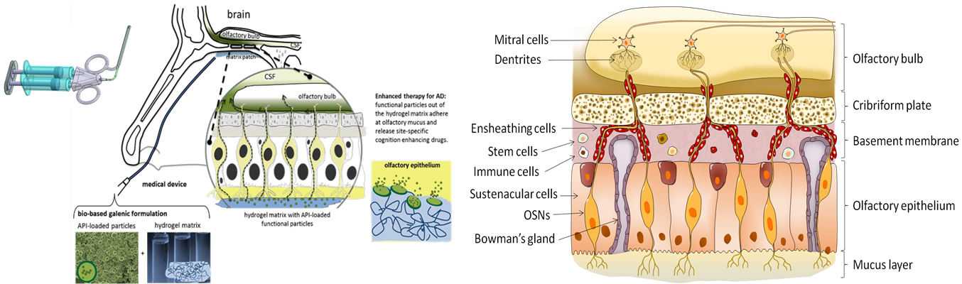
The role of the nasal cavity as an entry point for the brain-targeted delivery of various medications has been long identified as a potential alternative administration route to the intravenous delivery mode. Although highly advantageous due to its non-invasive nature, rapid onset of action and highly localized delivery resulting in low systemic exposure, the delivery of medications to the brain via the nasal cavity exhibits particular challenges, associated with the controlled and sustained release of biopharmaceutics across biological barriers or/and low drug stability attributed to the activity of enzymes residing in the nasal cavity.
In the present work, the development of an innovative nanotechnology-based formulation and application technology are described for the chronic treatment of CNS disorders. The novel drug formulation consists of biodegradable polymer nanoparticles (NPs) loaded with cognition enhancing drugs (e.g., long-acting insulin analogues). The drug loaded particles are embedded into a biodegradable hydrogel matrix that is deposited, via a nasal endoscopic applicator as a thin liquid-gelling film, onto the olfactory region.
2. Computational Methods
A multi-scale modelling approach, comprising models at different time and length scales, is applied to quantify the fundamental physical, transport and biological processes in relation to the nose-to-brain delivery of biopharmaceutics from the embedded nanoparticles in a hydrogel film deposited onto the olfactory epithelium. In particular, a CFD-based model is developed to describe the flow and deposition of a reactive polymer solution, through an endoscopic applicator, onto the olfactory mucus/epithelium, in terms of a polymer solution flow, its viscoelastic properties, gelation kinetics, extruded volume and applicator diameter, in relation to the formation of a hydrogel film onto the olfactory cleft. Moreover, a hydrogel/mucus model is developed to predict the polymer solution spreading, hydrogel formation and degree of swelling. To predict the cross-linking kinetics of functionalized hyaluronic (HA-ox, HA-Tyr) and hydrogel swelling, a kinetic model is developed, in terms of the leading moments of the molecular weight distribution. The crosslinking kinetic model takes into account the effects of initial molecular weight of the polymer, pH and ionic strength of the medium. In order to examine the long term stability and detachment of the deposited hydrogel patch onto the olfactory region, the hydrogel swelling deformation is analyzed in terms of the environmental conditions in the olfactory region. A dynamic drug release model is developed to describe the drug release rate from the drug-loaded nano-carriers embedded in the hydrogel matrix in terms of molecular and morphological properties of polymeric carriers and hydrogel matrix. Finally, a drug release model is derived to calculate the drug release rate for a population of size-distributed particles and analyze the effects of particle size distribution, particle loading, particle swelling and polymer degradation on the drug release profile. Note that the derived model can simulate the observed phenomena including the observed burst in the drug release rate or/and delayed release from the drug-loaded particles. Moreover, the effects of system variables (i.e., gelation onset time, patch volume, particle size and particle drug loading, polymer and hydrogel degradation kinetics, etc.) on the drug release rate are assessed and compared with available experimental measurements.
3. Results and discussion
The various sub-models are numerically solved to calculate the drug mass transfer rate from the embedded nanoparticles in the hydrogel matrix through the mucus layer and epithelium to the olfactory bulb. It is shown that model predictions are in close agreement with experimental measurements obtained from nose to brain drug transfer experiments in rats reported in the literature.
4. Conclusions
A multi-scale mathematical modeling framework has been developed to aid the design, simulation and optimization of nose to brain controlled drug delivery for treatment of CNS disorders and maximize the drug efficacy and bioavailability.
5. Acknowledgments
The present research has been financially supported by the EU No. 721098 grant application under the Research and Innovation Horizon 2020 European Framework Programme.

