FeedPlatePlus - Fed batch cultivation and protein purification in microtiterplates
Dr. Michael Hofer¹, Dr. Barbara Dittrich², Timm Keil³, Prof. Dr. Jochen Büchs³, Clemens Lattermann⁴
1 Fraunhofer Institute for Interfacial Engineering and Biotechnology IGB, Schulgasse 11a, 94315 Straubing, Germany, 2 DWI Leibniz-Institut für Interaktive Materialien e.V., Forckenbergstrasse 50, 52074 Aachen, Germany; 3 AVT – Biochemical Engineering, RWTH Aachen University, Forckenbeckstr. 51, 52074 Aachen, Germany, 4 Kuhner Shaker GmbH, Kaiserstrasse 100, 52134 Herzogenrath, Germany
*Corresponding author: michael.hofer@igb.fraunhofer.de
Highlights
- Optical accessible high-throughput fed-batch cultivation in microtiter plates
- High-throughput protein purification in microtiter plates

1. Introduction
For the development of biotechnological processes, a large number of microbial strains or enzyme variants are generated and have to be analyzed by high-throughput technologies. In these small-scale processes, the cultivation conditions are crucial for a successful strain development as well as for high protein productivities. To imitate production conditions already during early process development, the polymer-based Feed Plate® technology enables fed-batch conditions in microtiter plates [1]. Based on this technique, this study develops an upgrade to enable fed-batch feeding, protein purification and optical accessibility in one microtiter plate. This is realized by a 3D shaping of the polymer matrix (so-called feed rings) which are introduced into each well of a microtiter plate. Additionally, the surface of these feed rings is functionalized with Ni-NTA groups, which allows selective binding and thus purification of His-tagged proteins.
2. Methods
Feed Rings were produced by injection molding of a polysiloxane based polymer matrix containing defined amounts of glucose crystals. Surface modification of feed rings was achieved by addition of carboxylated monomers to the polymer matrix and subsequent esterification with suitable Ni-NTA groups.
3. Results and discussion
First prototypes were constructed, realizing the high-throughput fed-batch cultivaton in 96 well plates through the 3D shaped polymer matrix. The matrix is additionally surface modified to allow for targeted protein binding through Ni-NTA groups (figure 1).
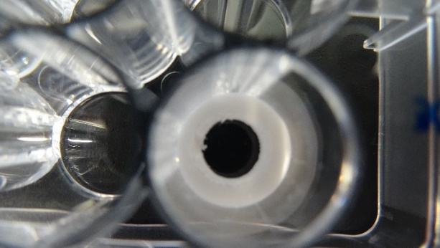
Figure 1. Feed ring in a 96 well plate.
4. Conclusions
Until now, cell culture, digestion, purification and analysis are performed in different microtiter plates. In doing so, almost every step consumes a new plate. Additionally, sterile pipette tips are required for transferring the solutions by means of pipetting. Thus, significant savings in consumables and thus costs can be achieved by the Feed Plate® technology. Another advantage for the scientific work is the reduction of sources of error that occur in particular through frequent pipetting.
References
- EP1879995

