Single Cell and System Modeling of Tubular Proton Conducting Solid Oxide Steam Electrolyzers for Intermittent Operation
Stefan Fogel*, Holger Kryk, Uwe Hampel
Helmholtz-Zentrum Dresden-Rossendorf e.V., Bautzner Landstraße 400, 01328 Dresden, Germany
*Corresponding author: s.fogel@hzdr.de
Highlights
- Transient FEM simulations of a single tubular SOEC using a 2D model.
- Examination of the cell behavior for different load variation speeds & flow configurations
- Development of a quasi-2D system model of a tubular stack & system behavior simulations
- Use of different load switching speeds is proven to be insufficient for cell control

1. Introduction
Due to the constantly growing utilization of wind and solar energy, the demand for technologies for temporal and spatial decoupling of energy provision and consumption is steadily increasing [1]. The application of proton-conducting solid oxide electrolysis cells (H-SOEC) has been a main concern in recent research activities since they offer an environmentally friendly and efficient technique for the conversion of excess energy into hydrogen [2]. As renewables occur intermittently, SOEC designs and all employed materials have to be capable of withstanding large electrical transients and therefore harsh operating conditions [3]. Tubular cell designs of SOEC received increased attention in recent years due to their inherent advantages. They offer rapid startup capabilities as well as high resistance to heat, thermal cycling, thermal stresses and high-pressure application capabilities [4, 5]. Since the knowledge of the dynamic behavior of SOECs is key to their future application, this work aims to study the transient behavior of a single, proton conducting SOEC during rapid load variations and of multi-tubular stacks on a system scale under high-pressure operation. The use of different load variation speeds is discussed with respect to cell control.
2. Methods
A 2D, dynamic and axisymmetric model of a tubular, proton conducting SOEC has been developed using the commercial software package COMSOL Multiphysics® 5.3a. The cell performance characteristics during rapid, short-period load variations are simulated. The model can be divided into four sub-models: the electrochemical sub-model, the heat transport sub-model, the hydrodynamics as well as the mass transfer sub-model. The simulations are used to identify limiting operating conditions as well as beneficial process parameter combinations for an improved cell operation. Furthermore, a dynamic, system scale and quasi-2D model of a tubular H-SOEC stack has been developed within the framework of MATLAB® Simulink® including first peripheral system components.
3. Results and discussion
The cell current in each simulated case is increased from 0 A to 30 A starting at the time of 10 s. Five different load gradients are studied, for which the full-load operation of the SOEC is reached within 0.1 s, 0.3 s, 2 s, 20 s and 200 s. Figure 1 (left) shows the cell potential as a function of time for the transient analysis. Due to the abrupt current changes, the cell potential shows different electrical transients with an increase from the initial open cell voltage of 0.95 V.
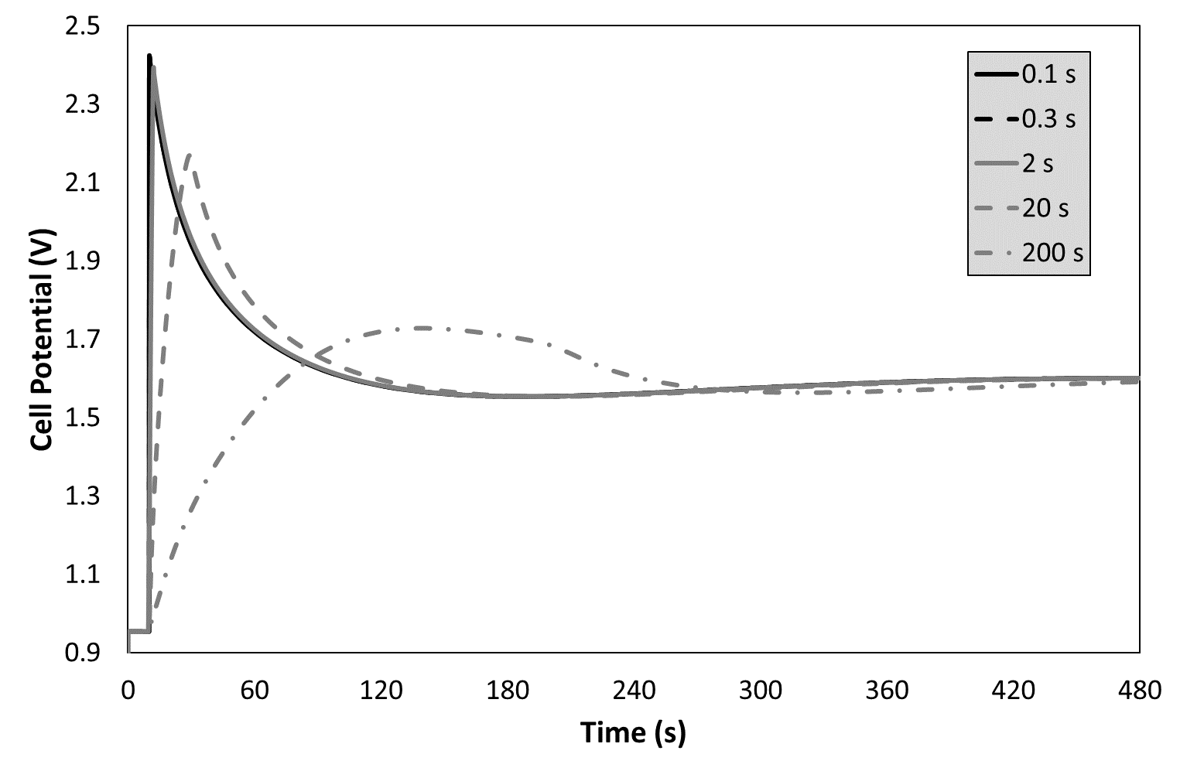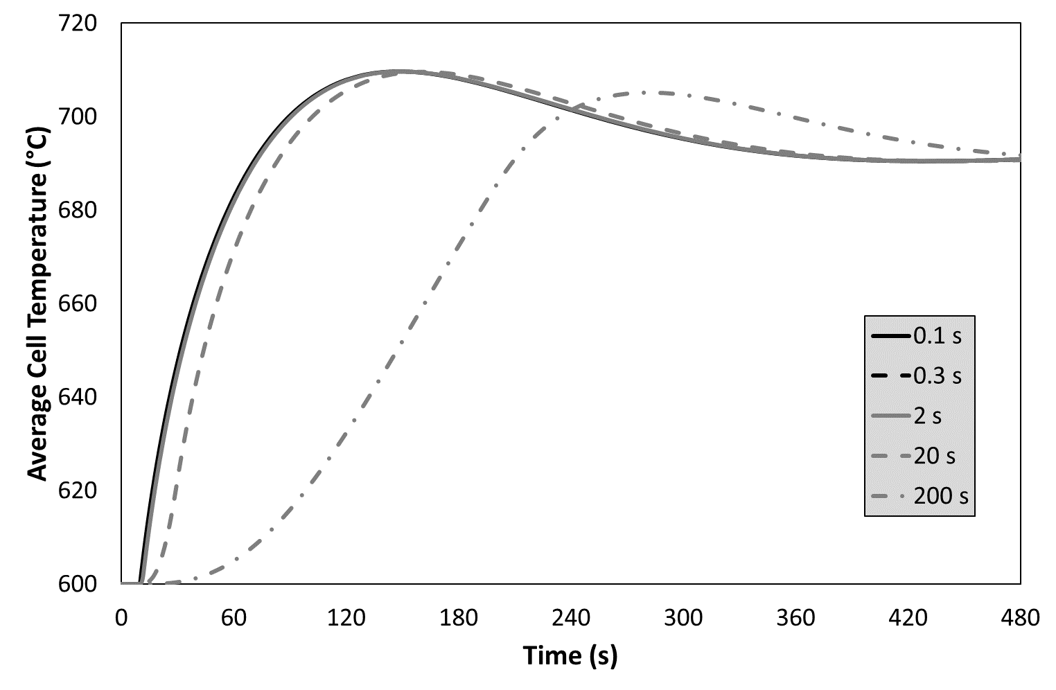
Figure 1. Cell potential (left) and temperature (right) as a function of time after different changes of the cell current from 0 A to 30 A (current changes of 0.1 s and 0.3 s show identical progressions).
For 0.1 s and 0.3 s, the time evolutions of the cell potential are nearly identical and are characterized by a large overshoot within the first seconds after the current change. The cell voltage increases to 2.42 V and decreases towards the stationary cell voltage of 1.60 V. However, the current changes within 2 s and 20 s show different potential progressions. The overshoot decreases with increasing switching time with maximum voltage values of 2.39 V and 2.17 V for the current change of 2 s and 20 s, respectively. In contrast, the cell potential progression for 200 s exhibits a noticeably reduced overshoot up to a cell voltage of 1.73 V. After applying the current changes, the average cell temperature increases from its initial value of 600 °C due to Joule heating and electrochemical heat sinks or sources as shown in Figure 1 (right). The thermal dynamics of the cell for the simulated current changes generally reveal a similar behavior with noticeable differences with respect to the apparent maximum temperature and the time needed to reach the steady state temperature. With longer current change duration, the cell needs more time to reach the steady state temperature.
4. Conclusions
The simulations show that different load switching speeds cannot be used as a sufficient operational strategy to prevent or generate specific temporal temperature progressions. Besides a distinct overshoot of the cell potential, there are no major differences in the electrical behavior of the cell, especially for fast load steps. No limiting operational states were identified.
This work is supported by the Sächsische Aufbaubank (SAB) and the European Union (EFRE) within the research project DELTA (Grant No. 100258734).
References
- I. Ridjan, B. V. Mathiesen, D. Connolly, D. Duic, Energy 57 (2013) 76–84
- M. Ni, M. K. H. Leung, K. Sumathy, D. Y. C. Leung, ‎Int. J. Hydrog. Energy 31 (2006) 1401–1412
- J. Udagawa, P. Aguiar, N. P. Brandon, J. Power Sources 180 (2008) 354–364
- S. Hashimoto, Y. Liu, M. Mori, Y. Funahashi, Y. Fujishiro, Int. J. Hydrog. Energy 34 (2009) 1159–1165
- W. Winkler, J. Krüger, J. Power Sources 71 (1998) 244–248

