Separation of SiO₂ Nanoparticles by Preparative Agarose Gel Electrophoresis with and without Limitation by Mesh Size.
Matthäus Barasinski¹, Georg Garnweitner¹
1 Technische Universität Braunschweig, Institute for Particle Technology and Laboratory for Emerging Nanometrology, 38106 Braunschweig, Germany
*Corresponding author: m.barasinski@tu-bs.de
Highlights
- Size fractionation of SiO₂ nanoparticles (10-300 nm) by agarose gel electrophoresis
- Particle migration is observed following a limited and an unlimited regime:
  - Limited migration of particles for sizes similar to gel mesh size
  - Unlimited migration of smaller particles according to zeta potential

1. Introduction
Monodisperse nanoparticles (NP) with completely uniform properties regarding size and morphology are essential already today e.g. for optical (plasmonic) applications. In future, such particles will be necessary for use in further areas, for example all complex nanosystems involving self-assembly processes. There these uniform NP promise structures with highest precision.
Since the required narrow particle size distribution or monodispersity typically is not reached after the synthesis at industrial scale, purification steps are needed. In most cases the high diffusion rates of NP are problematic for a practicable separation with conventional methods. For this reason, we investigate the use of gel electrophoresis for preparative purification, which provides the opportunity of a highly selective separation of synthesized NP by size and morphology. Thereby, the NP are spatially separated in an appropriate gel according to their different electrophoretic mobilities, with the gel matrix substantially reducing the NP diffusion. In principle, the mobility can be simply calculated by the measurement of zeta potential and utilization of the Henry formula.
2. Methods
The movement of the NP is traced during the migration by a simple camera and subsequent image processing, for correlation of the experimental data to the calculated electrophoretic mobility. Besides this, the separation of NP with regard to size and morphology is evaluated with SEM, TEM and small angle X-ray scattering (SAXS) inside the gel.
3. Results and discussion
After the Stöber-synthesis of silica NP under different ammonia concentrations, sizes and zeta potentials ζ were measured via DLS. The measured data show that bigger particles have greater absolute values of zeta potential. Once the voltage was set on, particles start to migrate from gel pockets through the gel from cathode to anode (here: due to negative zeta potential from top down). In Figure 1 different samples can be seen due to scattered light in a 0.2 wt-% agarose gel after 50 minutes at an applied voltage of 40 V. Two different migration regimes can be distinguished: the unlimited and the limited case. If there is no limitation by too small mesh sizes of the gel, bigger particles migrate faster due to their greater absolute value of zeta potential (samples A and B) than smaller ones. In contrast, sample D is influenced by the mesh size which limits its migration although this sample has the most negative zeta potential. For sample C both cases are valid because the particle size distribution is quite large. Bigger particles within sample C seem to be limited by mesh sizes whereas smaller ones show unlimited and fast migration on the basis of their zeta potential.
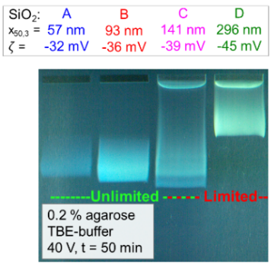
Figure 1. Migration of SiO₂-NP with different sizes in a 0.2 wt-% agarose gel after 50 minutes and an applied voltage of 40 mV.
As an example, in Figure 2 the migration of two SiO₂ samples and a separation of their binary mixture are presented. Sample D with the higher absolute value of zeta potential migrates much slower than sample B, because the mesh size of this specific agarose gel limits its migration speed. Here, the limited case is applied which acts like a sieve to separate the two fractions. After the electrophoretic experiment the particle sizes of the fractions were confirmed with dried gel samples by SEM images.
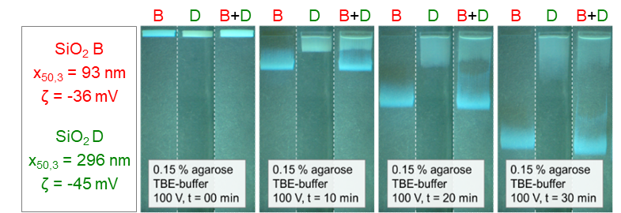
Figure 2. Separation of SiO₂-NP by limitation of sample D (bigger particles) in a 0.15 wt-% agarose gel at 100 V and different times (t = 0, 10, 20 and 30 min).
4. Conclusions
The influence of particle size and zeta potential on the migration behavior of particles inside an agarose gel was investigated and binary mixtures were successfully separated. After the electrophoretic experiment, particles were characterized by SEM, TEM and SAXS inside the gel.

