Experimental studies on ammonium heptamolybdate reaction with ammonium sulfide in turbulent micromixers
Michał Wojtalik, Wojciech Orciuch, Łukasz Makowski
Faculty of Chemical and Process Engineering, Warsaw University of Technology, Warsaw, Poland
* Michał Wojtalik: michal.wojtalik.dokt@pw.edu.pl
Highlights
- Precipitation of molybdenum disulphide nanoparticles has been investigated in semi-batch and turbulent micromixers
- Particles size distribution has been evaluated in terms of precipitation kinetics
1. Introduction
One of the promising ways to obtain molybdenum disulfide for special purposes such as catalyst, lubricant additives [1] or semiconductors is wet chemical synthesis using ammonium heptamolybdate and ammonium sulfide [2]. In such a process, one can produce an amorphous product of molybdenum disulphide containing sulfa. Further recrystallization and purification by heat treatment can be used to improve product crystallographic properties. Obtained product due to its high surface area can be much more valuable than natural origin.
For advanced applications such as catalyst high quality and purity is crucial. Synthesis carried out in turbulent micromixers allows to control the process and make it continuously. In this work, authors focused on precipitation kinetics in turbulent micromixers and semi-batch system.
2. Methods
Synthesis of molybdenum disulphide nanoparticles was carried out in the turbulent micromixers with coaxial and tangential geometry and also in the semi-batch system shown in Fig. 1. Ammonium molybdate tetrahydrate (NH₄)₆Mo₇O₂₄∙4H₂O (HMA), citric acid C₆H₈O₇ (CA), and ammonium sulphide (NH₄)₂S (AS) were used as substrates of the reaction [3]. Firstly, ammonium molybdate tetrahydrate and citric acid were dissolved at 90°C and mixed for at least 30 minutes with Mo:CA ratio of 1:2. This ratio was found best for the synthesis during previous tests in a batch procedure, due to the high selectivity of the reaction (up to 60% of MoS₂) and absence of sulphonic groups detected in obtained particles. Just before reaction, both prepared solutions were filtrated using 220 nm filters.
Produced particles were measured using LS Beckman&Coulter LS 13 320 analyzer, which uses PIDS – polarization intensity light scattering and LD – laser diffraction. Obtained particle size distribution was analyzed and used to calculate possible kinetics of the precipitation.
SEM imaging was also performed to determined particles agglomeration and morphology.
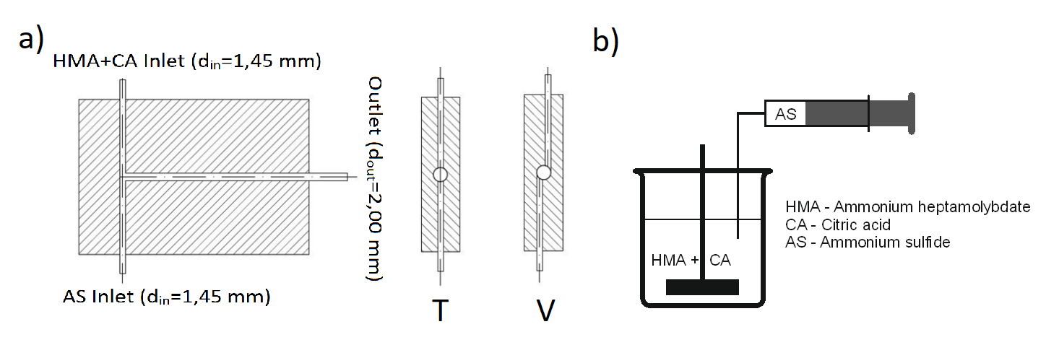
Figure 1. Turbulent micromixers (a) and semi-batch system (b) used in experiments
3. Results and discussion
The volume-weighted mean particle size D₄₃ of obtained particles and an example of particle size distribution were shown in Fig. 2. Only the primary particles were taken into account. On Fig. 2. One can see that the average size is close to 200 nm regardless of flow and reactor type.

Figure 2. Mean particle sizes of particles (left). Example of particles size distribution obtained (right)
4. Conclusions
Molybdenum disulphide can be obtained by wet chemical synthesis in the turbulent micromixers. However, it is highly contaminated with sulpha and unreacted substrates. Due to contamination, it is not possible to use produced molybdenum disulphide directly after the reaction. Therefore, proper separation techniques have to be developed.
Mixing conditions appears to have a small impact on product size in the applications. The initial concentration and Reynolds number impact on precipitation process have not been observed.
Acknowledgements
This work was supported by the National Science Centre [No.2017/27/B/ST8/01382]
References
- M.F. Sgroi, M. Asti, F. Gili, F.A. Deorsola, S. Bensaid, D. Fino, G. Kraft, I. Garcia, F. Dassenoy, Engine bench and road testing of an engine oil containing MoS2 particles as nano-additive for friction reduction, Tribol. Int. 105 (2017).
- F.A. Deorsola, N. Russo, G.A. Blengini, D. Fino, Synthesis, characterization and environmental assessment of nanosized MoS 2 particles for lubricants applications, Chem. Eng. J. 195–196 (2012).
- G. Santillo, F.A. Deorsola, S. Bensaid, N. Russo, D. Fino, MoS2 nanoparticle precipitation in turbulent micromixers, Chem. Eng. J. 207–208 (2012).

