Pebax®2533 and Graphene Oxide-Based materials for Carbon Capture Membranes
*Riccardo Casadei¹, Marco Giacinti Baschetti¹, Myung Jin Yoo², Ho Bum Park²
1: Department of Civil, Chemical, Environmental and Material Engineering (DICAM) – University of Bologna, Via Terracini 28, 40131 Bologna, Italy ;
2: Department of Energy Engineering, Hanyang University, Seoul 133-791, Republic of Korea
*Corresponding author: riccardo.casadei11@unibo.it
Highlights
- Flawless dispersion of GO in Pebax®2533 with concentration of 0,02 to 1 wt%
- Study of permeation trend caused by GO addition in Pebax®2533
- Comparison of permeation performances improvements of Pebax®2533 by addition of GO, PGO and PEAGO in low concentration (0,02 wt%)

1. Introduction
In this work, Pebax®2533 (figure 1a) and Its GO-based nanocomposites have been studied to check the CO₂ and N₂ permeation performances of these materials for carbon capture applications [1][2]. As nano-fillers, Graphene Oxide (GO), Graphene Oxide functionalized with Polyetheramine (PEAGO) [3] and Porous Graphene Oxide (PGO) [6] have been employed (Figure 1b, c, d respectively).
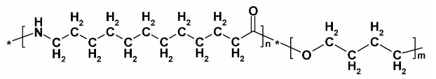a)
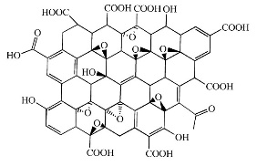 b) 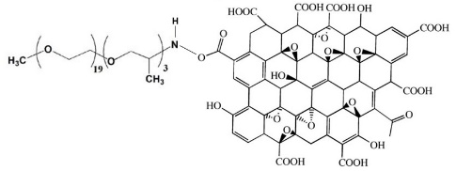 c) 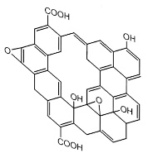 d)
Figure 1: Structure of the materials used: a) Pebax®2533, b) GO, c) PEAGO and d) PGO
2. Methods
For the dispersion of GO in Pebax®2533, a double-solvent solution has been achieved: water dispersion of GO was dropped in a Pebax®2533 - ethanol solution in order to reach concentration GO/Polymer of 0,02 to 1 wt%, leading to smooth and totally homogeneous membranes. Same mixing procedure have been used for PEAGO and PGO, but in these cases only 0,02 wt% loaded composites were homogeneous and reasonable to test.
All membranes have been obtained by pouring some polymer solution, or polymer + filler dispersion, in a PTFE petri, to then let the solvent slowly evaporate at room temperature
CO₂ and N₂ permeation test on the different materials have been carried out by using a single-gas static permeometer. All permeation tests have been conducted at 35 °C. with an upstream pressure of 1 bar. The permeability was measured by monitoring the pressure increase in the calibrated permeate site, which was in vacuum condition at the beginning of each test.
3. Results and discussion
Permeation results are reported in Figure 3 and table 1; the data in the figure in particular reports the effect of loading of separation performance on Pebax + GO matrix and showed that adding GO over 0,02 wt% decrease the CO₂ permeability while has no effect on CO₂/N₂ selectivity. At 0.02% loading on the other hand a slight increase in permeability was observed which became higher when other types of GO were considered. Porous GO in particular resulted the best material tested with a permeability increase in the order of 10% with respect to pure Pebax2533. As the increase in permeability did not caused any loss in selectivity, the addition og GO based nanofiller generally improved the separation performance of the original polymer.
 | Table 1 CO2 ppermeability and CO2/N2 selectivity of the different materials testedin the present work
 | Sample Name | wt% loaded | P CO2 (barrer) | Ideal α CO2/N2
 | Pebax2533 Pristine | 0,00 | 364,62 | 23,80
 | Pebax2533 + GO | 0,02 | 371,39 | 24,00
 | Pebax2533 + PEAGO | 0,02 | 380,44 | 24,19
Figure 3 Pebax-GO permeability as a function of loading | Pebax2533 + PGO | 0,02 | 397,35 | 23,75
4. Conclusions
In this work, It has been shown that mixing ethanol solution of Pebax®2533 with water dispersion of graphene oxide leads to a very homogeneous system and membranes.
It has been also determined that low concentration (0,02 wt%) of nano-fillers used in Pebax®2533 increase CO2 permeability (1%, 5% and 10% increase respectively achieved with GO, PEAGO and PGO) without any loss of selectivity thus slightly improving the separation performance of the composite membranes with respect to the initial polymer.
Acknowledgements: This work has been performed in the framework of the European Project H2020 NANOMEMC² “NanoMaterials Enhanced Membranes for Carbon Capture”, funded by the Innovation and Networks Executive Agency (INEA) Grant Agreement Number: 727734
References
[1] D.Y.C. Leung, G. Caramanna, M.M. Maroto-Valer, An overview of current status of carbon dioxide capture and storage technologies, Renew. Sustain. Energy Rev. 39 (2014) 426–443.
[2] I. Sreedhar, R. Vaidhiswaran, B.M. Kamani, A. Venugopal, Process and engineering trends in membrane based carbon capture, Renew. Sustain. Energy Rev. 68 (2017) 659–684.
[3] M.J. Yoo, H.W. Kim, B.M. Yoo, H.B. Park, Highly soluble polyetheramine-functionalized graphene oxide and reduced graphene oxide both in aqueous and non-aqueous solvents, Carbon N. Y. 75 (2014) 149–160.
[4] [6] C. Yu, B. Zhang, F. Yan, J. Zhao, J. Li, L. Li, Engineering nano-porous graphene oxide by hydroxyl radicals, Carbon N. Y. 105 (2019) 291–296.

