Crystal Contact Engineering to Promote Technical Protein Crystallization
Phillip Nowotny*, Johannes Hermann, Dariusch Hekmat, Dirk Weuster-Botz
Technical University of Munich, Institute of Biochemical Engineering, Boltzmannstr. 15, 85748 Garching, Germany
*Corresponding author: p.nowotny@lrz.tum.de
Highlights
- Crystal contact engineering effects faster crystallization of the enzyme LbADH
- LbADH variants crystallize at reduced concentration of crystallization agent PEG
- Both properties result in increased space-time yield and lowered process costs
- Enhanced crystallizability of LbADH variants can be explained on the atomic level

1. Introduction
Technical protein crystallization is an attractive alternative to preparative chromatography as a main purification step of proteins in biotechnological processes [1]. Recombinant insulin, being the most prominent example, has been industrially crystallized for several decades. However, only a few proteins are sufficiently well crystallizable and molecular processes during protein crystallization are barely understood. Crystal engineering has been investigated since the early 1990s and it has become a common method to optimize crystal size and diffraction quality for crystallographic purpose [2]. Our approach was to transfer and expand the knowledge of crystal engineering towards technical crystallization purposes on the basis of the enzyme Lactobacillus brevis alcohol dehydrogenase (LbADH) [3]. The objectives were to i) enhance its crystallization properties allowing for the use of technical crystallization by engineering the crystal contact patches and ii) to understand the underlying mechanisms on the atomic level.
2. Methods
LbADH variants were produced with Escherichia coli in shaking flasks or stirred-tank bioreactors and purified via affinity chromatography. After dialysis and protein concentration, crystallization was triggered by the addition of a crystallization buffer containing polyethylene glycol (PEG 550). µL-batch crystallization was monitored by automated microscopic imaging, mL-batch crystallization was monitored by measurements of the protein concentration in the supernatant and microscopy of the crystals. In parallel, the enzymatic activity and the purity of all mutants were assessed experimentally. X-ray diffraction was performed for structural analysis of relevant LbADH mutants.
3. Results and discussion
More than 50 LbADH variants were designed following deterministic approaches, produced and purified to equal purity grade and protein concentration. Crystallization in microbatch experiments under identical conditions were the foundation for tracing back distinct crystallization properties to single amino acid exchanges. Enzymatically active LbADH variants were generated with increased crystallization success rate which correlated with a larger amount of crystals, a reduced time till crystallization equilibrium and crystallizability under reduced concentration of crystallization agent PEG 550. X-ray diffraction analysis elucidated enhanced crystallizability of LbADH variants on the atomic level. Crystallization on a mL scale in stirred tanks revealed increased volumetric productivities and crystallization yield of LbADH variants (exemplarily shown by WT-LbADH and variant K32A, Figure 1) [4].
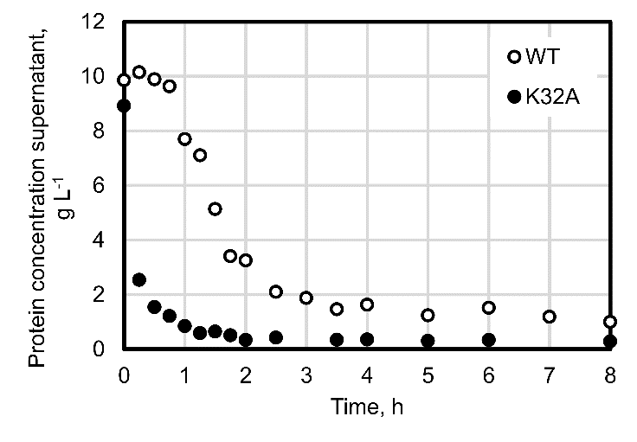
Figure 1. Crystallization kinetics of WT-LbADH (white) and mutant K32A (black) in a stirred tank crystallizer (V = 5 ml, initial protein concentration = 10 g L⁻¹, T = 20 °C) [4].
4. Conclusions
We have demonstrated for the first time that crystal contact engineering is a powerful tool to improve a protein’s crystallizability for the use in technical crystallization. Single amino acid exchanges preserve enzymatic activities of engineered LbADH variants and lead to significantly enhanced crystallization space-time yields. Moreover, crystallization of LbADH variants takes place at concentrations of crystallization agent PEG 550 where the WT does not crystallize anymore. Both latter properties reduce process costs of technical large-scale protein crystallization, making it increasingly attractive for its integration into biotechnological downstream processes.

References
- D. Hekmat, Bioprocess Biosyst. Eng. 38 (2015), 1209−1231.
- Z. S. Derewenda, P. G. Vekilov, Acta Crystallogr., Sect. D: Biol. Crystallogr. 62 (2006), 116−124.
- J. Hermann et al., Acta Crystallogr., Sect. F: Struct. Biol. Commun. 74 (2018) 754−764.
- P. Nowotny et al., Cryst. Growth Des. 19 (2019) 2380−2387.

