**Numerical simulations supporting process models of chemical engineering: applications for membrane systems.**

Luigi Gurreri1*\**, Imen El Mokhtar2, Salah Al Tahar Bouguecha2, Mariagiorgia La Cerva1, Alessandro Tamburini1, Andrea Cipollina1, Michele Ciofalo1, Giorgio Micale1

*1 Dipartimento di Ingegneria, Università degli Studi di Palermo, viale delle scienze ed. 6, 90128 Palermo, Italia; 2 Water, membrane and environmental biotechnology laboratory, Water Researches and Technologies Center, Borj-Cedria Technopark Tourist Route of Soliman Nabeul, 8020 Soliman, Tunisia*

*\*Corresponding author: luigi.gurreri@unipa.it*

**Highlights**

* Spacer features affect significantly transport phenomena.
* Electrical resistance and deformation can be effectively predicted.
* Results are easily integrated in multi-scale process models.

**1. Introduction**

In the last years, the scientific community has been exhibited a growing interest towards several separation processes based on membrane technologies. For the development of novel and optimized designs, the implementation of robust and reliable process models is a challenge. An effective modelling strategy, able to provide accurate predictions with a sustainable computational demand, is represented by a multi-scale modelling approach [1]. In a structured separation of scales, numerical simulations analyze in detail transport phenomena at the lowest scale of modelling and provide correlations to the higher scale models, which simulate the whole membrane/channel assembly, unit and plant.

This work presents computational fluid dynamics simulations aimed at characterizing flow and mass/heat transport mechanisms in spacer-filled channels for membrane processes, with particular reference to (reverse) electrodialysis and membrane distillation. Further kinds of numerical simulations were performed in order to assess aspects poorly studied so far, i.e. electrical “shadow” effects of spacers and membrane deformations.

**2. Methods**

Spacer-filled channels and profiled-membrane channels were simulated by the periodic unit cell approach, i.e. assuming fully developed conditions. The basic set of differential equations includes continuity and Navier-Stokes equations, transport of enthalpy and convective-diffusive transport of solute. Equilibrium, compatibility and constitutive equations were solved in simulations aimed at finding configurations deformed under an imposed load mimicking a trans-membrane pressure. Finally, the Laplace equation for the electric potential was solved in simulations assessing the Ohmic resistance. Grid-sensitivity of results was assessed, in order to present results practically unaffected by the discretization degree. The finite-volume Ansys-CFX code and the finite-element Ansys-Mechanical code were used.

**3. Results and discussion**

Dimensionless quantities were computed from CFD simulation results, namely Darcy friction factor (*f*), Sherwood number (Sh) and Nusselt number (Nu). Figure 1 reports some typical results for different configurations. It can be observed that woven spacers enhance mass/heat transfer compared to overlapped spacers, but at the expense of larger pressure drops. The *P/H* value has straightforward effects only in the case of woven spacers. SST *k-ω* turbulence model predictions for non-steady flows fairly agree with laminar simulation trends, but direct numerical simulations would be more appropriate for incipient turbulence regimes. Nu and *f* predictions were validated against experimental data and exhibited a good agreement.

Significant effects of membrane deformation were observed: friction and mass transfer coefficients increased in the compressed channel, while they decreased in the expanded channel.

The spacer shadow factor for the Ohmic resistance was found to be close to the reciprocal of the average between porosity and open area, in agreement with experimental findings.

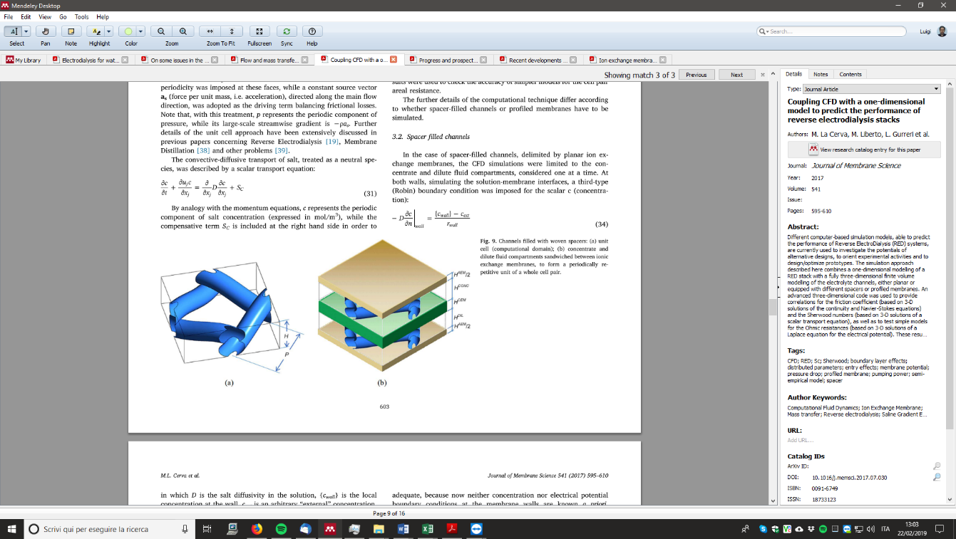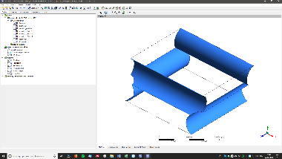 

Flow direction

SST

SST

**Figure 1.** *f*, Sh and Nu in spacer-filled channels as functions of the Reynolds number (Pr=4.33, Sc=600).

**4. Conclusions**

Simulation tools implementing well-established and validated physical models and numerical methods were presented. CFD predictions showed that spacer features can significantly affect flow and heat/mass transfer characteristics. Novel models showed to be effective in the simulation of aspects poorly investigated so far, such as the mechanical response and the electrical resistance.

The present outcomes provide correlations to integrated process simulators in order to calculate pressure drop, temperature/concentration polarization effects, electrical resistance and fluid-structure interactions. The present numerical simulations represent basic predictive tools for optimization studies and for the development of novel designs and concepts.

**Acknowledgments**

This work has been performed within the REvivED water project (*Low energy solutions for drinking water production by a REvival of ElectroDialysis systems*), Horizon 2020 programme, Grant Agreement no. 685579, [www.revivedwater.eu](http://www.revivedwater.eu).

**References**

1. A. Campione, L. Gurreri, M. Ciofalo, G. Micale, A. Tamburini, A. Cipollina, Desalination 434 (2018) 121–160.