Flexible and efficient process synthesis and optimization based on Aspen Plus simulations - MTBE production case study.
Maximilian Cegla¹, Tim Janus¹, Stephen Tlatlik², Peter Krause³, Thomas Bäck³,
Axel Gottschalk², Sebastian Engell¹
1 TU Dortmund University; 2 SUPREN GmbH; 3 Divis Intelligent Solutions GmbH
*Corresponding author: Maximilian.cegla@tu-dortmund.de
Highlights
- Global optimization using Aspen Plus flowsheet simulations
- Memetic algorithm
- Flexible customizable cost function
- Reduction of the total cost compared to expert solution

1. Introduction
The decisions taken during process development are critical for the economic success of process engineering projects. The design engineer needs to screen, develop and evaluate a large number of process alternatives. Even when sophisticated software tools are applied for modelling and analysis, iteratively carrying out the design usually requires month to years. Due to the strong involvement of human work force, high personnel costs are incurred and the results depend on the experience of the developers. Obviously, also the risk of human errors e.g. by prematurely ruling out alternative solutions is always present.
Marking a breakthrough in boosting the efficiency of process development a novel process optimization tool has been established in a joint project between divis, SUPREN and TU Dortmund. Starting from an existing simulation flowsheet that was created by a design engineer, a memetic algorithm is applied to investigate, globally optimize and assess alternative process configurations and conditions in an automated fashion. The tool supplements the process understanding and creativity of an engineer with the reliability and efficiency of optimization. Replacing human labor by computations, the repetitive work in the course of process development is accelerated while the related costs decrease.
2. Methods
This contribution presents the results of the application of our computer-aided optimization procedure to the production of methyl tert-butyl ether (MTBE) (world production volume 18 Mtons/year in 2005) that is inspired by the Oxeno-technology [1]. A memetic algorithm is applied because of its capabilities to act as a global solver and to handle integer design variables. The memetic algorithm used combines an evolutionary algorithm, e.g. an evolution strategy (ES), with a local solver. At the beginning of the optimization procedure the ES gen erates a population (a set of individuals) with integer design variables and continuous operation parameters within given bounds. For this first population, using the widely used simulation tool Aspen Plus, process simulations are performed. The results are evaluated automatically with regard to customizable – often economic – objective functions. Based on the results of the ES, the memetic algorithm generates new individuals (offspring) by the recombination and mutation of two of the afore-investigated individuals. This procedure is repeated until the convergence criteria are met. [2]
The optimization problem discussed includes 22 continuous and 7 integer design variables and 3 process constraints. Based upon objective functions that are available in the library of the tool along with problem-specific information, the economics of the process alternatives are assessed.
3. Results and discussion
Commencing from a previously optimized solution created by an experienced engineer for an industrial client, the optimizer achieves a further improvement of 1.2% of the overall costs. Exploiting the simulation file present from the manual investigation, about 2 hours of time are needed to define the optimization problem. Afterwards, without interaction with an expensive design engineer, 3 days of computation time are required to reach the results presented in Figure 1. Multiple runs of the stochastic optimization establish the uniqueness of the result.
Figure 1: Improvements of the economic cost function with the expert solution as reference.
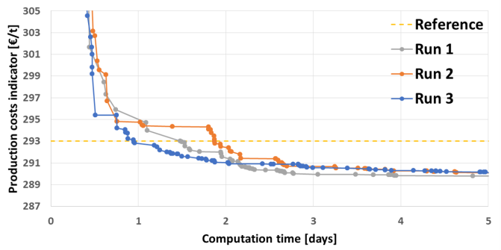
Due to the use of a commercial simulation environment the required computation time is high, but the advantage is the flexibility of the approach. Changes to the flowsheet such as the introduction of additional process equipment can be performed easily and fast. For the current case, modifications of the model were tested and realized in timespans of well under 30 minutes of human work and 3 days of calculation time. Thanks to a fully automated documentation, the results of the optimization run are summarized in the form of easily accessible spreadsheets and the corresponding Aspen simulation files are stored. Based on this information, each individual solution or the optimization run can be analyzed in detail with regard to the identified operation and design parameters as well as to the objective functions.
4. Conclusions
The presented approach is capable of enhancing the process development workflow using the reliable and efficient memetic algorithm in combination with the creativity and knowledge of the process engineer. Due to the use of a commercially available simulation tool, industrially trusted results are generated. In summary, the application of the tool leads to overall better process designs involving the engineer primarily in the creative development process rather than in repetitive and tedious elements of the workflow.
References
- M. Winterberg et al.: „Methyl Tert‐Butyl Ether”, Ullmann's Encyclopedia of Industrial Chemistry, Electronic Release, chap. 4, Wiley-VCH, Weinheim, 2010.
- Urselmann, M. et al.: „A memetic algorithm for global optimization in chemical process synthesis problems.” IEEE Transactions on Evolutionary Computation 15 (5) (2011), 659-683.

