Development of a catalyst for oxidative coupling of methane in a gas-solid vortex reactor
Saashwath Swaminathan Tharakaraman¹, Guy B. Marin¹, Mark Saeys^{1*}
1 Laboratory for Chemical Technology, Ghent University, Technologiepark 125, 9052 Gent, Belgium;
*Corresponding author: Mark.Saeys@ugent.be
Highlights
- Synthesis of a thermally and mechanically stable catalyst for OCM in a GSVR.
- First demonstration of oxidative coupling of methane in GSVR.
- Process intensification of OCM

1. Introduction
Oxidative coupling of methane (OCM) is a promising pathway for the direct synthesis of C₂ hydrocarbons from methane according to the following global chemical reactions.^{[1]}
2CH₄ + O₂ → C₂H₄ + 2H₂O | ΔH_{r}⁰ = -282 kJ mol⁻¹ | ( 1 )
2CH₄ + 0.5O₂ → C₂H₆ + H₂O | ΔH_{r}⁰ = -177 kJ mol⁻¹ | ( 2 )
The presence of oxygen and the high reaction temperature can facilitate the overoxidation of reactants and products to CO and CO₂, typically limiting the C₂ hydrocarbon yields to below 30%.^{[2]}
CH₄ + 2O₂ → CO₂ + 2H₂O | ΔH_{r}⁰ = -801 kJ mol⁻¹ | ( 3 )
The high reaction exothermicity moreover dictates the need for a suitable heat management strategy.
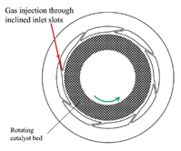
In a gas-solid vortex reactor (GSVR), a rotating fluidized bed of solids is obtained by the tangential injection of gas at high velocities (Figure 1). ^{[3]} In the bed, the centrifugal forces on the catalyst particles balance the drag forces, leading to a dense and uniform bed. The very high gas-solid slip velocities intensify interfacial transfer of mass, energy and momentum, allowing a reduction in gas phase residence time. Using extensive computational fluid dynamics (CFD) simulations, a gas-solid vortex reactor has been designed and commissioned at Ghent University^{[3]}. The diameter of the reaction chamber is 80 mm, containing 8 inlet slots with a width of 1 mm (Figure 1).^{[3]}
Figure 1 . Top view and operation of a gas solid vortex reactor in static geometry

Using bifurcation analysis incorporating detailed microkinetic models, Vandewalle et al. ^{[4]} showed that the good thermal back mixing combined with limited species back mixing in the GSVR can potentially improve C₂ yields when the reactor is operated on an ignited branch close to the extinction state. ^{[5]}
The high reaction temperature, the high solid velocities, and the low space times in the GSVR at those conditions require the development of a novel catalyst with high attrition resistance, high thermal stability, high activity, and proper size distribution. In this presentation, we report the development of such a supported catalyst, and compare its performance in a fixed bed reactor with that in the GSVR.
2. Results and Discussion
Figure 2 a) Azimuthal velocity of solids in the GSVR ^{[3]} and b) CH₄ conversion and C₂ selectivity vs. space time for synthesized catalyst at 800 °C
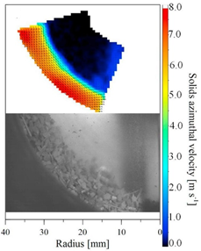  a) | 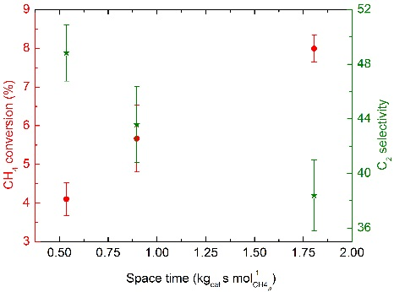  b)
Cold flow experiments were performed in the GSVR with inlet gas flow rates in the range of 15-30 Nm³ hr⁻¹, and slot velocities exceeding 100 m s⁻¹ to test the stability of the catalyst bed and its attrition resistance. Under these conditions, a stable bed of 10 g of catalyst material with a thickness of about 10 mm could be retained in the GSVR at room temperature for a duration of 1 hour (Figure 2a). Over the 1 hour experiment, less than 1% of the material was entrained. Similar experiments with conventional Sr/La₂O₃ OCM catalyst pellets and with inert α-Al₂O₃ pellets resulted in rapid attrition and entrainment of the pulverised pellets with the gas stream. The gas flow rates and the catalyst material holdup in the GSVR correspond to very low space times of 0.1 kg_{cat} s mol⁻¹ _{CH4,0}. For these space times, the synthesized catalyst material was tested in a quasi-isothermal fixed bed reactor at 800 °C and for a O₂:CH₄ inlet ratio of 4. A reasonable C₂ selectivity of 40-50% and a CH₄ conversion of 5-10 % were obtained for this high activity catalyst (Figure 2b). Typical OCM catalysts like Li/MgO and NaMnWO₄/SiO₂ show essentially no CH₄ conversion for space times below 5.0 kg_{cat} s mol⁻¹_{CH4,0}. ^{[6]} Next, the synthesized catalyst will be tested under reactive conditions in the GSVR. Based on detailed microkinetic simulations based on the fixed-bed experiments, a methane conversion of 4% and a C₂ selectivity of 45% are expected.
3. Conclusions
A thermally and mechanically stable OCM catalyst material was synthesized, which forms a stable catalyst bed under the harsh conditions in the GSVR reactor. At the conditions and at low space times, the synthesized catalyst material displayed a methane conversion between 5 and 10 % and a C₂ selectivity around 50%. Detailed simulations indicate that a similar performance can be expected in the GSVR. These proof-of-concept experiments are currently scheduled and will be reported at the conference.
References
- G. Keller, M. Bhasin. J. Cat. 73 (1982). 9-19.
- U. Zavyalova, M. Holena, R. Schlögl,M. Baerns. ChemCatChem 3 (2011). 1935-1947.
- A. Gonzalez-Quiroga, P.A. Reyniers, S.R. Kulkarni, M.M. Torregrosa, P. Perreault, G.J. Heynderickx, K.M. Van Geem,G.B. Marin. Chem. Eng. J .329 (2017). 198-210
- L.A. Vandewalle, I. Lengyel, D.H. West, K.M. Van Geem, G.B. Marin. Chem. Eng. Sci. (2018).
- S. Sarsani, D. West, W. Liang,V. Balakotaiah. Chem. Eng. J.328 (2017). 484-496
- V. Alexiadis, M. Chaar, A. van Veen, M. Muhler, J. Thybaut, G.B. Marin. App. Cat. B: Environmental 199 (2016). 252-259

