Traveling Microwave Reactor
Alberto Martínez González, Farnaz Eghbal Sarabi, Andrzej Stankiewicz, Hakan Nigar*
Process & Energy Department, Delft University of Technology, Leegwaterstraat 39, 2628CB, Delft, The Netherlands
*Corresponding author: H.Nigar@tudelft.nl
Highlights
- Traveling Microwave Reactor (TMR) enables the process scale-up.
- Traveling-wave concept prevents the formation of a standing wave.
- It is suitable for high-energy demanding reactions, e.g., catalytic methane coupling
- TMR enables the temperature homogenization along the reactor.

1. Introduction
With the growing influence of renewable electricity as a primary energy source on Earth, the significance of the electricity-based technologies in process industries is likewise expected to increase. Microwave (MW) heating is a well-established electricity-based industrial technology employed on the commercial scale in various operations, such as drying, thawing, pasteurization, sintering, and ceramic processing. MW-assisted chemical reactions have been investigated for more than three decades, starting with liquid-phase homogenous systems then also in the heterogeneous solid gas-phase catalytic processes. Although there are many encouraging results of various laboratory-scale studies, commercial implementations of MWs in heterogeneous catalysis are non-existent. This is essentially due to the complexity of the interaction between MWs and solid catalysts, as well as to several important design factors influencing the performance of a continuously operated MW-assisted flow reactor [1]. The current study examines the above interactions and factors in a novel reactor concept, the so-called Traveling Microwave Reactor (TMR) [2]. The TMR concept will be validated on a high-energy demanding process, i.e., non-oxidative methane coupling.
2. Methods
The TMR has been designed based on the coaxial cable configuration. To do this, a three-dimensional finite element model, which couples electromagnetic waves and heat transfer, has been developed using the Comsol Multiphysics® simulation environment. Figure 1 shows a cross-sectional schematic view of the modeled TMR along the axial direction. The TMR has been constructed with the stainless-steel inner and outer conductors, which form the coaxial structure having a reaction zone in between, see Figure 1. The reaction zone is an annular space between two concentric quartz cylinders. The heating tests have been conducted with different geometry (e.g., foams and extrudes) of silicon carbide (SiC) material in the packed-bed configuration. The temperature measurement has been performed with four thermocouples introduced inside the reactor through a hole in the inner conductor.
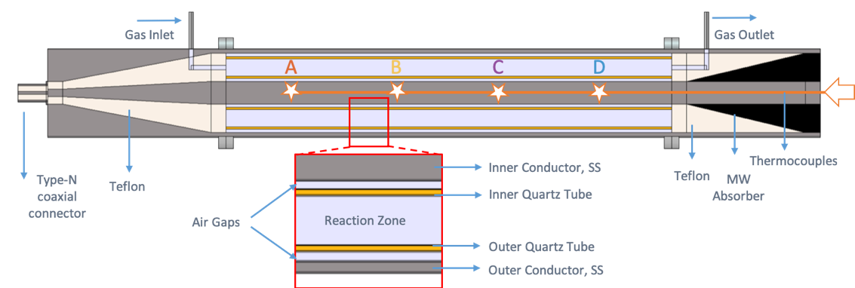
Figure 1. A cross-sectional schematic view of the TMR.
3. Results and discussion
Simulation results show that the MW energy is transported in the fundamental transverse electric and magnetic (TEM) mode, where the electric field lines run radially, while the magnetic field lines run in circles around the inner conductor. The good matching of spectral response and impedance characteristics shows that the behavior of the microwave model agrees well with the experimental setup which allows the validation of the model from the electromagnetic point of view. The transient temperature profile in the TMR fully loaded with a SiC packing is presented in Figure 2. The results reveal that the front part of the reactor has a temperature range 475-550ºC (thermocouples A, B, and C) and the final part has a range of 250-300ºC (thermocouple D). Since SiC is a good MW absorbent, most of the MW energy has been consumed in the front part of the reactor. Different packed-bed length and diameter are going to be further studied to improve the homogenous temperature distribution.
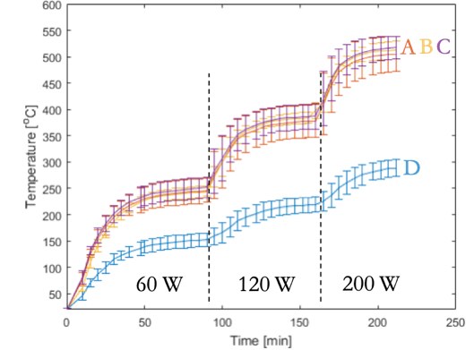
Figure 2. Transient temperature profiles with different MW power input.
4. Conclusions
A novel coaxial traveling microwave reactor is proposed to optimize the heat generation by avoiding the resonance. Simulation results prove that standing wave is not formed along the reactor and microwave energy travels ahead. Consequently, the heating uniformity in the TMR is expected to improve. To validate that expectation, heating characteristic of different catalysts in the designed reactor are under investigation. It is envisaged that this particular reactor concept may enable process scale-up beyond the intrinsic restrictions of cavity systems.
References
- A. Stankiewicz, F.E. Sarabi, A. Baubaid, P. Yan, H. Nigar, Chemical Record, 19 (2019) 40-50.
- G.S.J. Sturm, A. Stankiewicz, G.D. Stefanidis, RSC Green Chemistry (2016) 93-125.

