Rapid estimation of fractal dimension of microalgal aggregates
Patricio Lopez-Exposito, Carlos Negro, Angeles Blanco
Universidad Complutense de Madrid
Department of Chemical Engineering and Materials, Avda. Complutense s/n
28040 Madrid
Corresponding author: cengro@ucm.es
Highlights
- A method to estimate the fractal dimension of microalgal aggregates is proposed
- A machine learning model processes laser reflectance data to estimate fractal dimension
- The method is effective to resolve the 3D geometry of microalgal flocs
- The model can be used to control flocculation and produce optimally shaped flocs
1. Introduction
In order to deploy the full potential of microalgae as a source of variety of valuable products, the cultivation and harvesting costs associated to the production of microalgal biomass. The most cost-effective strategy to attain the harvesting of microalgal biomass is considered to consist in the combination of a flocculation stage followed by a concentration step based on settling, filtration or centrifugation. The effectiveness of the concentration step is affected by the size and shape of flocs produced in the flocculation stage. At present, however, no control over these two parameters is carried out at industrial level. The present communication describes a novel approach to estimate the average fractal dimension (D_{f}) of microalgal flocs suspensions by interpreting chord length distribution spectra acquired through a laser beam reflectance probe. This monitoring method could be applied on-line to control the stirring in flocculation processes so that the average geometry of aggregates is optimal for the subsequent concentration step.
2. Methods
The development of the estimation method involves in-silico and experimental steps. First, several families of virtual flocs, each having a consigned fractal dimension were created by means of applying a random growth algorithm. These virtual aggregated were virtually scanned through a computer emulator of the FBRM probe. The data generated were employed to train a machine learning random forest regression model (RFR) to learn the relationship between chord length distribution data and average fractal dimension. The estimation model was validated with real data of microalgal flocs suspensions of known fractal dimension.
3. Results and discussion
- Several families of virtual flocs resembling real ones were generated though a growth algorithm (Fig. 1).
- The virtual flocs were scanned through an FBRM emulator to produce the training data for a random forest regression model (fig. 2a).
- The model was successfully verified with real CLD data of real suspensions of known D_{f}. (fig. 2a).
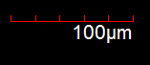
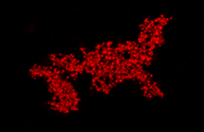

Figure 1. Real (left) and virtual (right) flocs of similar size.
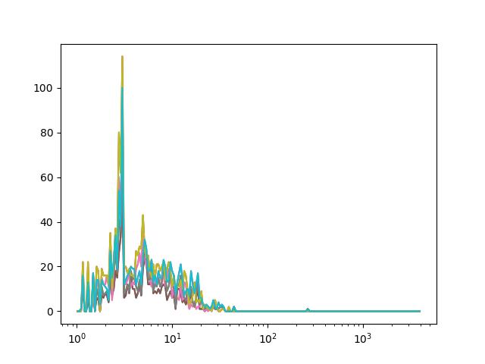
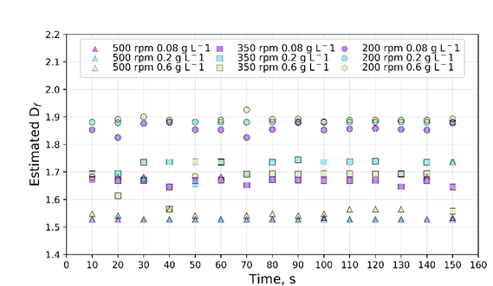
Chord length, μm
# events
Figure 1. Real (red ) and virtual (white) flocs of similar size. [Calibri 9].

Figure 2. a) CLD of virtual floc and b) estimation of D_{f} on real data. [Calibri 9].
4. Conclusions
A model to directly estimate the fractal dimension form CLD data was successfully developed and verified with real data. The model can be applied as a means to monitor the flocculation of biomass to tune the stirring conditions so as to produce optimally shaped flocs for the subsequent separation phase. The present method could be adapted to other flocculating systems of organic or inorganic nature involving particles detectable through FBRM.
Acknowledgements
The authors wish to acknowledge the financial support of the Community of Madrid through the RETO-PROSOST-CM Programme (S2013/MAE-2907).
References
Chakraborti, R. K., J. F. Atkinson and J. E. Van Benschoten (2000). "Characterization of alum floc by image analysis." Environmental science & technology 34(18): 3969-3976.
Gmachowski, L. (2000). "Estimation of the dynamic size of fractal aggregates." Colloids and Surfaces A: Physicochemical and Engineering Aspects 170(2): 209-216.
Lopez-Exposito, P., Blanco, A., & Negro, C. (2017). Estimating fractal dimension of microalgal flocs through confocal laser scanning microscopy and computer modelling. Algal research, 28, 74-79.Schmid, M., A. Thill,
Vandamme, D., I. Foubert and K. Muylaert (2013). "Flocculation as a low-cost method for harvesting microalgae for bulk biomass production." Trends in biotechnology 31(4): 233-239.
Wan, C., M. A. Alam, X.-Q. Zhao, X.-Y. Zhang, S.-L. Guo, S.-H. Ho, J.-S. Chang and F.-W. Bai (2015). "Current progress and future prospect of microalgal biomass harvest using various flocculation technologies." Bioresource technology 184: 251-257.

