Utilizing the photo-induced hydrophilicity of TiO₂ to enhance permeate flux of composite membranes
Duc-Trung Tran, Julie Mendret*, Jean-Pierre Mericq, Catherine Faur & Stephan Brosillon
IEM (Institut Européen des Membranes), UMR 5635 (CNRS-ENSCM-UM), 34095 Montpellier, France
*Corresponding author: julie.mendret@umontpellier.fr
Highlights
- Photo-active PVDF-TiO₂ composite membranes were prepared by NIPS method.
- Membrane WCA decreased upon UV irradiation due to photo-induced hydrophilicity of TiO₂.
- Permeate flux increased during filtration with UV irradiation (photo-filtration).
- Photo-filtration method offers potential benefits in operating cost.

1. Introduction
Other than being a photocatalyst for chemical reactions, TiO₂ also possesses an important property called photo-induced superhydrophilicity, in which its surface can become extremely hydrophilic upon UV irradiation [1]. As such, composite membranes containing TiO₂ nanoparticles have become very attractive prospects due to their excellent anti-fouling and self-cleaning properties. In addition, when membrane filtration is coupled with UV irradiation (photo-filtration), the permeate flux can be further enhanced thanks to said photo-induced effect [2]. In this study, that phenomenon was comprehensively investigated to explore the mechanism behind such flux enhancement and estimate the potential benefits in cost/efficiency balance of this new filtration method.
2. Methods
PVDF-TiO₂ membranes were prepared by the nonsolvent-induced phase separation (NIPS) method. The PVDF concentration was 20 wt% while the mass ratio of TiO₂ to PVDF was 1:5. The distribution of TiO₂ on membrane surface was characterized by energy-dispersive X-ray (EDX) mapping, while the water contact angle (WCA) was measured for membranes before and after UV irradiation. Photo-filtration tests were performed with pure water, humic acids (HA) and sodium alginate (SA) solutions in a crossflow filtration cell built with a Quartz window on top, so that the membrane could be irradiated by a 365-nm UV lamp. Filtration was performed in constant pressure mode, while irradiation mode was varied in terms of UV cycle (UV on/off time ranging from 15 to 90 min) and irradiance (I = 0.04-1 mW.cm⁻²). The advantages of photo-filtration was demonstrated by comparing the behavior of normalized flux (the ratio between the flux at a given time (J) and the initial flux at the beginning of the test (J₀)) when UV was and was not utilized.
3. Results and discussion
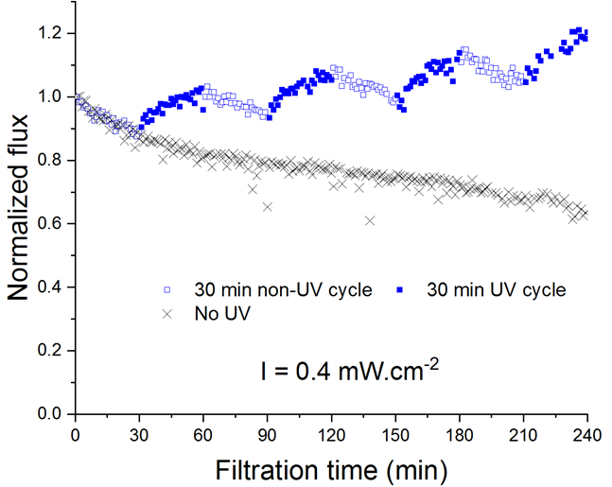
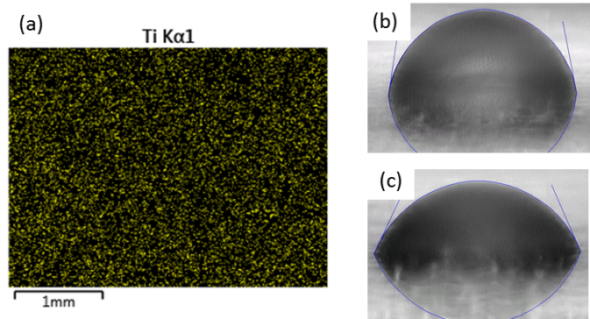
Via EDX mapping, it can be seen that TiO₂ nanoparticles were dispersed uniformly on the surface of the membranes (Fig. 1a), suggesting photo-induced effects could occur once the membranes were exposed to UV irradiation. Indeed, as the WCA was 77.4±1.2º for the membrane in normal condition (Fig. 1b), as opposed to 68.2±1.8º after it was irradiated by UV for 30 minutes (Fig. 1c). The decrease in WCA indicates an increase in membrane hydrophilicity, which was believed to be responsible for the rise in pure water flux during photo-filtration, as shown in Fig. 2.
Figure 1. (a) Distribution of Ti on membrane via EDX mapping; and WCA of membranes in (b) normal condition and (c) post-UV-irradiated condition

Figure 2. Permeate flux of water during photo-filtration with 30-min on/30-min off UV cycle

Despite that the membrane suffered an inherent flux decline due to compaction, every time UV was activated, a considerable rise in pure water flux could be observed. Even if UV was only utilized for 50% of the filtration time, a significant increase in water output could be achieved for the photo-filtration method compared to normal filtration, thanks to the flux “memory effect” in which the flux remained higher than usual even after UV was deactivated (Fig. 2). The permeate flux increase was also obtained for photo-filtration tests of HA and SA solutions, given the foulant concentration did not exceed 5 ppm for HA and 50 ppm for SA, with a rejection rate of 64% for HA and 90% for SA. Although UV irradiation increases energy consumption, the total operating cost for the whole process could be reduced, taking into account the extra water output. By varying the irradiation mode, several photo-filtration conditions were tested with pure water at lab scale, and the obtained experimental data were extrapolated to a large-scale water processing system (capacity 3000 m³/day). It was estimated that, to achieve the same water output, utilizing photo-filtration in appropriate modes (for example, a moderate UV irradiance of 0.4 mW.cm⁻² and UV irradiation cycle of 30 minutes) could reduced the daily total operating cost up to 8.3% compared to normal filtration.
4. Conclusions
When PVDF-TiO₂ composite membrane was irradiated by UV, its hydrophilicity increased thanks to the photo-induced hydrophilicity effect of TiO₂, which led to a steady increase in permeate flux during photo-filtration. Thus, photo-filtration proved to be a promising method to improve the cost/efficiency balance of the filtration process in terms of water output, let alone the benefits from photocatalysis.
References
- R. Wang, K. Hashimoto, A. Fujishima, M. Chikuni, E. Kojima, A. Kitamura, M. Shimohigoshi and T. Watanabe, Nature 388 (1997) 431-432.
- J. P. Mericq, J. Mendret, S. Brosillon and C. Faur, Chem. Eng. Sci. 123 (2015) 283-291.

