Synthesis of valuable carotenoids in a heterotrophic microalgae fed-batch process – aspects of process modelling and scale-up
Felix Krujatz*¹, Christiane Grasse², Felix Wollmann¹, Thomas Walther¹, Juliane Steingroewer¹
¹Institute for Natural Materials Technology, TU Dresden, Germany, Bergstr. 120, 01069 Dresden
²Li-iL GmbH Arzneimittel und Arzneibäder, Leipziger Straße 300, 01139 Dresden
*Felix.Krujatz@tu-dresden.de

- Heterotrophic microalgae bioprocess was scaled-up from shake flask to 50 L stirred tank reactor
- In-silico approach allows the design of process strategies
- Heterotrophic fed-batch process yielded dry weight concentrations > 30 g L⁻¹
- Astaxanthin, Canthaxanin and Lutein/Zeaxanthin are the predominant carotenoids.

1. Introduction
Algal biotechnology has gained an increased industrial interest over the last decade. For several years, microalgae served as source for natural-derived antioxidants and coloring carotenoids like ß-carotene or astaxanthin [1]. The photoautotrophic production of algal biomass and products is still state of the art. However, the supply of photosynthetic active radiation (PAR) as sole source of energy in photobioreactors systems remains one of the major challenges for photo-biotechnological processes resulting in low biomass concentrations of 0.5 – 5.0 g L⁻¹ dry weight in large scale bioprocesses [2]. Additionally, photoautotrophic production impedes a world-wide production of algae biomass due to the process boundary conditions (e.g. temperature, light). Consequently, a trend is towards the production of high-quality microalgae products (e.g. the production of poly-unsaturated fatty acids by DSM/Evonik) by heterotrophic bioprocesses based on organic carbon and energy sources. This strategy allows the use of established technologies in biotechnology and the avoidance of some bottlenecks using photoproduction. The aim of this study is the development of a heterotrophic bioprocess to produce natural-derived carotenoids (with special focus on Astaxanthin) from microalgae [3].
2. Methods
First, a suitable production strain was identified by screening several Chlorella ssp. strains originated from European strain databases (SAG, CCAP, CCALA). The strains were screened on their heterotrophic growth rates µmax [h⁻¹] and yield coefficients Y_{X/S} [g_{dw} g_{Glc}⁻¹] to identify a potential production strain. The chosen strain was characterized regarding the growth kinetics using glucose as sole carbon source (100 mL shake flask scale, modified BM medium) to setup a process model for an in silico process development and scale up (to 3 L and 50 L stirred tank bioreactors).
All modeling approaches were conducted in the free accessible software Berkley Madonna®. Finally, batch and fed-batch processes were performed in 3 L (Labors 5, Infors HT) and 50 L (Applikon Biotechnology) stirred tank bioreactors to validate the scale-up. Process monitoring was performed by glucose and nitrogen analytics, flow cytometry analysis (population dynamics), microscopy, carotenoid extraction and HPLC analysis.
3. Results and discussion
By screening several Chlorella ssp. strains we could identify a suitable natural producer which attained a high yield coefficient Y_{X/S} using glucose as sole carbon source. The kinetic growth parameters µmax, K_{S}, K_{I} and Y_{X/S} were determined in shake flask cultivations and implemented into a MONOD based process model. Using the in silico approach a fed-batch feeding strategy was established which was validated in 3 L and 50 L scale-up processes. The heterotrophic bioprocess yielded high dry weight concentrations > 30 g L⁻¹. Astaxanthin, Canthaxanthin and Lutein/Zeaxanthin were identified as the major carotenoid fraction in the cells.
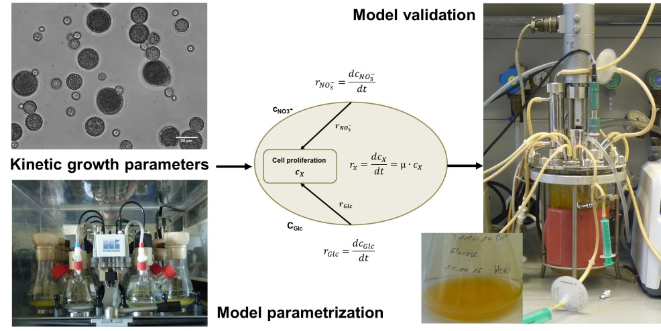
Figure 1. Process development of a heterotrophic Chlorella ssp- based bioprocess to produce natural-derived carotenoids.
This process allows the production of high-quality natural carotenoids from microalgae at high cell densities and thus offers an alternative to the complex photoautotrophic production by Haematococcus pluvialis which is independent on the production site and their climatic conditions (e.g. temperature, light).
4. Conclusions
Heterotrophic microalgal bioprocesses allow high cell density cultivation and facilitate scaled-up compared to photoautotrophic cultivation. Model validation performed in shake flask experiments and lab-scale bioreactor fermentations indicated robustness of the process model at different scales. Thus, the results provide a foundation for advanced model-based bioprocess development for heterotrophic microalgal processes.
References
[1] L. Gouveia, A. Raymundo, A. P. Batista, I. Sousa, J. Empis,, Eur. Food Res. Technol. 222 (2006) 362–367.
[2] M. Grima E, E.H. Belarbi, F.G. Acién Fernández, A. Robles Medina, Y. Chisti, Biotechnol. Adv. 20 (2003) 491–515.
[3] J. Liu, Z. Sun, H. Gerken, Z. Liu, Y. Jiang, F. Chen, Mar. Drugs, 12 (2014) 3487-3515.

