Design And Development of an Innovative Aerosol Generation Setup for Simulating the Inhalation Exposure to Ambient PM_{2.5}.

Sina Taghvaee¹, Amirhosein Mousavi¹, Mohammad H. Sowlat¹, Constantinos Sioutas*^{,1}
¹University of Southern California, Department of Civil and Environmental Engineering, Los Angeles, California, USA
*Corresponding author: sioutas@usc.edu
Highlights
- A new method was developed to generate aerosols that are representative of ambient PM.
- Re-aerosolizing the aqueous extracted filters recovered water soluble portions of PM.
- The VACES/aerosol-into liquid collector tandem was able to recover all components of PM.

1. Introduction
Several detrimental health impacts are documented as a result of exposure to ambient particulate matters (PM). While toxicological studies are in need of real-world ambient PM for inhalation exposure assessments, the commercially available aerosols are not good representatives of ambient PM, due to its complex chemical composition. Furthermore, the ambient PM concentrations are not at levels causing acute adverse health consequences. Therefore, the main purpose of this study was to develop an innovative method for generating physically and chemically stable aerosols that are well representative of ambient particulate matters (PM) and can further be used for health exposure studies.
2. Methods
In this research, the ambient PM samples were collected on filters (20 × 25 cm, 3.0 μm pore size, PALL Life Sciences, USA) by the means of a high-volume sampler; followed by aqueous extraction of filters in ultrapure Milli-Q water. In addition to these aqueous extracted slurries, the versatile aerosol concentration enrichment system (VACES)/aerosol-into-liquid tandem technology was employed to capture ambient particles directly into the Milli-Q water. Subsequently, we re-aerosolized the aqueous PM solutions from both methods using commercially available HOPE nebulizers (Model 11310, B&B Medical Technologies, USA). Afterward, the size distribution of nebulized aerosols were investigated under various compressed air pressures of the nebulizer, and dilution air flow rate, using a scanning mobility particle sizer (SMPS 3936, TSI Inc., USA) in conjunction with a condensation particle counter (CPC 3022A, TSI Inc., USA). In addition, the re-aerosolized PM were collected on filters for further chemical analysis. In this regard, the collected PM samples (both ambient and re-aerosolized) were analyzed for their chemical compositions including elemental and organic carbon (EC/OC), water soluble organic carbon (WSOC), polycyclic aromatic hydrocarbons (PAHs), metals and trace elements, and inorganic ions.
3. Results and discussion
Our finding revealed that the water soluble constituents of ambient PM (e.g., water-soluble organic matter, and water-soluble inorganic ions) can be recovered effectively by re-aerosolizing the aqueous extracted filters. However, this protocol was deficient in reconstructing EC, PAHs, and some of the redox-active metals and trace elements as important insoluble components of ambient PM. On the other hand, employing the VACES/aerosol-into-liquid tandem technology for collecting ambient PM directly into ultrapure water enabled us to effectively recover all components (i.e., water soluble, and water insoluble) of ambient PM. For instance as presented in Figure 1, there were great agreement between chemical compositions of ambient PM_{2.5} (collected on VACES) versus re-aerosolized PM_{2.5} (from the direct capturing of PM into the ultrapure water by the means of VACES/aerosol-into-liquid tandem technology).
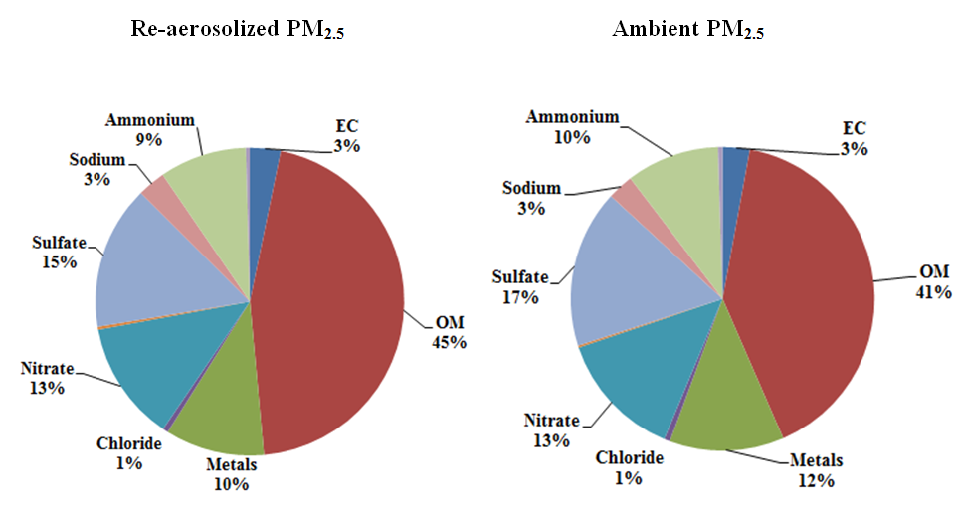

Figure 1. Chemical composition of re-aerosolized versus ambient PM_{2.5}
4. Conclusions
Our finding corroborate the superiority of implementing VACES/aerosol-into liquid tandem technology for producing PM solutions; followed by re-aerosolization procedure to generate stable aerosols that are fully representative of ambient PM in terms of physical and chemical compositions. Therefore, this protocol can be implemented to simulate the inhalation exposure to real world ambient PM. .
References
- S. Kim, M. Chang, D. Kim, C. Sioutas, Inhal. Toxicol. 12 (2000), 121–137.
- S. Kim, P.A. Jaques, M. Chang, T. Barone, C. Xiong, S.K. Friedlander, C. Sioutas, J. Aerosol Sci. 32 (2001), 1299–1314.
- D. Wang, P. Pakbin, A. Saffari, M.M. Shafer, J.J. Shauer, C. Sioutas, 2013. Aerosol Sci. Technol. 47 (2013), 1226–1238.

