Surfactin Recovery from Bacillus subtilis O9 Cultures by Means of Foam Formation Separation
Joaquín Orejas^{1*}, María Lucca², Marcelo Flores¹
1 Universidad Nacional de Río Cuarto. Facultad de Ingeniería. Grupo de Ingeniería de las Reacciones (G.I.R.). Ruta Nacional 36 Km 601 CP: X5804BYA. Río Cuarto. Córdoba. ARGENTINA; 2 PROIMI – Universidad Nacional de Tucumán. San Miguel de Tucumán. Tucumán – ARGENTINA
*Corresponding author: jorejas@ing.unrc.edu.ar
Highlights
- Continuous extraction of foam is an excellent recovery and concentration method for surfactin.
- This technique can be used to reduce costs of extraction and purification of surfactin.
- The proposed method avoids operation problems found in batch bioreactors.

1. Introduction
Surfactin is a very powerful surfactant produced by the bacteria Bacillus subtilis, which is able to reduce the interfacial tension of water from 72 to 27 mN.m⁻¹. Although it has excellent properties and therefore a large number of potential industrial applications ranging from petrochemistry to pharmacy, the costs involved in its production and purification processes are still restricting its commercialization. A common strategy to reduce these costs is to focus on the optimization and innovation on the purification stages. During the production of surfactin in a stirred tank bioreactor, the continuous change of the physicochemical properties of the culture and the high stirring and aeration requirements are responsible for the formation of a significant amount of foam. Thus, an operation strategy must be used.
In the present study, fractioning with foam was directly applied during the culture of B. subtillis in a batch stirred tank bioreactor to concentrate surfactin.
2. Methods
The experiments were performed in a 3 L Applikon® bioreactor provided with a Rushton agitator with 6 paddles, always operating discontinuously and with a working volume of 1.7 L. The diameter of the Rushton turbine is 4.5 cm., while the internal diameter of the bioreactor is 12.9 cm. The exhaustion air outlet was redesigned to continuously collect the formed foam and store it in sterile vessels. Then, the foam was stored at -18 °C to facilitate its collapse. The agitation, air flow, temperature and pH were set and controlled at 200 r.p.m, 1 v.v.m, 30 °C and 7, respectively. Two different chemically defined culture media with slight differences in their elemental traces were used, which had a significant influence on the production of surfactin. During the reaction, the dissolved oxygen concentration was continuously measured. Also, the concentrations of biomass, residual sugar, and surfactin were determined in the bioreactor. Finally, the volume, surfactin and biomass content were analyzed in the obtained foams.
3. Results and discussion
In order to evaluate the efficiency and convenience of the foam separation process coupled to the bioreactor, the variation of foam and remaining culture as a function of time and the surfactin recovery index were analyzed. These results are shown on Figures 1 and 2. The surfactin percentual recovery (SR%) was obtained by means of the following expression:
$$SR\%= \frac{Surfactin mass in the foam}{Total surfactin mass} x 100$$
This quantity represents the percentage of extracted surfactin in the foam and it is an indicator of the efficiency in the continuous extraction of foam as a fractioning and concentration method for surfactin.
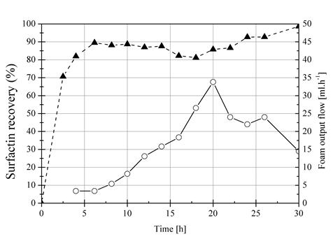  Figure 1. Surfactin recovery % () and foam output flow () | 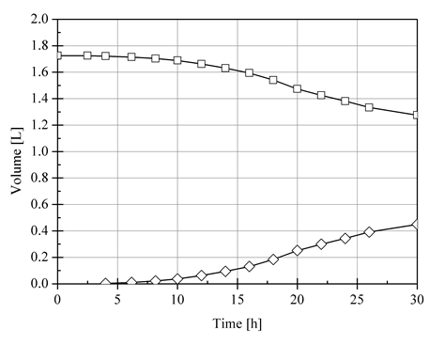  Figure 2. Culture volume in the bioreactor () and foam volume ()
As shown in Fig. 1, the recovery of surfactin in the foam reaches values over 98% of the total produced surfactin. What is more, by using an agitation of 200 r.p.m. only 26.1 % of the initial liquid volume in the bioreactor is dragged with the foam after 30 hours of operation, as presented in Fig. 2. These results indicate that the production of foam was not significant and didn’t complicate the operation of the bioreactor in any way. These results are not in agreement with the ones of Davis et al. [1] where agitation velocities of 204 and 269 r.p.m. generated excessive levels of foam formation and losses of 50% of the culture volume after 36 hours of operation, which consequently led to very low levels of surfactin production. However, the obtained results in the present study agree with Cooper et al. [2].
4. Conclusions
Based on the obtained experimental results, one can conclude that the continuous extraction of foam is an excellent recovery and concentration method for surfactin from a culture medium, with the additional advantage of reducing the extraction and purification costs of the overall process.
References
- D.A. Davis, H.C. Lynch, J. Varley, Enzyme and Microbial Technology 28 (2001) 346-354.
- D.G. Cooper, C.R. MacDonald, S.J.B. Duff, N. Kosaric.Appl. Environ. Microbiol.42 (1981) 408-412.

