Catalytic thermal decomposition of methane using solar energy
SungEun Kim¹, HakJoo Kim^{2,*}, JongKyu Kim², SangNam Lee²
1 Korea University, 5 Anam-ro Seoul Republic of Korea;
2 Korea Institute of Energy Research, 152 Gajeong-ro Daejeon Republic of Korea
*Corresponding author: hakjukim@kier.re.kr
Highlights
- Methane was catalytically decomposed to hydrogen and carbon black.
- Various carbon-based catalysts were tested.
- Pore size and content of disordered carbon affected the catalytic activity and stability.
- Carbon black catalysts were active and stable for long operation time.

1. Introduction
Biogas produced from municipal waste typically contains methane and carbon dioxide as main products. Since methane concentration in the biogas is generally around 50%, it is combusted as a fuel for heating or cooking. Combined with the removal process of CO₂, methane can also be used in a gas engine to convert its energy into electricity and heat or compressed as CNG to power motor vehicles. Since methane is combusted in the gas or motor engines, production of CO₂ is inevitable. The thermal decomposition of methane (TDM) to hydrogen and carbon black using renewable energy is considered as a promising route to use efficiently the energy of methane without emitting greenhouse gas CO₂. The carbonaceous solid product can be either sequestered without CO₂ release or used as a valuable material commodity in different applications. It can also be applied as reducing agent in metallurgical industry. The generated H₂-rich gas mixture can be directly used as fuel for internal combustion engines or further processed to high purity H₂ for being used in fuel cells [1]. TDM (non-catalytic) typically requires temperatures higher than 1,300 ºC in order to achieve reasonable reaction rates. Consequently, the use of catalysts (either metallic or carbonaceous catalysts) was investigated in order to operate at lower temperature and improve the process kinetics [2].

2. Methods
In this work, carbonaceous catalysts were prepared by pelletizing commercial carbon black with chemical binders and iso-propyl alcohol and thermal aging process. The prepared catalysts were characterized by SEM, XRD, BET, TGA, FT-IR. The activity of the catalysts toward methane decomposition was evaluated in a conventional fixed bed reactor. The catalysts, under a stream of CH₄/N₂ (50%vol CH₄/ N₂ at a total flow of 100mLmin⁻¹), were heated from RT up to 1,000 ºC at 10 ºC min⁻¹ and kept constant at 1,000 ºC for 4h.
3. Results and discussion
Four type of carbon-based catalysts, activated carbon(AC) derived from palm trees, commercial carbon blacks(CB) in bead and pellet form and mesoporous carbon were tested. From the analysis of N₂ adsorption isotherms, CB bead and mesoporous carbon showed an isotherm pattern having mesoporous pore structure. The methane decomposition was carried out at 1,000ºC with the residence time of 1.02s. Among the catalysts tested, CB catalyst in bead form showed the best activity and stability with 200 minutes of reaction time. All other catalysts showed an incremental deactivation or poor initial activity. The catalyst activity is summarized by comparing the values of maximum and stabilized conversion level. The physical properties of the used catalysts were found to dramatically change with the reaction. A deep loss of BET SA was observed with all the tested catalysts, especially with those having mainly micro pore structures like the AC and CB pellet form catalysts. Pore re-construction was thought to be present due to the deposition of carbon within the pore structure of the catalysts. Average pore diameters tended to increase after the reaction. Graphitic mesoporous carbon had poor activity towards methane decomposition. Among the tested catalysts, CB bead form catalyst retained its mesoporous structure within after exposure to the high temperature reaction temperature, carbon nano-tubes were found to be formed with the pores of the catalysts. Initial turbostratic carbon and mesoporous pore structure present in the CB bead catalyst was found to be resistant for the pore re-construction and blockage leading to catalyst deactivation.
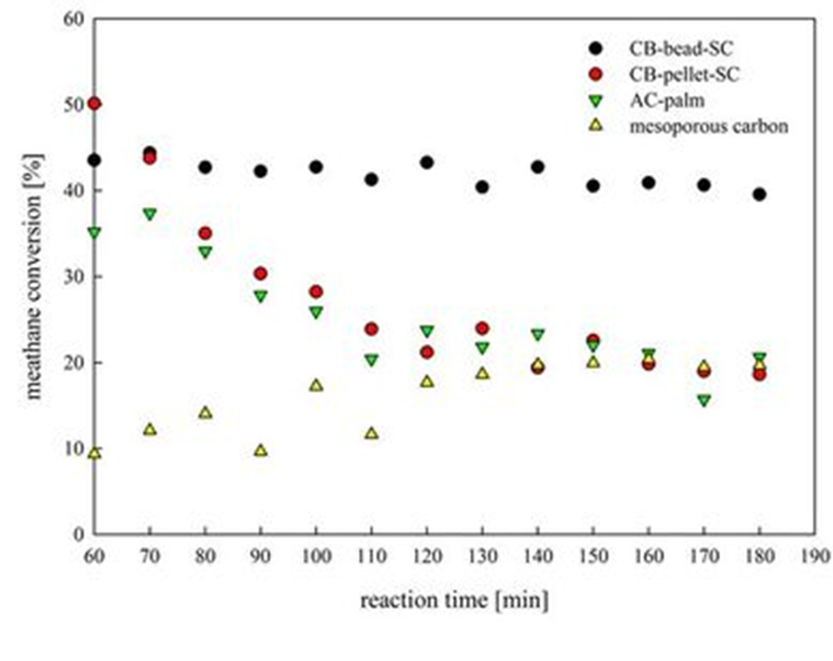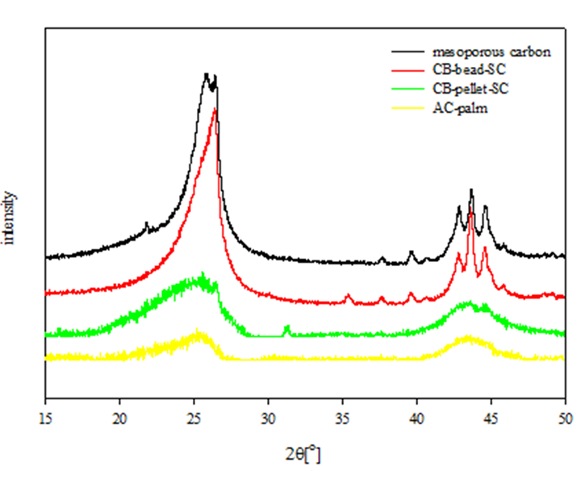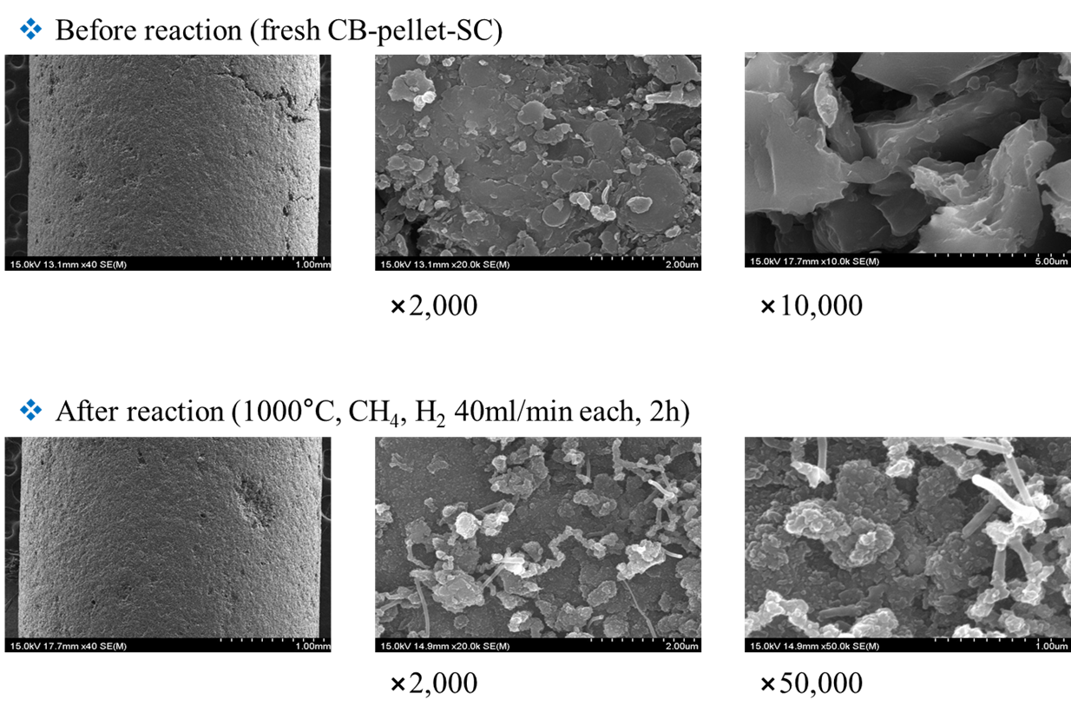
Figure 1. Catalyst activity. Figure 2. XRD patterns Figure 3. SEM images of CB pellet catalyst

4. Conclusions
Pore re-construction has undergone during methane decomposition. Filamenteous carbon growth blocked the mouth of micro-pores, which decreased severely the BET SA and developed new meso-pores. Catalytic activity of methane decomposition catalysts was related to the nature of carbon present on the surface in the order of amorphous > turbostratic > graphitic.
References
- S. Abanades, H. Kimura, H. Otsuka, Fuel Proces. Tech. 122 (2014) 153-162.
- R. Guil-Lopez, J.A. Botas, J.L.G. Fierro, D.P. Serrano, Appl. Catal. A Gen. 396 (2011) 40-51.

