**Techno-Economical Evaluation of the Rotating Packed Bed Technology for the Recovery of Natural Aromas from Fermentation Broth .**

Ilya Lukin1, Gerhard Schembecker1*

*1Laboratory of Plant and Process Design TU Dortmund University,   
Emil-Figge-Strasse 70, D-44227 Dortmund/Germany*

*Dortmund/Germany*

*\*Corresponding author: gerhard.schembecker@tu-dortmund.de*

**Highlights**

* RPB showed larger investment and operation costs for small-scale processes
* The cost analysis revealed the limitations of the novel technology
* The flexibility analysis covers the recovery of differently volatile aroma mixtures

**1. Introduction**

An increasing supplementation of products with aromas leads to an enhanced interest in biochemical production as an alternative to natural feedstock extraction[1]. Although advantageous, the economic success of aroma fermentation is still often limited by the challenging downstream process. An in-situ stripp-absorption using a Rotating Packed Bed (RPB) presents a novel approach for the recovery of natural aromas from crude biochemical broth. Our recent research shows that the mass transfer limitation of the absorption of volatile aromas can be overcome in a centrifugal field of the RPB increasing the process productivity. However, the rotation of the packing causes additional cost compared to the conventional techniques. Moreover, the lack of experience in operational boundaries and scale up parameters is yet a hurdle on the way to broad industrial application. Thus, the competitiveness of this novel technology needs to be evaluated in terms of its flexibility and costs.

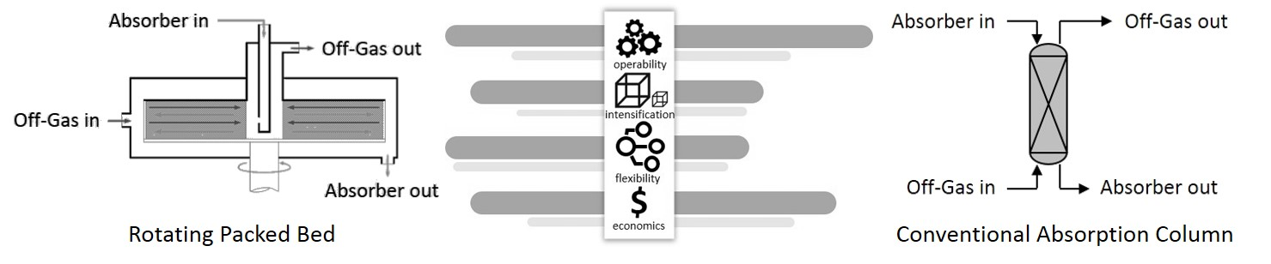**Figure 1**. Techno-Economical comparison of a Rotating Packed Bed and conventional recovery techniques

**2. Methods**

The profitability is evaluated in terms of investment and operational costs, which are calculated in dependence of the separation task scale and difficulty. Experimental results support the analysis of the influence of the production stage parameters as well as of the physico-chemical properties of the target compound. The operational boundaries of the RPB absorption are analyzed using flexibility maps[2].

**3. Results and discussion**

At the conditions for the absorption of a model aroma compound from an exemplary fermentation process investigated in this study, the small scale RPB showed larger costs than a simple bubble column (Fig 2).

W:\Mitarbeiter\aktuelle Mitarbeiter\Lukin, Ilya\Applications, Abstracts & Co\ECAB5\Analysis 1.emf

**Figure 2.** Total costs for the recovery of model aroma from the bioreactor off-gas for the Rotating Packed Bed and conventional Bubble Column (based on an exemplary fermentation process (100 h, 1 vvm aeration, constant aroma release, 95 % recovery) after the scale-up form laboratory experiments).

The analysis revealed that the costs of the RPB process were mainly driven by the large volume of water used as absorbent. Although low, the energy costs of RPB were three times higher than that of a bubble column. Obviously, the RPB could not fully display its advantages at operation with water. In order to reduce the absorbent consumption, the more hydrophobic liquids like plant oil were used. On the one hand, the enormous recovery increase is expected due to the rotation assisted mass transfer enhancement. On the other hand, only minor increase of operational costs is expected due to moderate pressure drop increase. Especially when dealing with highly viscous liquids like plant oil the RPB should be superior to other recovery techniques.

Further expansion to the broad range of aroma compounds of different volatility classes as well as to aroma mixtures will lead to more elaborated understanding of the technological potentials and limitations for the recovery of different products.

**4. Conclusions**

The stripp-absorption with Rotating Packed Bed presents a novel approach to the recovery of biochemically produced aromas. The results of the techno-economical evaluation of this potent technique will be presented. The flexibility analysis will reveal the potential and limitations of the RPB use for different classes of biotechnological aromas in comparison to classical downstream techniques.

**References**

[1] V.F. Cataldo, J. López, M. Cárcamo, E. Agosin, Appl. Microbiol. Biotechnol. 100 (2016) 5703-5718.

[2] D. Sudhoff, M. Leimbrink, M. Schleinitz, A. Górak, P. Lutze, Chem. Eng. Res. Des. 94 (2015) 72-89.