Operando characterization of products in electrochemical reactions using unique real-time analytics
Peyman Khanipour, Mario Löffler, Andreas M. Reichert, Ricarda Kloth, Iosif Mangoufis-Giasin, Karl J.J. Mayrhofer, Ioannis Katsounaros
Forschungszentrum Jülich GmbH, Helmholtz Institute Erlangen-Nürnberg for Renewable Energy (IEK-11), Egerlandstraße 3, 91058 Erlangen, Germany
*Corresponding author: i.katsounaros@fz-juelich.de
Highlights
- Electrochemical synthesis can be used to make added-value chemicals of fuels
- Real-time methods are needed to determine selectivity at dynamic conditions
- A novel method to determine products at the time they are formed is presented
- The discovery of new interfaces for selective electrosynthesis will be accelerated

1. Introduction
Electrochemical synthesis is the formation of valuable chemical compounds with the direct use of electricity. The field of electrochemical synthesis is currently growing rapidly because renewable electricity can be harvested to produce highly efficient fuels or fine, added-value chemicals. The classical way to characterize the selectivity of electrochemical reactions involves electrolysis at steady state (constant potential or current) and periodic product determination with GC, GC/MS, HPLC, NMR, IC, etc [1-3]. The advantage of this approach is that quantitation is possible in terms of reaction rates, yields, selectivities or faradaic efficiencies. However, two important limitations exist: First, only one material-electrolyte-potential (or current) combination is addressed at a time, thus looking for selective interfaces for new electrocatalytic processes is time-consuming. Second, the temporal resolution is in the order of minutes so transient, dynamic processes that occur within seconds cannot be captured. To address these points, we developed a new method that allows for the real-time detection of gaseous and liquid electrochemical reaction products.
2. Methods
Electrochemical real-time mass spectrometry (EC-RTMS) is based on coupling an electrochemical cell with two mass spectrometry techniques. It allows for the detection of gaseous products as in previously existing methods (e.g. differential electrochemical mass spectrometry [4]) but also the highly sensitive detection (sub-ppm range) of liquid products independent of their vapor pressure. The achieved acquisition frequency is in the order of 1 Hz, which therefore enables investigations under truly dynamic conditions, e.g. during potential sweep or potential step experiments. In the basic EC-RTMS configuration, the electrochemical reactor is an electrochemical scanning flow cell (SFC) [5], where a channel withdraws the electrolyte at the electrode vicinity for analysis. Gases are extracted from the electrolyte outlet with a hydrophobic membrane and analyzed with electron impact quadrupole mass spectrometry (EI-QMS). The degassed electrolyte is nebulized and the generated mist is transferred for analysis with direct analysis in real time - time-of-flight mass spectrometry (DART-TOF-MS).
3. Results and discussion
The strength of EC-RTMS in characterizing multiple reaction products in real time will be demonstrated by presenting examples from the reduction of carbon dioxide and the oxidation of C₁-C₃ alcohols. Figure 1 shows the product distribution during the electrochemical oxidation of ethanol on platinum. The potential protocol involved a combination of potential steps at 0 V_{RHE} and sweeps from 0 to +1.2 V_{RHE} (black curve in bottom panel - the oxidation current is also shown in red). Simultaneously, the product formation is followed with EC-RTMS. Gaseous products are CO₂ (m/z = 44 and 22) and CH₄ (m/z = 15), the latter formed from the reduction of adsorbed CHx species at low potential. Liquid products are CH₃CHO (m/z = 45), CH₃COOH (m/z = 61) and ethyl acetate (m/z: 89).
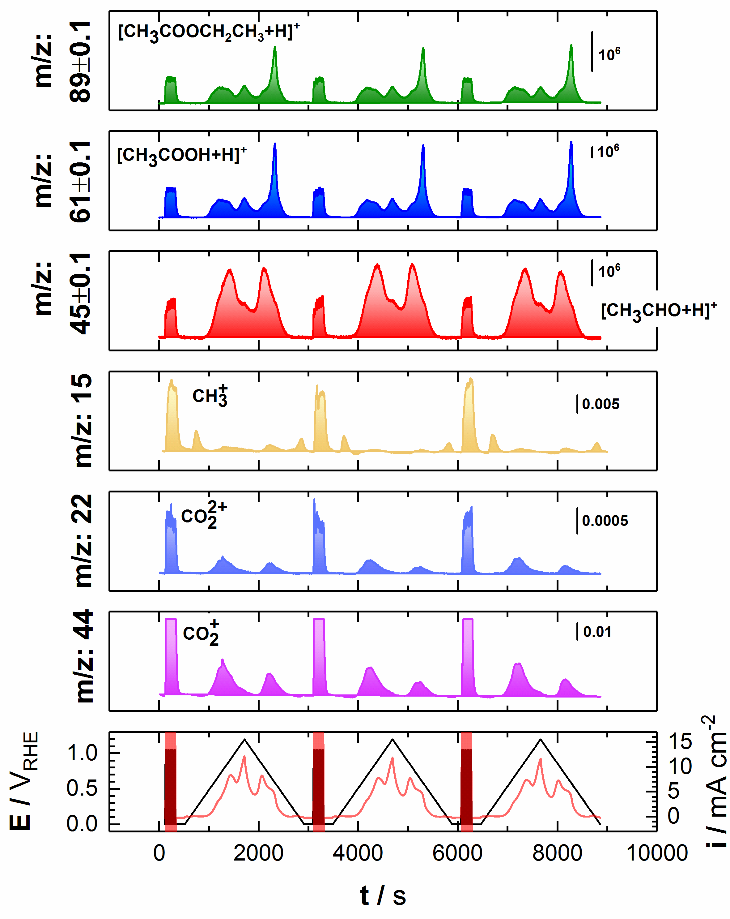
Figure 1. Determination of reaction products with EC-RTMS during the oxidation of 0.2 M ethanol on platinum in 0.1 M HClO₄: ethyl acetate (m/z = 89), acetic acid (m/z = 61), acetaldehyde (m/z = 45), methane (m/z = 15), and carbon dioxide (m/z = 22 and 44). The bottom panel shows the electrode potential (black) and the associated current (red).
4. Conclusions
EC-RTMS is a novel method that allows for the simultaneous detection of gaseous and liquid products of electrochemical reactions with excellent temporal and potential resolution. The greatest development is the characterization of liquid products in real time, as it drastically expands the possibilities of complete product determination during an electrochemical reaction independent of analyte vapor pressure or the presence of salts. We anticipate that EC-RTMS will accelerate the design of robust interfaces for highly selective electrochemical processes.
Acknowledgments
This work was funded by the Federal Ministry for Education and Research (BMBF) under the project grants 033RC004C (eEthylen) and 03SFK2Z0 (Power-to-X), and by the Deutsche Forschungsgemeinschaft (DFG, German Research Foundation) under Germany´s Excellence Strategy – Exzellenzcluster 2186 “The Fuel Science Center”.
References
- K.P. Kuhl, E.R. Cave, D.N. Abram, T.F. Jaramillo, Energy Environ. Sci. 5 (2012) 7050-7059.
- C.W. Li, J. Ciston, M.W. Kanan, Nature 508 (2014) 504-507.
- R.S. Sherbo, R.S. Delima, V.A. Chiykowski, B.P. MacLeod, C.P. Berlinguette, Nat. Catal. 1 (2018) 501-507.
- H. Baltruschat, J. Am. Chem. Soc. Mass Spectrom. 15 (2004) 1693-1706.
- A.K. Schuppert, A.A. Topalov, I. Katsounaros, S.O. Klemm, K.J.J. Mayrhofer, J. Electrochem. Soc. 159 (2012) F670-F675.

