Investigating reverse osmosis membrane fouling and scaling by membrane autopsy.
Nishtha Dhunnoo¹, Luiza C. Campos², Pablo García-Triñanes ¹
¹ Flow, Heat and Reaction Engineering Group (FHRENG), School of Engineering, University of Greenwich, Medway, ME4 4TB, United Kingdom;
² Department of Civil, Environmental and Geomatic Engineering, University College London, Gower Street, London WC1E 6BT, United Kingdom
*Corresponding author: p.garciatrinanes@gre.ac.uk
Highlights
- The study involved performing membrane autopsy and carrying out a series of tests to investigate the mitigation of fouling and scaling.
- Diatoms, pseudomonas and polysaccharides were the main biofoulants identified.
- Analysis revealed aluminium, calcium and silica as the main elements contributing to inorganic scaling.
- The findings pointed out flaws in pretreatment system of the household water treatment equipment.

1. Introduction
Population bloom, economic growth, industrialisation, climate change and water mismanagement are contributing to diminution of water globally. Many countries have adopted seawater reverse osmosis (RO) desalination to cope with increasing water demand [1]. However, fouling and scaling are crucial problems in the implementation of desalination which increases the cost of running this technology. Reduced efficiency is experienced in terms of a decrease in product output and permeate flux, high energy demand, increased operating pressure and reduced membrane lifetime [2]. The purpose of this research involves the study of proactive methods to mitigate RO membrane fouling and scaling.
2. Methods
This research involves investigating a desalination equipment used in household water treatment. Visual inspection was first carried out to observe the physical integrity to visually identify potential foulants. This step is important in determining subsequent analyses. Scanning electron microscopy (SEM) analysis was then performed to determine the topography and morphology of samples. This was conducted in conjunction with Energy Dispersive Spectroscopy (EDS) to identify and quantify the composition of the sample based on its element. Fourier Transform Infrared (FTIR) spectroscopy was then carried out to compare the wavelength of the foulant to identify the chemical bonds present. This was followed by three microbiological tests, namely catalase test, gram stain and API (Analytical Profile Index) test, to identify the bacteria causing biological fouling.

3. Results and discussion
Through visual inspection, Reverse Osmosis (RO) membrane fouling was visible as an irregularly distributed, thin and watery fouling layer. Scanning Electron Microscopy (SEM) characterization showed inorganic scaling in the form of salt crystal deposits. Different types of diatoms were also identified. Energy Dispersive Spectroscopy (EDS) analysis showed high concentration of Oxygen (O) and Carbon (C) suggesting deposits of organic and biological materials, with composition of C varying from 3.7% to 52.2% while that for O varying from 17% to 60% in the first membrane. Inorganic elements identified in the fouling layer through EDS are Al, Ca and Si. The spectrum obtained from Fourier Transform Infrared (FTIR) characterisation is shown in Figure 1. Amine group, amide group, proteins, polysaccharides, nucleic acid and aromatic compound were identified though interpretation of the frequency bands [3,4]. Different pseudomona species were identified through microbiological test analyses, confirming bacteria as one of the main causes for biofouling.
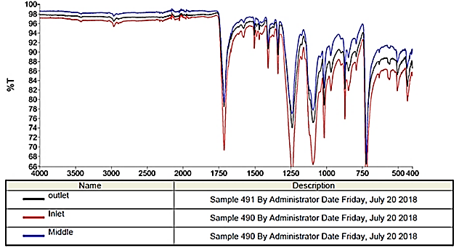
Figure 1. FTIR spectrum of membrane for outlet, middle and inlet sample.
4. Conclusions
Conclusions drawn through interpretation of membrane autopsy analyses indicate that biofouling is very pronounced due to the high number of diatoms, bacteria and the presence of carbon and oxygen. Inorganic scaling has also taken place in the membrane. The current pretreatment system being used in the water treatment equipment proves to be inefficient and inadequate. Additional pretreatment is required to protect the membrane from fouling and scaling. This need to be implemented based on the water quality flowing through the equipment.
References
- United Nations. (2018). Report of the Inter-agency Task Force on Financing for Development, New York: United Nations publication.
- Goh, P., Lau, W., Othman, M., Ismail, A. (2018). Membrane fouling in desalination and its mitigation strategies. Desalination, Volume 425, pp. 130-155.
- Jung, J., Ryu, J., Choi, S.Y., Park, K.Y., Song, W.J., Yu, Y., Jang, Y., Park, J., Kweon, J. (2018). Autopsy study of irreversible foulants on polyvinylidene fluoride hollow-fiber membranes in an immersed microfiltration system operated for five years. Separation and Purification Technology, Volume 199, pp. 1-8.
- Yu, T., Meng, L., Zhao, Q., Shi, Y., Hu, H., Lu, Y., (2017). Effects of chemical cleaning on RO membrane inorganic, organic and microbial foulant removal in a full-scale plant for municipal municipal wastewater reclamation. Water Research, Volume 113, pp. 1-10.

