A combined mathematical and experimental investigation of multiphase flow and shear sensitivity in the performance of mammalian cell cultures
Artemis Danae Charalambidou^{1*}, Martina Micheletti¹, Alexandros Kiparissides¹
1 University College London, Department of Biochemical Engineering,
Torrington Place, London, WC1E 7JE, UK
*Corresponding author: a.charalambidou@ucl.ac.uk
Highlights
- Conduction of detailed single phase computational fluid dynamics (CFD) simulations in a 250 mL bioreactor.
- Study of the impact of critical simulation parameters on model output and accuracy.
- Experimental validation of CFD simulation output via particle image velocimetry (PIV) measurements.
1. Introduction
The biopharmaceutical industry is in the forefront for the production of innovative drugs from mammalian cell cultures. Baffled or unbaffled stirred tank reactors (STRs) equipped with one or multiple impellers are most commonly used for the production of monoclonal antibodies (MAbs) and recombinant proteins. Their flexibility arises from the ease to control several operating parameters such as impeller speed and aeration techniques, which can improve homogeneity and thus the transport processes in the interior of the vessel (Rodriguez et al., 2013). Nevertheless, the large number of operating parameters makes the selection of an optimal configuration a laborious task and its complexity arises from the lack of detailed understanding of the underlying physics within a stirred vessel (Joshi et al., 2011). Experimental and computational fluid dynamics are widely recognised tools that contribute in the prediction of flow mechanics in STRs and estimation of turbulence associated quantities such as, microeddy formation, energy dissipation rate (EDR) and turbulence kinetic energy (TKE) which might eventually affect cell morphology, viability and productivity (Farzan, Mistry, & Ierapetritou, 2017; Morchain, Gabelle, & Cockx, 2014). However, although many attempts have been made to investigate the flow dynamics in STRs, a well-established and experimentally validated model for the meticulous description of critical hydrodynamic parameters in STRs does not exist. In this study we follow a systematic approach to establish a robust and experimentally validated CFD model based on a 250 mL STR configuration with one Rushton turbine, to assess various turbulent models and mesh structures as well as the effect of each on the estimation of key hydrodynamic parameters which influence mammalian cell cultures.
2. Methods
Commercial CFD software package ANSYS Fluent 19.0 is used to solve the liquid phase hydrodynamics in 3D. The liquid used is water (ρ=998.2 kg m⁻³, μ=10⁻³ Pa s) and the impeller rotational speed is initially set to 250 rpm, resulting in a Reynolds number of 5,000. Simulations are conducted in both steady state and transient mode via moving reference frame (MRF) and sliding mesh (SM) technique respectively for the simulation of impeller rotation. Convergence criteria were 10⁻⁵ and 10⁻⁶ for the continuity and turbulence closure equations respectively. The grid of the rotational zone was formed to be finer than the grid in the outer zone to achieve better accuracy. For mesh independence studies grid densities evaluated varied from 280,638 to 1,728,348 tetrahedral cells.
3. Results and discussion
Figure 1 presents preliminary results of the mesh independence study conducted over a wide range of grid densities. Reynolds Averaged Navier-Stokes equations (RANS) approach coupled with k-epsilon Realizable turbulence model is initially used due to its success to satisfactorily model rotational flows. Global maximum for radial velocity and EDR was located at the impeller plane. Minor differentiations were exhibited among the grid densities for radial velocity profiles (Fig. 1(a)). The consistency of the results was tested via calculating average velocities in dispersed control volumes in the interior of the bioreactor (results not shown). Lower grid density resulted in lower global maximum for EDR (Fig. 1(b)) leading to the conclusion that the corresponding solution is not optimum. 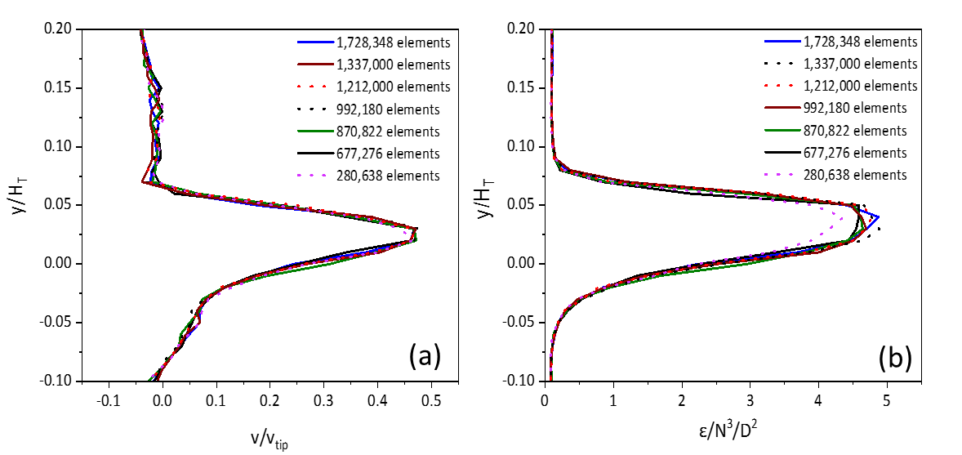
Figure 1. Local effect of grid density in the prediction of selected variables. Axial profiles close to the blade tip (r=T/4) of (a) radial velocity, (b) EDR.
4. Conclusions
A variety of different grid densities gave acceptable approximations for the critical parameters evaluated when RANS approach was used. For both EDR and TKE the results obtained were similar and 11% increase was observed from the coarser to the finer grid density. At the next stage, simulations will be run with structured mesh and different turbulence models to assess results quality and accuracy while experimental validation will mainly contribute in the clarification of the location and intensity of critical hydrodynamic parameters to ultimately quantify potentially destructive effects on mammalian cells.
References
[1] P. Farzan, B. Mistry, M. G. Ierapetritou, AIChE Journal 63(2) (2017) 398–408.
[2] J.B. Joshi, N. K. Nere, C.V. Rane, B. N. Murthy, C. S. Mathpati, A. W. Patwardhan, V. V. Ranade, The Canadian Journal of Chemical Engineering 89(1) (2011) 23–82.
[3] J. Morchain, J. Gabelle, A. Cockx, AIChE Journal, 60(1) (2014) 27–40.
[4] G. Rodriguez, W. Weheliye, T. Anderlei, M. Micheletti, M. Yianneskis, A. Ducci, Chemical Engineering Research and Design 91(11) (2013) 2084–2097.

