**Absorption of Natural Aromas in a Rotating Packed Bed.**

Ilya Lukin1, Gerhard Schembecker1*

*1Laboratory of Plant and Process Design TU Dortmund University,   
Emil-Figge-Strasse 70, D-44227 Dortmund/Germany*

*\*Corresponding author: gerhard.schembecker@tu-dortmund.de*

**Highlights**

* The faster rotation speed of an RPB increases the absorption efficiency
* Variation of the rotation speed allows flexible throughput at equal efficiency
* RPB can be operated with highly viscous absorbents at a low pressure drop

**1. Introduction**

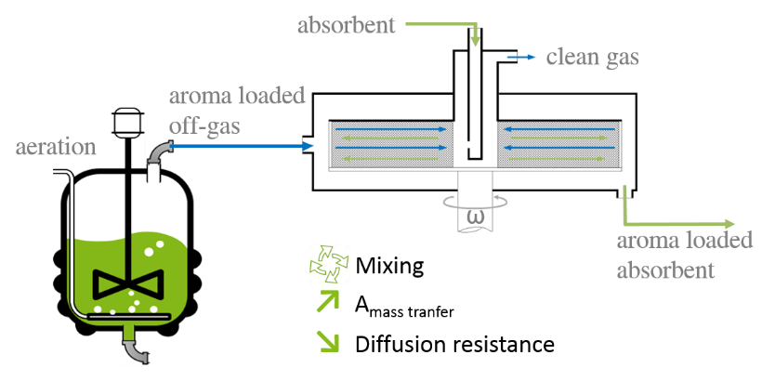An increasing demand for natural aromas enhances the role of a biochemical production as an alternative to the natural feedstock extraction [1]. A combination of in-situ product stripping and absorption in a Rotating Packed Bed (RPB) is a novel potent technique to overcome downstream challenges during the recovery of natural aromas from crude biochemical mixtures (Figure 1).

Figure 1: Schematic process of the recovery of natural aromas using Rotating Packed Bed technology

Inside a rotating circular packing of an RPB, the centrifugal force leads to an intensified gas‑liquid mixing increasing the mass transfer of a target compound[2-4]. In order to investigate the influence of process parameters on the recovery of aromas, a newly designed small-scale RPB was integrated into a laboratory aroma stripping and absorption plant.

**2. Methods**

A stripping column was used in order to mimic a bioreactor. Inside the stripping column, the air was loaded with the desired aroma and then brought into contact with the absorbent in the rotating packing of the RPB. The results of gas and liquid phase analytics were used for the calculation of absorption efficiency, pressure drop and mass transfer resistances.

**3. Results and discussion**

The results show that the absorption efficiency of an aroma compound decreases with the increased gas throughput implicating some mass transfer limitations (Figure 2). Due to the intensified mixing at higher rotation speed the later could be overcome leading to an increased efficiency. Altogether, the variation of the rotation speed enables larger gas loadings at constant absorption efficiencies leading to higher space-time productivity of the recovery process.



Figure 2: Effect of the rotation speed of an RPB on the absorption efficiency   
of benzaldehyde in water at varying gas throughputs.

A further efficiency increase is expected when stronger hydrophobic absorbents, e.g. plant oils, are used. The often challenging distribution of highly viscous oils in conventional absorption columns can be assisted by the generated centrifugal field allowing the operation of the RPB at moderate pressure drops (Figure 3) decreasing the process costs.

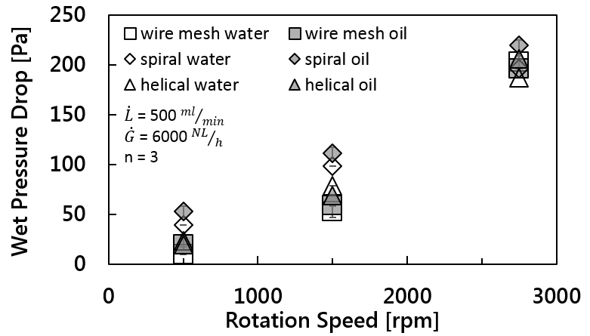

Figure 3: Wet pressure drop of different packings inside an RPB for water and rapeseed oil at varying rotation speed.

**4. Conclusions**

The use of the centrifugal field inside the packing of a Rotating Packed Bed helps to overcome mass transfer limitations leading to the improvement of the recovery process. Rotation assisted liquid distribution expands the selection of absorbents towards highly viscous plant oils.

**References**

[1] V.F. Cataldo, J. López, M. Cárcamo, E. Agosin, Appl. Microbiol. Biotechnol. 100 (2016) 5703-5718.

[2] C. Ramshaw, Chem. Eng. (1983) 13-14.

[3] L. Agarwal, V. Pavani, D.P. Rao, N. Kaistha, Ind. Eng. Chem. Res 20 (2010) 10046-10058.

[4] Y.S. Chen, F.Y. Lin, C.C. Lin, C.Y.D. Tai, H.S. Liu, Ind. Eng. Chem. Res. 20 (2006) 6846-6853.