Bipolar membrane (reverse) electrodialysis acid/base flow battery for energy storage: a multi-scale model for increased efficiency.
- Culcasi, A. Zaffora, L. Gurreri, A. Cipollina, A. Tamburini*, G. Micale
Dipartimento di Ingegneria, Università degli Studi di Palermo (UNIPA) - Viale delle Scienze Ed.6, 90128 Palermo, Italia
*Corresponding author: alessandro.tamburini@unipa.it
Highlights
- A 4-scale model ranging from the channel scale to the plant scale was developed.
- Pressure drops and polarization have minor effects on the process performance.
- Ionic short-circuit currents via manifolds may halve the Round Trip Efficiency.

1. Introduction
The renewable energy market is rapidly increasing. Most of renewable energy sources are intermittent, e.g. wind and solar among them. This has led to the need for new large scale energy storage systems. In this regard, the Acid/Base Flow Battery (AB-FB) represents an innovative, safe and sustainable way to store energy with high performances [1]. The energy density accumulated in an AB-FB, in the form of pH and salinity gradients, can theoretically reach 7 kWh/m³ which is higher than the values relevant to the most used technologies (e.g. pumped hydropower and compressed air). The core of the battery is the stack where two membrane separation processes are carried out: bipolar membrane electrodialysis during charge phase and its opposite bipolar reverse-electrodialysis during discharge. A stack consists of repetitive units called cells or “triplets”, composed by a cation exchange membrane, a salt solution, an anion exchange membrane, an acidic solution, a bipolar membrane and a basic solution. The aim of this work is to develop a simulation tool able to predict the operation and performances of the battery.
2. Methods
The modelling tool was developed using a multi-scale approach. The lowest scale is the single channel. At this level, all variables are discretized along the main flow direction and correlations coming from Computational Fluid Dynamics [2] are implemented in the model in order to evaluate the concentration polarization effects and the channel pressure loss. The medium-low scale simulates the triplet, computing its electrical behavior and all fluxes through the membranes (ohmic, diffusive, osmotic and electro-osmotic). The medium-high scale simulates the stack and predicts its pressure losses and ionic short circuit currents via manifolds [3]. The highest scale simulates the external hydraulic circuit, the electrolyte solutions storage tanks and the transient behavior of the battery. All the levels of the multi-scale model are fully integrated and predict the distribution of the process variables as well as meaningful performance parameters, such as the Round Trip Efficiency (RTE).
3. Results and discussion
Preliminary experiments show a good agreement with the model predictions. Thus, a sensitivity analysis was performed in order to assess the effect of stack features and operating conditions. Under most conditions simulated, pumping power and voltage drop due to concentration polarization have only minor effects on the process efficiency. Conversely, ionic short circuit currents via manifolds affects significantly the system performance. Just as an example, Figure 1 reports simulation results concerning the impact of the parasitic currents on the cell currents, triplet by triplet: the lower the ratio reported in the y-axis of the figure the higher the parasitic currents impact. Each line refers to a different electric current supplied to an external circuit (discharge, Fig.1a) or coming from it (charge, Fig.1b). As the external current decreases, the impact of parasitic current losses becomes more important (see distance from the horizontal line at I_{cell}/I_{cell,max} =1). RTE reduction due to ionic short circuit currents ranges from 13 to 46 % (RTE range 21–31 %).
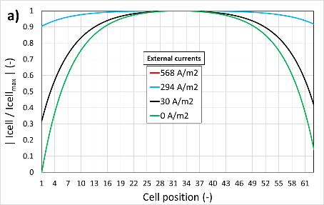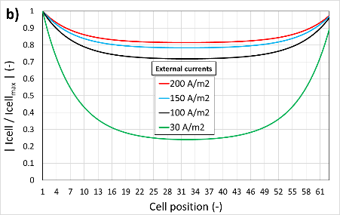
Figure 1. Ratio between cell current and maximum cell current along the stack for discharge (a) and charge (b). Stack of 63 triplets, membrane area 0.19x0.21 m², spacer thickness 500 µm, manifolds diameter 8 mm, mean flow velocity 0.4 cm s⁻¹, starting composition: acid 1M HCl-0.25M NaCl, base 1M NaOH-0.25M NaCl, salt 0.02M HCl, 0.25M NaCl.
4. Conclusions
A mathematical multi-scale tool was developed in order to simulate AB-FB units. From a sensitivity analysis, pumping power and polarization were found to slightly affect the battery performance. On the other hand, ionic short-circuit currents represent the major issue, leading up to almost halved values of RTE (∼30 %). These preliminary results provide important insights for improved designs, and further studies are ongoing to achieve competitive RTE values, e.g. larger than 70%.
Acknowledgements
This work was performed in the framework of the BAoBaB project (Blue Acid/Base Battery: Storage and recovery of renewable electrical energy by reversible salt water dissociation). The BAoBaB project has received funding from the European Union’s Horizon 2020 Research and Innovation program under Grant Agreement no. 731187 (www.baobabproject.eu).
References
- W.J. van Egmond, M. Saakes, I. Noor, S. Porada, C. J. N. Buisman, H.V.M. Hamelers, Int. J. Energy Res. (2017) 1-12.
- M. La Cerva, M. Di Liberto, L. Gurreri, A. Tamburini, A. Cipollina, G. Micale, M. Ciofalo, J. Membr. Sci. 541 (2017) 595-610.
- J. Veerman, J.W. Post, M. Saakes, S.J. Metz, G.J. Harmsen, J. Membr. Sci. 310 (2008) 418-430.

