Single Drop Rising and Salt Effects in Low Interfacial Tension System.
Jiyizhe Zhang¹, Yundong Wang¹, Geoffrey W Stevens² , Weiyang Fei¹
1 The State Key Laboratory of Chemical Engineering, Department of Chemical Engineering, Tsinghua University, Beijing 100084, China , 2 Department of Chemical and Biomolecular Engineering, The University of Melbourne, Parkville, Victoria 3010, Australia
*Corresponding author: wangyd@mail.tsinghua.edu.cn
Highlights
- Terminal velocities were evaluated for the low interfacial tension system.
- By plotting d_{e}-v_{t}-Re in a three dimensional way, application range of implicit correlation can be observed apparently.
- Influences caused by salt addition was investigated.

1. Introduction
Liquid-liquid extraction plays an important role in petrochemical, pharmaceutical, hydrometallurgical, as well as post-processing in nuclear industry. Single drop rising is one of the most fundamental behaviors which influences the terminal velocity and affects mass transfer rate ultimately. However, the motion of droplet is sensitive to contaminations, like salt ions, surfactants or solid particles, which are usually unavoidable in industrial operations. In general, drop terminal velocities can be predicted in three ways ^{[1]}: explicit correlations and models in the form of v_{t}=f(d_{e}), implicit correlation of C_{D}=f(Re) and generalized graphical correlation in terms of Eötvös number, Reynolds number and Morton number. Although different methods have been adopted for calculating terminal velocity, few of them are validated in low interfacial tension system. In addition, contaminations like surfactants have been investigated, but limit work has been done to determine the influence caused by salt ions, e.g. salt concentration and type.
In this study, single drop rising in low interfacial tension system (i.e. butanol-water system) was recorded by high speed camera to obtain terminal velocity. Then the terminal velocities were compared to the predictions by correlations from literature, both explicit and implicit. Furthermore, salt effect was determined by adding different salt with various concentrations into continuous phase.
2. Methods
As proposed by European Federation of Chemical Engineering (EFCE), n-butanol/water was chosen as the standard low interfacial tension system and the two phase were mutually saturated before use. Different type of salts were used, e.g. NaCl, Na₂SO₄, NaAc, NaI, MgCl₂, MgSO₄, and AlCl₃. Droplet rising was accomplished in a lab-scale column and was recorded by high speed camera. Images were analyzed by software ImageJ to derive drop diameter and terminal velocity.
3. Results and discussion
For the low interfacial tension system, correlations for terminal velocity were evaluated both explicitly and implicitly. For implicit correlation given as C_{D}=f(Re), by plotting d_{e}-v_{t}-Re in a three dimensional way, the application range of the correlation can be viewed obviously.
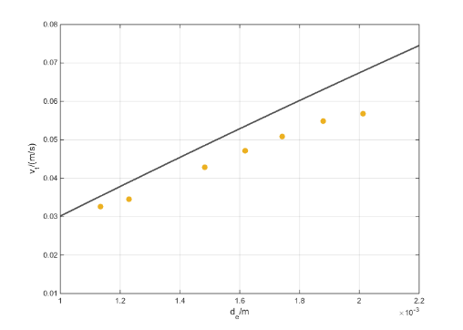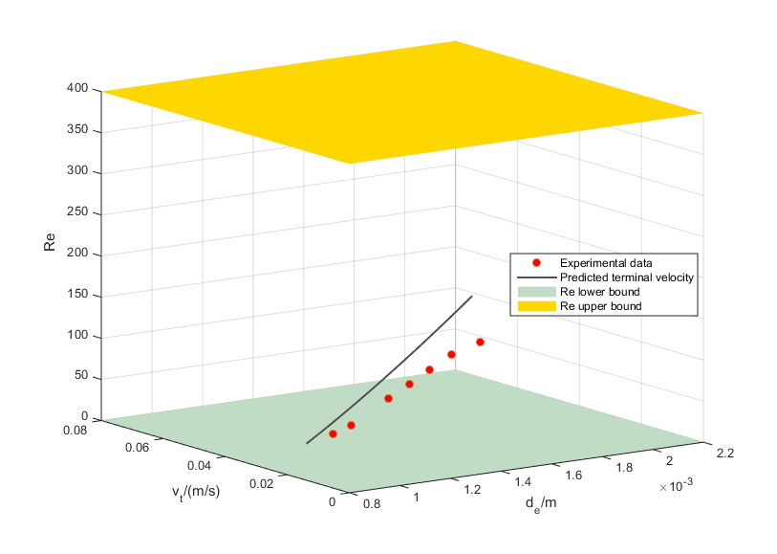
Figure 1. Terminal velocity predicted from Saboni drag coefficient correlation^{[2]}
The addition of salt changes the physical properties of the system and influences the hydrodynamic behaviors of droplet consequently. From a general view in Figure2, the terminal velocity increases with concentration. When the concentration is low, the increase of terminal velocity is not obvious. In this case, ions absorb at the interface and slightly decreases the interfacial tension. However, as the concentration increase further, the increase of terminal velocity becomes apparent. This is because the interface becomes saturated and subsequently addition of salt increases the bulk concentration as well as density.
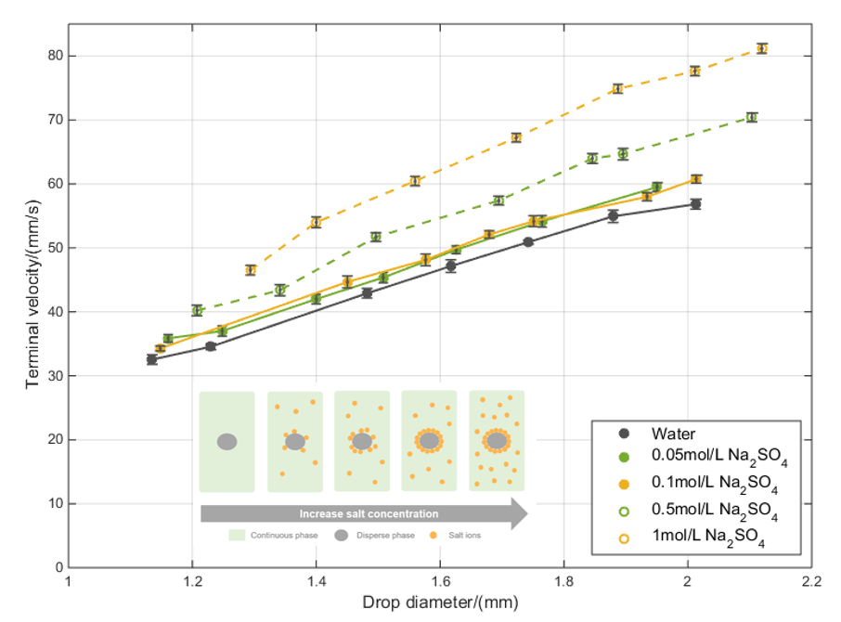
Figure 2. Influence of Na₂SO₄ concentration on terminal velocity
4. Conclusions
Terminal velocities for n-butanol drop rising in water as well as in salt solution have been investigated experimentally. Various explicit and implicit correlations for terminal velocities were evaluated. For the implicit correlations, the application range was considered carefully by plotting d_{e}-v_{t}-Re in a three dimensional way. Influence of ions showed that physical properties change caused by salt addition should be analyzed at the same time.
References
- M. Wegener, N. Paul, and M. Kraume, International Journal of Heat and Mass Transfer, 71 (2014) 475-495.
- A. Saboni, S. Alexandrova, AIChE journal, 48(2002), 2992-2994.

