Experimental study of a novel finned and tube phase change material storage for low-temperature applications
Giorgio Besagni¹, Lorenzo Croci¹
1 Ricerca sul Sistema Energetico - RSE S.p.A., Power System Development Department, via Rubattino 54, 20134 Milano (Italy)
*Corresponding author: giorgio.besagni@rse-web.it
Highlights
- A pilot-scale phase change material storage is build and tested.
- The effect of operating parameters have been evaluated.
- The energy stored is 80% higher compared with a water storage.

1. Introduction
Thermal energy storage (TES) is a matter of intense research and discussion, to decouple the “demand-side” and the “supply-side”. This field of study is of paramount importance interesting in the residential sector, to support the large-scale deployment of renewable energy-based technologies to support the decarbonistaion pathways. A promising solution to reduce the primary energy consumption at the household scale regards solar-assisted systems (i.e., solar assisted heat pumps, SAHPs). In this perspective, this paper contributes to the existing discussion by developing a “pilot-scale” finned and tube phase change material storage for low-temperature applications (viz., storage temperatures in the range of 20 - 30 °C, accordingly with the experimental outcomes of Besagni et al. [1])
2. Methods
A novel “pilot-scale” phase change materials storage is proposed, designed and tested. To this end, a laboratory test facility has been designed and build; it aims testing the influence of a variation in the boundary conditions (flow rate, temperature, heating load) on the global and local performances and charging/discharging times (Figure 1, see Table 1 for the details of the instrumentation). Following the discussion of Palomba et al. [2], a fin-and-tube heat exchanger is selected (see Table 1). The phase change material used is paraffin RT26 [3].
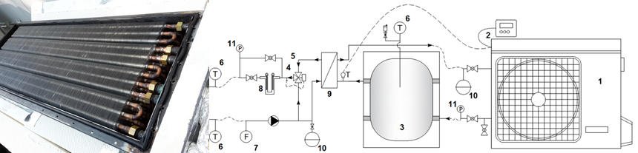
Figure 1. Test facility (details of the experimental system is Table 1).
Table 1. Details of the experimental system.
Code name (Figure 1) | Equipment and details
1 | Reversibile heat pump (MAXA, i-HWAK//V4 06, R410A)
2 | Remote control system for the reversible heat pump
3 | Buffer storage tanks for heat pumps; 51l, water storage
4 | Deviation valve
5 | Variable speed circulation pump
6 | Temperature probe - RTD Pt100 (1/5DIN)
7 | Electromagnetic flow meter
8 | Two electrical resistances (1500 W each)
9 | Plate heat exchanger
10 | 8dm³ expansion tank
11 | Pressure Transducer
3. Results and discussion
The heat exchanger was tested in two different configurations (viz. series and parallel), to investigate the influence of the non-uniformity of heat exchange on the global (energy storage) and local (local temperature inside the storage). For example, Figure 2a shows the energy storage inside the storage unit for given inlet (T_{in}) and outlet (T_{out}) temperatures. Conversely, (the locations of T₁, T₂ and T₃ are displayed in Figure 2b. It was found that the exchanger in the parallel configuration was able to achieve better performances, stored approximately 80% higher compared with a water storage (temperatures in the range of 15 ° C - 40 ° C). This increase is higher than that the one previously shown in the previous literature [2].
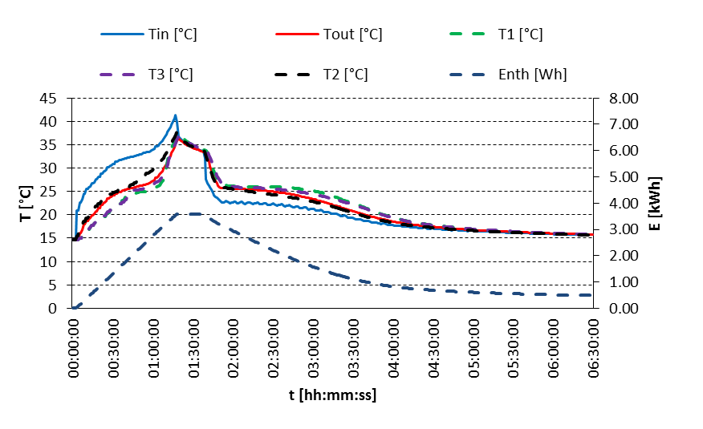
(a) heating load 2.8 kW, parallel configuration | (b) location of internal probes
Figure 2. Test Experimental results.
4. Conclusions
A “pilot-scale” finned and tube phase change material storage for low-temperature applications was built and tested, showing promising performances (i.e., energy stored is 80% higher compared with a water storage). In future studies, the obtained data can also be used to calibrate and validate a numerical model.
References
- G. Besagni, L. Croci, R. Nesa, L. Molinaroli, Renewable energy 132 (2019): 1185-1215.
- V. Palomba, V. Brancato, A. Frazzica, Applied energy 199 (2017): 347-358.
- Rubitherm GmbH, «RT 26,». Available: www.rubitherm.eu/en/index.php/productcategory/organische-pcm-rt.

