Investigations of molybdenum-promoted manganese-based solid sorbents for H₂S capture
Jianyu Ma¹, Kumar R. Rout², Maximilian Sauer³, Mehdi Mahmoodinia¹, Edd A. Blekkan^{1*}
1 Dept. of Chemical Engineering, Norwegian University of Science and Technology (NTNU), NO-7491 Trondheim, Norway
2 SINTEF Industry, NO-7465 Trondheim, Norway
3 Technical University of Munich, Germany
*Corresponding author: edd.a.blekkan@ntnu.no
Highlights
- Mo-promoted Mn-based solid sorbents for desulphurization were studied
- Real-time residence H₂S concentration was monitored on-line
- Mo addition promoted sorbent capacity and stability significantly

1. Introduction
Biomass gasification and subsequent fuel synthesis is a realistic route to 2nd generation biofuels. However, the produced syngas contains undesired species and contaminants (tar, alkali, sulfur species etc.) that has severe detrimental effects on downstream equipment and catalysts [1]. Therefore, gas cleaning and gas conditioning are important steps. From a process design point of view high-temperature gas cleaning is beneficial in terms of energy efficiency and investment cost. A key contaminant in biomass-based syngas is hydrogen sulfide, and this contaminant must be removed in order to avoid rapid deactivation of catalysts for fuel synthesis, e.g. cobalt-based Fischer-Tropsch catalysts [2]. Several materials have been proposed for high-temperature sulfur removal and manganese is reported to be a promising candidate based on thermodynamics (calculated sorption properties at high temperatures) as well as other chemical features (resistance to reduction, volatilization and carbide formation) [3]. The properties of sorbents can be improved by addition of promoters. Molybdenum oxide is selected in this study as a promoter on account of its ability to provide higher desulphurization capacity and improve stability of catalysts [4].
2. Methods
A series of Mo-promoted manganese sorbents supported on alumina were prepared by incipient wetness impregnation method using Mn-nitrate and ammonium molybdate as precursors. The samples were dried at 90°C and calcined at 700°C to decompose the salt. The nominal Mn loading was 15 wt% and Mo loadings were 2wt%, 5wt% or 8wt%, and 8wt% made using 2-step impregnation. Their H₂S sorption properties were investigated in a laboratory setup, see [5] for further details. The sorption was done on pre-reduced samples at 600°C using a dry gas mixture containing 0,4 vol% H₂S and 40% H₂, the balance being inert gases (Ar, N₂). The regeneration was done at 650°C and ambient pressure, using a gas containing 25 vol% air. The testing was performed as 10 cycles of sorption - regeneration. The residual H₂S level was monitored at different sorption temperatures with a specific sulphur analyzer, Thermo-Fisher 450i.
3. Results and discussion
All the samples initially adsorbed H₂S down to a very low level. After some time the concentration of H₂S in the exit gas started to increase (breakthrough), the sorption was then terminated by flushing the reactor with inert gas. The sorbent capacity before breakthrough were calculated from the amount H₂S adsorbed. Subsequently the sorbent was regenerated by diluted air. The only sulfur species detected in the gas phase during regeneration was SO₂. The initial sorption capacities declined in the following order: 15Mn5Mo-Al₂O₃> 15Mn8Mo-Al₂O₃> 15Mn8Mo-2step-Al₂O₃>15Mn2Mo-Al₂O₃>15Mn-Al₂O₃, indicating that addition of Mo increases sorbent initial capacity. After one cycle, the capacities for sorbent 15Mn8Mo-Al₂O₃ and 15Mn8Mo2step-Al₂O₃ increased obviously and remained stable for subsequent cycles. However, the capacity of 15Mn2Mo-Al₂O₃ suffered large deactivation and turned to be even lower than sorbent without Mo. The sorption capacity after 10 cycles declined in the following order: 15Mn8Mo-2step-Al₂O₃> 15Mn8Mo-Al₂O₃> 15Mn5Mo-Al₂O₃>15Mn-Al₂O₃>15Mn2Mo -Al₂O₃.
The residence H₂S concentration after sulfidation by 15Mn8Mo-Al₂O₃ was as low as around 1.95ppm at a sorption temperature of 400°C. At 600°C, the residual concentration increased to around 2.65ppm. In contrast, the 15Mn-Al₂O₃ showed a similar result at 400°C, 2.4ppm, however, a significantly higher value of 11ppm was recorded at 600°C sorption temperature.
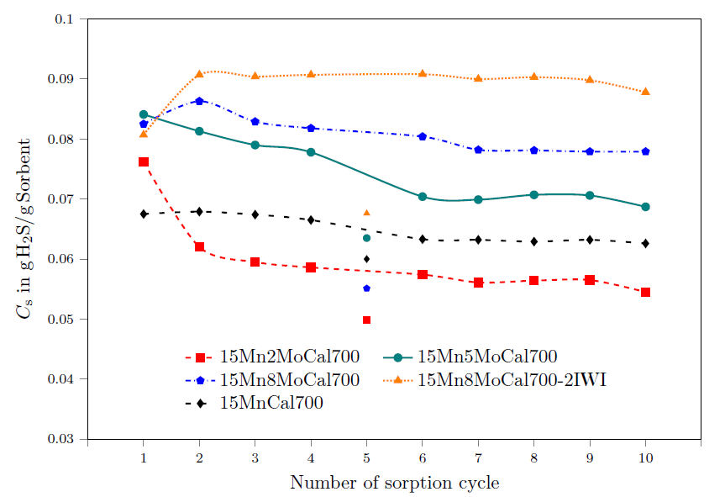
Figure 1. Capacities of Mn-based sorbents promoted with Mo.
4. Conclusions
The addition of Mo is found to be beneficial for Mn-based sorbents, in terms of capacity, stability and residual H₂S concentration in the gas phase after sorption.
References
- G.W. Huber, S. Iborra, A. Corma, Catal, Eng, Chem. Rev. 106 (2006) 4044–4098.
[2] A.H. Lillebø, A. Holmen, B.C. Enger, E.A. Blekkan, WIREs Energy. Environ. 2 (2013), 507–524.
[3] W.F. Elseviers, H. Verelst, Fuel 78 (1999) 601–612
[4] Laosiripojana, N., and S. Assabumrungrat. Applied Catalysis A: General, 290.1-2 (2005): 200-211.
[5] S. Chytil, M. Kure, R. Lødeng, E.A. Blekkan, Fuel, 196 (2017) 124–133.

