Expansion of human mesenchymal stem cells on Corning® Synthemax II™ – coated dissolvable microcarriers in a serum-free cell culture medium
C.Sion^{1,2}, S. Bailly³, S. Poncet³, E. Guedon^{1,2}, I. Chevalot^{1,2}, E. Olmos^{1,2}
1 CNRS, Laboratoire Réactions et Génie des Procédés, UMR 7274, 2 avenue de la forêt de Haye, TSA 40602, Vandœuvre-lès-Nancy, 54518, France ; 2 Université de Lorraine, LRGP, 2 avenue de la forêt de Haye, TSA 40602, Vandœuvre-lès-Nancy, 54518, France ; 3 Corning, Life Sciences, Amsterdam, The Netherlands
*Corresponding author: eric.olmos@univ-lorraine.fr
Highlights
- Corning dissolvable carriers provided a scalable solution for large-scale harvest of functional hMSC by enabling simplified detachment.
- Complete dissolution of microcarriers was observed during the harvest phase resulting in an efficient hMSC recovery.

1. Introduction
Mesenchymal stem cells extracted from the Wharton’s jelly of human umbilical cords (hWJ-MSC) are of increasing interest for cell therapies due to their reduced immunogenicity, high expansion capabilities, fast growth kinetics and various growth factors synthesis capabilities. Development of bioprocesses capable of producing large numbers of hMSC in a robust and safe manner is critical for therapeutic applications. Scalable expansion of hWJ-MSC on Cytodex-1 or other types of microcarriers usually found in cell culture, involved specific cell detachment using trypsin. Trypsin or other cell detachment enzymes could have harmful effects on cells and their viability. Besides, a filtration step is required because carriers remained in the cell culture medium. In this study, the efficiency of novel xeno-free dissolvable microcarriers for the culture and detachment of hWJ-MSC was demonstrated.
2. Methods
hWJ-MSC were cultivated on Corning Synthemax II-coated dissolvable microcarriers (DM) in HPL-supplemented medium, with an initial concentration of 7000 cells/cm². Previous studies (Loubière et al. 2018) showed that the best choice of microcarrier for hWJ-MSC adherence and expansion, in dynamic conditions, was Cytodex-1 [1], but cell detachment remained difficult. A culture in 200 mL spinner flasks with DM microcarriers was performed and compared with a culture on Cytodex-1. Glucose, glutamine, ammonium, lactate and lactate dehydrogenase concentrations were monitored every day. Moreover, cells were counted from the post-processing of DAPI-stained cells pictures [1]. At the end of the culture, cells were harvested following the protocol given by Corning. A solution of harvest was prepared using a mix of different enzymes and chemicals: a protease and a pectinase, and a chelating agent (EDTA). This harvest solution was directly used in the culture system and its action was about 20 minutes. After this, cells were directly centrifuged.
3. Results and discussion
The first results showed that the choice of Cytodex-1 or dissolvable carriers from Corning did not influence cell adherence. Cell viability was equivalent and maintained over time in both cultures (Figure 1). Once the attachment and kinetics of cell culture (growth, death, glucose and glutamine consumption, lactate and ammonia production) evaluated, cell detachment was studied. After the treatment with the harvest solution, cells were counted and microcarriers observed under microscope. Results indicated that Corning microcarriers were well digested, and two million of viable cells were collected after centrifugation (95% of viability), against, only 800 000 cells collected from Cytodex-1 using the classical proteolytic harvest treatment (89% of viability). By image analyses, it was shown that with DMC, complete cell detachment and microcarrier dissolution were obtained while cells remained attached on Cytodex-1 microcarriers.
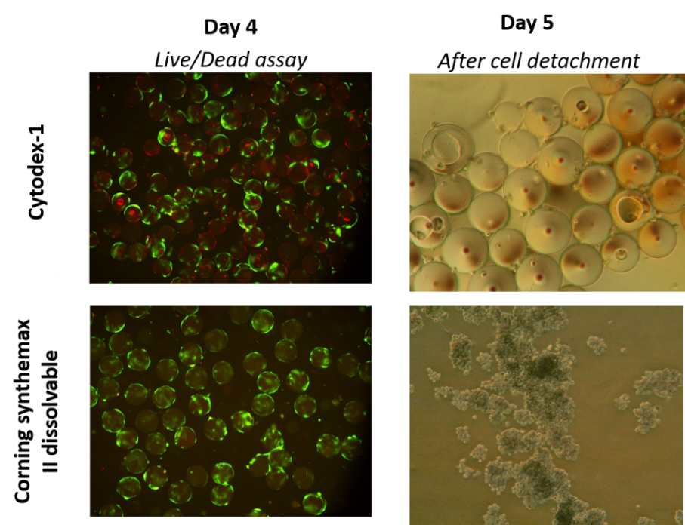
Figure 1. Comparison of cell culture and detachment on dissolvable carriers and Cytodex-1.
4. Conclusions
Recently, Nienow and colleagues developed a method of harvesting cells, which combines more intense agitation speeds, proteolytic enzymes and temperature inside the bioreactor, in order to improve cell detachment and viability. After the cell detachment, most of the applications, especially therapeutics, will require separation of cells from microcarriers, but by using dissolvable carriers this step would be avoided. To conclude, the use of dissolvable microcarriers would be an effective way to do scalable expansion and harvest of hWJ-MSC.
References
- Loubière, C., et al., (2018). Impact of the type of microcarrier and agitation modes on the expansion performances of mesenchymal stem cells derived from umbilical cord. Submitted to Biotechnology Progress.

