Removal of pharmaceuticals with supported ionic liquids
Márcia C. Neves*, Maria Santos, Beatriz Rocha, Guilherme Lobo-Sousa, Sandra C. Bernardo, Luciana Rocha, Hugo Almeida, Mara Freire
Department of Chemistry and CICECO-Aveiro Institute of Materials, University of Aveiro, 3810-193 Aveiro, Portugal
mcneves@ua.pt
Highlights
- Supported Ionic Liquids are efficient adsorbents for pharmaceuticals.
- Sodium diclofenac, ketoprofen, naproxen and acetylsalicylic acid undergo different adsorption processes onto SILs.
- Different ionic structures as counter ions in SILs lead to different adsorption processes.

1. Introduction
The presence of organic pollutants has been shown to have potentially adverse effects on man and the environment. Mainly due to their large worldwide consumption, active pharmaceutical ingredients (APIs) were already found in a wide variety of environmental aqueous samples, in concentrations ranging from ng/L to µg/L. This is due to the inability of current technologies used in sewage treatment plant (STPs) and wastewater treatment plants (WWTPs) to remove such compounds, thus leading to serious environmental and public health concerns after long-term exposures. Therefore, the treatment of water contaminated with these compounds is extremely important.
Ionic liquids (ILs) have a great potential to remove biomolecules from aqueous solutions [1], including pharmaceuticals [2]. Despite the many advantages associated to ILs, their immobilization in materials would overcome some leaching problems. ILs can be immobilized on solid supports by the covalent bonding of the cation, resulting in functionalized materials: supported ionic liquids (SILs). Based on the high potential of SILs in separation/removal techniques and on the health and environmental concerns that we aim to overwhelm, silica based SILs will be investigated to develop an efficient approach to remove pharmaceuticals from aqueous solutions.
2. Methods
SILs were obtained as described in the literature [3]. Silica gel 60 was used as supported for SILs synthesis, namely SilPrMImCl, SilPrNEt₃Cl, SilPrNBu₃Cl SilPrN(C₈)₃Cl, SilPrNMe₂BuCl (Figure 1). Five additional SILs were prepared from SilPrMImCl by anion exchange with the correspondent sodium salts, namely SilPrMImSCN, SilPrMImN(CN)₂, SilPrMImTos, SilPrMImMale and SilPrMImNTf₂.
3. Results and discussion
Adsorption kinetics and adsorption isotherms were performed for sodium diclofenac, ketoprofen, naproxen and acetylsalicylic acid with the synthetized SILs. The supported ionic liquid SilPrMImCl showed to be the most efficient material for the adsorption of sodium diclofenac, ketoprofen and naproxen, being the removal efficiency 91, 51 and 59%, respectively. For sodium diclofenac, the obtained adsorption equilibrium data are well described by the Langmuir or the Freundlich isotherm models, being dependent on the imidazolium supported materials counter ion. A maximum equilibrium concentration of sodium diclofenac in the solid phase of 240 mg.g⁻¹ of adsorbent was obtained with SilPrMImCl. Regarding the ketoprofen and naproxen the obtained adsorption equilibrium data are best described by the Langmuir-Freundlich (or Sips) isotherm model and a maximum equilibrium concentration for these pharmaceuticals of 88 and 41 mgg⁻¹ was obtained with SilPrMImCl.
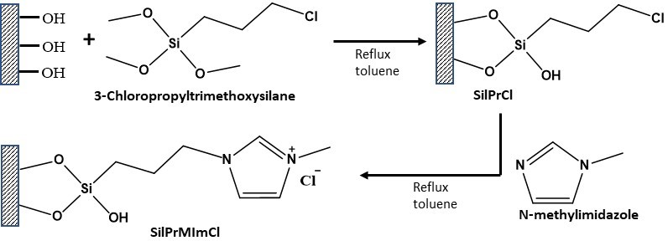
Figure 1- Synthetic route for SilPrMImCl.

In the case of acetylsalicylic acid, the equilibrium concentration of adsorbate in the solid phase decreases in the following sequence of SILs: SilPrNMe₂BuCl > SilPrNBu₃Cl > SilPrN(C8)₃Cl. The obtained adsorption equilibrium data are best described by the Langmuir model with a maximum equilibrium concentration of adsorbate in the solid phase of 220 mg of drug per gram of SilPrNMe₂BuCl.
4. Conclusions
The synthetized SILs are efficient adsorbents for pharmaceuticals. However, the adsorption mechanisms and maximum equilibrium concentrations depend on the SILs chemical structure and on the drug.
Acknowledgments
This work was developed within the scope of the project CICECO-Aveiro Institute of Materials, FCT Ref. UID/CTM/50011/2019, financed by national funds through the FCT/MCTES. This work is funded by national funds (OE), through FCT – Fundação para a Ciência e a Tecnologia , I.P., in the scope of the framework contract foreseen in the numbers 4, 5 and 6 of the article 23, of the Decree-Law 57/2016, of August 29, changed by Law 57/2017, of July 19. M.C. Neves acknowledge the Individual Scientific Employment Stimulus CEECIND/00383/2017.
References
[1] S.P.M. Ventura, F.A. e Silva, M. V. Quental, D. Mondal, M.G. Freire, J.A.P. Coutinho, Chem. Rev., 117 (2017) 6984–7052.
[2] H.F.D. Almeida, I.M. Marrucho, M.G. Freire, , ACS Sustain. Chem. Eng., 5 (2017) 2428–2436.
[3] H. Qiu, S. Jiang, X. Liu, J. Chromatogr. A, 1103 (2006) 265–270.

