Comparison of functional membranes of PCL doped with different graphene-based nanomaterials to modulate neural differentiation
Nazely Diban¹, Olga Tapia², Maria Teresa Berciano³, Miguel Lafarga², Ane Urtiaga¹

1 Dpt. of Chemical and Biomolecular Engineering, University of Cantabria-IDIVAL (Spain); 2 Dpt. of Anatomy and Biology and CIBERNED, University of Cantabria-IDIVAL (Spain); 3 Dpt. of Molecular Biology, University of Cantabria-IDIVAL.
*Corresponding author: dibann@unican.es
Highlights
- Polycaprolactone (PCL)/Graphene-based nanomaterial (GbN) membranes favor cell response
- Differentiation of C6 cells to astrocytes on PCL/GbN membranes was better than on PCL
- Different oxygen content on the GbN affects the cellular response
- Chemical defects in GbNs could be involved in the mechanism of neural activation

1. Introduction
Recent studies in tissue engineering and regenerative medicine have demonstrated that graphene-based nanomaterials used as scaffolds for in vitro stem cells cultures, induce cell differentiation toward specific tissues [1]. Furthermore, in our previous work we observed that graphene oxide (GO), and particularly reduced graphene oxide (rGO) doped in the matrix of polymer membranes of polycaprolactone (PCL), induced a significant improvement on neural differentiation of human Neural Progenitor Cells (hNPC) towards neurons, as well as a higher neural functional activity after maturation [2]. However, there is a lack of data in the literature covering the comparison of the effect of incorporating graphene-based nanomaterials with different chemical and physical characteristics on polymer scaffolds for the modulation of neural differentiation. The aim of this work is to broaden the comparison of different type of GbNs immersed on PCL/GbN composite membranes to be able to find out more information about the potential properties of GbNs that might trigger the differentiation of stem cells to neural cells.

2. Methods
In this study flat composite membranes with PCL and GO, with different oxygen content and produced using different exfoliation procedures, were used. The nanomaterials produced by anodic exfoliation contained either 2% (GO2%Ox) or 20% (GO20%Ox) of oxygen groups respectively (supplied by the Carbon Institute, INCAR-CSIC, Oviedo) [3]. Furthermore, GO was also produced using a modified Hummer’s method, followed by a reduction of oxygen groups by a hydrothermal process, forming rGO. Then flat PCL/Graphene-based Nanomaterials (GbN) composite membranes (PCL/GO2%Ox, PCL/20%Ox, PCL/rGO) were fabricated using phase inversion following the procedure described elsewhere [4]. Plain PCL membranes were also produced for comparison.
Membranes were characterized by SEM, Raman and cyclic voltammetry. Furthermore, C6 cell cultures were carried out on every type of membrane and the differentiation degree was quantified by assessing the nuclear size, length and number of cellular processes and percentage of cells that could express GFAP protein (an astrocyte’s specific protein marker).
3. Results and discussion
Figure 1 shows confocal microscopy images showing the proliferation (Figures 1a-e) and differentiation (Figures 1f-j) stages of C6 seeded on the different membranes and in tissue control plate (TCP) as control. At day 1, TCP showed better cell proliferation (Figure 1a), though interestingly at day 3 (Figure 1f), C6 cells on TCP differentiated towards fibroblast instead of astrocytes. The differentiation to astrocytes was particularly better for PCL/rGO membranes (Figure 1j) and, at a lower extent, in PCL/GO20%Ox membranes (Figure 1i). Contrary to expectations, despite GO2%Ox nanomaterials have the closest Raman spectrum to CVD-quality graphene [3], PCL/GO2%Ox membranes presented the worst cell differentiation among the PCL/GbN membranes (Figure 1h).
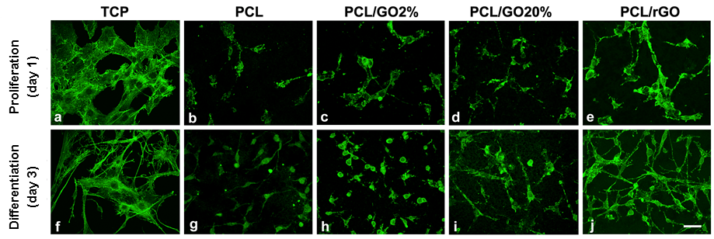
Figure 1. Confocal images showing the length of emitted projections of non-differentiated (day 1) and differentiated (day 3) C6 cells (F-Actin staining in green). Cell morphology at day 3 on TCP corresponded to fibroblasts. The emitted projections (astrocyte-like) on PCL/rGO and PCL/GO20%Ox were significantly longer than in the rest of membranes. (Scale bar 30 μm)
4. Conclusions
The evidences shown in this work highlight that graphene based nanomaterials with chemical defects on PCL/GbN composite membranes might be more favorable than pristine graphene to modulate the differentiation towards neural cells for neural in vitro models. However, the actual mechanisms behind the effect of GbNs on neural stimulation need to be explained, and therefore, further studies have to be performed.
Financial support through project InnVal17/20 (IDIVAL, Spain) and nanomaterials supply by Carbon Institute, INCAR-CSIC, are gratefully acknowledged.
References
- O. Akhavan, J. Mater. Chem. B 4 (2016) 3169-3190
- Sánchez-González, S. Diban, N, Bianchi F., Ye, H. Urtiaga, A. Macromol. Biosci. doi: 10.1002/mabi.201800195 (2018)
- Munuera, J.M., Paredes, J.I., Villar-Rodil, S., Castro-Muñiz, A., Martínez-Alonso, A., Tascón, J.M.D (2018) Appl. Mater. Today 11 (2018) 246–254
- Diban, N., Sánchez-González, S. Lázaro-Díez, M., Ramos-Vivas, J., Urtiaga, A. J Membr. Sci. 540 (2017) 219–228

