Modeling Batch Preferential Crystallization for Conglomerates Forming Systems using Shortcut Models
S. Bhandari^{2*}, T. Carneiro¹, E. Temmel¹, H. Lorenz^{1,2}, A. Seidel-Morgenstern^{1,2}
1. Max Planck institute for Dynamics of complex technical Systems, Magdeburg, Germany
2. Otto von Guericke University, Chair of Chemical Process Engineering, Magdeburg, Germany
*bhandari@mpi-magdeburg.mpg.de
Highlights
- Shortcut models are formulated and introduced for Preferential Crystallization
- Enantiomers of Monohydrate and anhydrate systems are studied
- Key performance indicators are evaluated
1. Introduction
Evaluating various kinetic mechanisms, Population Balance Models (PBMs) are a powerful tool to describe crystallization processes. Due to the consideration of many details, the resulting set of equations is difficult to solve and expensive in applying it for simulation and optimization. Preferential crystallization (PC) is a strong technique capable to resolve mixtures of enantiomers [1, 2]. In this study a shortcut model based on assuming uniform particles sizes and only one lumped kinetic mechanism is introduced. Correspondingly model parameters are calculated using the experimental data for batch preferential crystallization of conglomerate forming chiral systems. The analysis is based on the enantiomers of DL-threonine in water and DL-asparagine (DL-Asn) in water. The latter system forms a monohydrate. An evaluation of Key Performance Indicators (KPI) of the process (i.e. productivity and purity) is performed for the two systems using the shortcut models. The predictions are compared with the experimental results. A possible extension of the shortcut models to simulate preferential crystallization in racemic compound forming systems will be also shortly discussed.
2. Methods
The shortcut models are developed to describe batch preferential crystallization (PC) exploit the principle of “total mass transfer” that causes mass depletion of the liquid phase and mass build-up of the solid phase during the process. The following assumptions are made to derive the shortcut model for PC:
- Nucleation and growth rate are lumped and connected with a constant${ k}_{\overline{GB}}^{eff}$. The two mechanism jointly cause liquid phase mass depletion and solid phase mass build up
- All crystals of one enantiomer are spheres of the same increasing size (no size distribution)
- A certain number of very small “crystals” of the counter-enantiomer are assumed to be initially present along with the seeds of the preferred enantiomer
- A production time $t_{prod}$ is introduced as a function of supersaturation, which is the time at which the crystals of counter enantiomer is activated
- Driving forces respect metastable solubility limits in the 3-phase regions
- No aggregation or breakage occurs.
The basic equations of the model are:

Liquid phase mass balance:
 | $$\frac{dm_{i}}{dt}={-k}_{\overline{GB}}^{eff}{4π N}_{i}R_{i}^{2}{\left(S_{i}-1\right)}^{n^{eff} } i∈\left\{1,2\right\}$$ | (1)
Solid phase mass balance:
 | $$\frac{dR_{i}}{dt}=\frac{k_{i,\overline{GB}}^{eff}}{ρ_{Sol}}{\left(S_{i}-1\right)}^{n_{i}^{eff}} i∈\left\{1,2\right\}$$ | (2)
3. Results and discussion
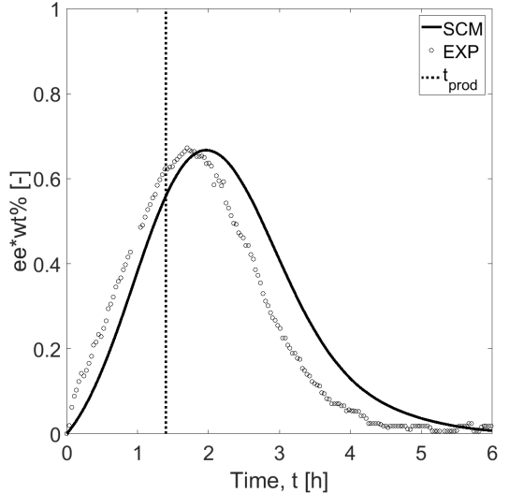  $$t_{prod}$$  (a) | 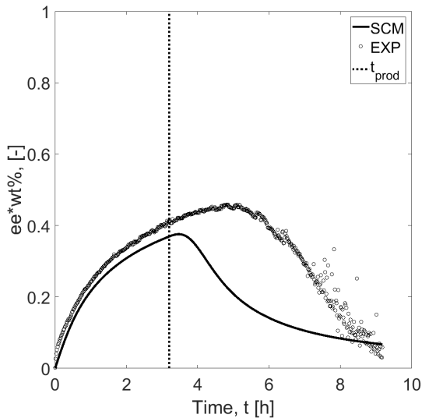  $$t_{prod}$$  (b)
Figure 1. Comparison between shortcut model and experimental data of batch isothermal PC. Enantiomeric excess profiles of case (a) DL-threonine in water and (b) DL-asparagine monohydrate in water
Experimental results of case (a) threonine [3] and case (b) asparagine monohydrate were used to evaluate the potential of the shortcut model. As shown in Figure 1, both cases differ significantly in the initial rates and the process trajectories. The shortcut model is capable to capture these differences by using different effective order of crystallization kinetics ($n^{eff}$ = 1 and $n^{eff}$ = 6.6) respectively. The other two parameters required in shortcut model for PC is effective crystallization rate constant $k_{\overline{GB}}^{eff}$ and stop time${ t}_{stop}$. The parameter estimation in both the cases is performed using least square fitting method. Figure 1 clearly shows the performance of the model within the production time is satisfactory as compared with the experimental results.
4. Conclusions
The above results show that shortcut models can describe essential features of the PC process. The experimental results regarding enantiomeric excess compare well with predictions of the shortcut model. It is seen as a useful tool for preliminary estimations of KPI as productivity, yield, purity and identifying optimal operating parameters. Clear limitation of the shortcut model is the fact that it cannot predict the crystal size distribution and higher moments are not conserved.
References
- J. Jacques (1994): Enantiomers, Racemates and Resolutions. Krieger Publishing Company Malabar, FL.
- G. Coquerel (2007): Preferential Crystallization. Top Curr Chem 269, 1-51
- M. Eicke (2016): Process Strategies for Batch Preferential Crystallization (Doctoral dissertation). Retrieved from Otto-von-Guericke University, Magdeburg Bibliography Database.
This research has received funding as part of the CORE project (October 2016 – September 2020) from the European Union’s Horizon 2020 research and innovation programme under the Marie Sklodowska-Curie grant agreement No 722456 CORE ITN

