Feasibility studies on biomass waste utilization for alternate energy generation
Hammad Siddiqi^{1*}, B. C. Meikap^{1,2}
1 Department of Chemical Engineering, Indian Institute of Technology (IIT) Kharagpur, West Bengal-721302, India
2 Department of Chemical Engineering, School of Engineering, Howard College, University of Kwazulu-Natal, Durban, 4041 South Africa

*Corresponding author: hsiddiqi@iitkgp.ac.in
Highlights
- Alternate energy from biomass waste.
- Thermo-kinetic studies to access its feasibility.
- Prediction of reaction model using master plots.

1. Introduction
Rising energy consumption and the acute energy crisis lead to a long-term cleaner and renewable alternative that is abundantly available, easily accessible and also have positive footprints on the environment along with its economic feasibility. Another major challenge that is also associated with population rise is waste management. Therefore, utilization of this waste for energy production will be most viable solution to these two problems. Present work focuses on generation of alternate energy from a biomass waste, a detailed thermo-kinetic analysis to evaluate its energy potential. The effect of various physiochemical properties will be investigated to correlate its effect on final product distribution via thermochemical conversion
2. Methods
Physiochemical characterization include proximate and ultimate analysis which was carried out using ASTM standards. Also the components of cell wall consisting of hemicellulose, cellulose and lignin have been determined using chemical process. Thermo-gravimetric analysis at different heating rates for non-isothermal heating have been performed to determine the kinetic factors and further the reaction model.
3. Results and discussion
The activation energy of the sample was determined using different differential and integral isoconversional models and the average value is calculated as 109.90 kJ/mol. Also the physiochemical analysis indicate the energy potential in the feedstock. Further the pre-exponential factor was evaluated along with the reaction model which indicate a two stage process. The values of change in enthalpy, entropy and free energy suggests spontaneity of the process and its thermodynamic feasibility.

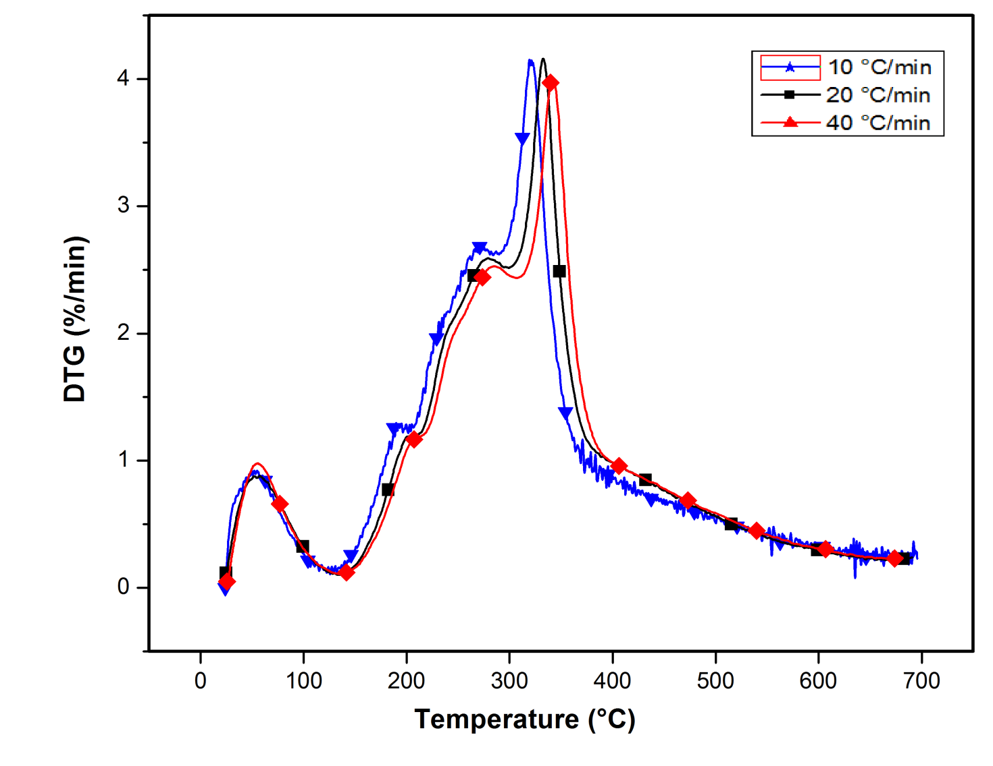
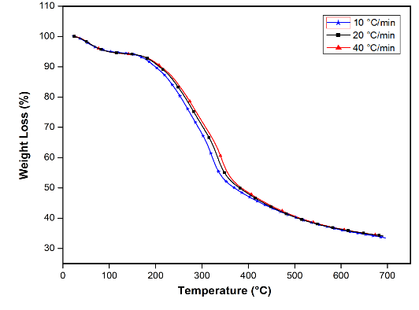
Figure 1. Weight loss curve at different heating rate. Figure 2. DTG curve at different heating rate.
4. Conclusions
Detailed physiochemical characterization of feedstock clearly indicates that energy can be extracted from it and it can be utilized as an alternate source of energy giving various liquid, gaseous and solid products. The various kinetic parameters indicates the mechanism taking place for the thermochemical conversion of this biomass. It indicates system is very reactive at the beginning and its reactivity decreases with extent of reaction. Further these studies will be significant in design of reactors, mass and energy balance and process optimization.
References
- I. Ali, H. Bahaitham, R. Naebulharam, A comprehensive kinetics study of coconut shell waste pyrolysis, Bioresouce Technol. 235 (2017) 1–11.
- R. K. Mishra, K. Mohanty, Pyrolysis kinetics and thermal behavior of waste sawdust biomass using thermogravimetric analysis, Bioresouce Technol. 251 (2018) 63–74.
- P. McKendry, Energy production from biomass (part 1): overview of biomass, Bioresouce Technol. 83 (2002) 37–46.
- M. J. Starink, The determination of activation energy from linear heating rate experiments: a comparison of the accuracy of isoconversion methods, Thermochim. Acta 404 (2003) 163–176.
- V. Dhyani, J. Kumar, T. Bhaskar, Thermal decomposition kinetics of sorghum straw via thermogravimetric analysis, Bioresouce Technol. 245 (2017) 1122–1129.
- P. S. Jimenez, L. P. Maqueda, A. Perejon, J.M. Criado, Generalized master plots as a straightforward approach for determining the kinetic model: the case of cellulose pyrolysis. Thermochim. Acta 552 (2013) 54–59.
- F. J. Gotor, J. M. Criado, J. Malak, N. Koga, Kinetic analysis of solid-state reactions: the universality of master plots for analyzing isothermal and nonisothermal experiments. J. Phys. Chem. A 104 (2000) 10777–10782.
- S. R. Naqvi, R. Tariq, Z. Hameed, I. Ali, M. Naqvi, W. H. Chen, S. Ceylan, H. Rashid, J. Ahmad, S. A. Taqvi, M. Shahbaz, Pyrolysis of high ash sewage sludge: Kinetics and thermodynamic analysis using Coats-Redfern method, Renew. Energ. 131 (2019) 854-860.

