**Production of 5-hydroxymethylfurfural from fructose in a heterogeneous reaction using supported triazolium-based ionic liquids.**

Claudio Araya-Lopez1, Gabriel Abarca2, Cristian Valdebenito1, Ricardo Salazar1, Julio Romero1*

*1 University of Santiago de Chile, Av. Libertador Bernardo O’Higgins 3363, Estación Central, Santiago, Chile*

*2 Universidad Mayor, Camino la Pirámide 5750, Huechuraba, Santiago, Chile*

*\*Corresponding author:* [*julio.romero@usach.cl*](mailto:julio.romero@usach.cl)

**Highlights**

* Dehydration of fructose to produce 5-hydroxymethylfurfural.
* Supported triazolium-based ionic liquid catalysts.
* Click chemistry for the synthesis of triazolium salts.

**1. Introduction**

5-hydroxymethylfurfural (5-HMF) is considered a furan-type platform chemical derived from the dehydration of hexoses, along with being a versatile and critical intermediate in biofuel chemistry and an important building block to produce plenty of chemical compounds, such as dimethylfuran (DMF), 2,5-diformylfuran (DFF) among others. Nevertheless, the reaction to produce 5-HMF shows the disadvantage of promoting side-reactions with undesired by-products. Furthermore, the rehydration of 5-HMF takes place frequently forming levulinic and formic acid. In order to produce 5-HMF, a wide range of conditions has been assessed, from homogeneous to heterogeneous catalyst as well as the use of monophasic or biphasic systems that are coupled with different separation techniques. The main technical challenge is to achieve the efficient production of 5-HMF through cleaner and greener chemical reactions and separation steps, due to the exponential growth of the green chemistry and its benefits to chemical processes [1]. In this framework, ionic liquids ( ILs) are one of the most promising green solvents, specially triazolium-based ionic liquids, which are synthesized under click chemistry concepts by 1,3 dipolar cycloadditions, acting as a chemically supported Bronsted acidic ILs [2]. This work is based on the study of a new family of triazolium-based ionic liquids supported on silica or alumina to be used as a catalyst in the dehydration of fructose. Moreover, the 5-HMF production yield was quantified in this work as well as the reaction kinetic in order to identify the best-operating conditions.

**2. Methods**

**Synthesis of supported triazolium-based ionic liquids:** a first triazolium salt was synthesized pouring together sodium azide and benzyl bromide in water (2mL); meanwhile, iodo tris(triphenylphosphine) copper (I) was used as catalyst. After stirring of 30 min, 3-butyn-sulfonate was added, and the reaction was kept at room temperature for 24h. A second triazolium salt was also synthesized pouring together the 3-azidopropane sulfonate and phenylacetylene at the same conditions, using the same reaction solvent and catalyst of the previous reaction. The anchoring of triazolium salt was carried out putting the triazolium salt together (iodobutyl) trimethylsilane-functionalized silica or alumina (the triazolium salt mass corresponded to 20% with respect to support mass) refluxing in toluene for three days. The obtained product was a supported triazolium-based ionic liquid. Finally, to functionalize the ionic liquid with [HSO4]-, H2SO4 was used according to the procedure reported by Zhang and coworkers [3].

**Dehydration reaction of fructose:** 2%(w/w) of fructose was pouring in DMSO (4mL) and 20%(w/w) of supported triazolium-based ionic liquid catalyst with respect to the fructose. The reaction was left at 100°C for 2h. The produced 5-HMF was quantified by UV-HPLC.

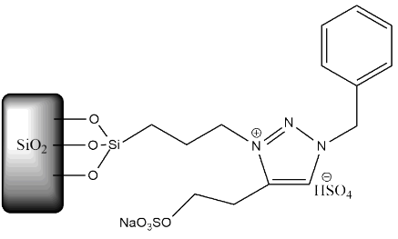  
**Figure 1.** First supported triazolium-based ionic liquid, TR1-Si-HSO4

**3. Results and discussion**

The main idea for synthesizing this new type of ILs considers that the 1,2,3-triazolium salts can be produced under click chemistry concepts, being greener, cleaner and closer to green chemistry processes. As far as the reaction of fructose is concerned, this is carried out under acid conditions; this characteristic is provided by the [HSO4]- anion, which was functionalized with the ionic liquids, owing to its acid characteristics. Figure 1 and 2 show the structures of both catalysts, which were supported in SiO2. For the case of Al2O3 support, the same ILs were anchored. The chosen solvent was DMSO as it is highly polar and capable to stabilize 5-HMF [4]. Therefore, it allows comparing the catalysts with each other avoiding the rehydration reaction to some extent.

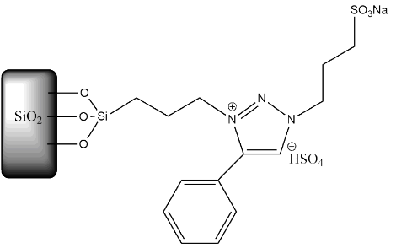  
**Figure 2.** Second supported triazolium-based ionic liquid, TR2-Si-HSO4

The results presented in figure 3 show that the silica support allows obtaining better yields than alumina support after 2h, being of 80% and slightly lower than 70%, respectively, in comparison with the others, which around 60%. Moreover, the kinetic reaction was faster using silica support.

**Figure 3.** Reaction kinetic of 5-HMF,   
yield vs reaction time



As far as the triazolium ionic liquid is concerned, independently of the support, the second triazolium presented better results than its counterpart, probably due to the steric/electronic effect produced by the aromatic group attached directly to the triazolium ring, which could modify the physicochemical properties of the ionic liquid. This fact could favour the interaction between the anion and the HMF, via transfer of electron density from the O to OH groups, that is a crucial step to break the inter and intramolecular hydrogen bonding. However, these results were obtained considering just a few amounts of catalyst mass, so that the results could improve, and the yields may be higher than the non-catalyst case when the mass of catalyst increases.

**4. Conclusions**

The use of a new kind of ionic liquids based on triazolium salts anchored in different supports could represent a promising alternative supported catalyst for greener processes. Furthermore, these catalysts could be used to obtain high yield in the dehydration of fructose to produce 5-HMF.

**References**

1. R. Van Putten, J. Van der Waal et. al., [Chem. Rev. 2013, 113, 3, 1499-1597](https://pubs.acs.org/action/showCitFormats?doi=10.1021%2Fcr300182k).
2. Zekarias Yacob and Jürgen Liebscher (October 10th 2011). 1,2,3-Triazolium Salts as a Versatile New Class of Ionic Liquids, Ionic Liquids, Scott T. Handy, IntechOpen.
3. [Qiang Zhang](https://pubs.rsc.org/en/results?searchtext=Author%3AQiang%20Zhang),  [Jun Luo](https://pubs.rsc.org/en/results?searchtext=Author%3AJun%20Luo)  and  [Yunyang Wei](https://pubs.rsc.org/en/results?searchtext=Author%3AYunyang%20Wei). **Green Chem.** 2010, **12**, 2246-2254.
4. Quanxi Bao, Kun Qiao et. al., *Catalysis Communications, 2008, 9*(6), 1383-1388